Establishing the European Geological Surveys Research Area to deliver a Geological Service for Europe

GeoERA WP4  Questions and answers |  | Authors and affiliation:  Monitoring team  ^{[geozs]}  E-mail of lead author:  monitoring.geoera@geo-zs.si  Version: 04-10-2019
 |  | This document is part of a project that has received funding from the European Union’s Horizon 2020 research and innovation programme under grant agreement number 731166.
Document Data
Dissemination level | GeoERA projects
Document name | Questions and answers
Work package | WP4
Lead WP | GeoZS

TABLE OF CONTENTS
1 PROJECT CHANGES 2
2 REPORTING procedure 4
3 Monitoring procedures 9
4 FINANCE 11
5 Audits 21
6 REFERENCES 24
7 ANNEX 1: reporting to the European commission 25

PROJECT CHANGES
At the beginning of the project, the consortia agreed on timeline, finances, deadlines and workflow, and specified it in Project Agreement and Description of work. Below are some answers regarding project modifications and amendments.

When is Project Amendment necessary?

The Project Amendment is necessary if the change impacts project plan as stated in Project plan.

Table 1: List of changes that need / do not need an amendment
Change conserns | Amendment needed | Amendment NOT needed
Partnership | Addition or removal of partners / third linked parties  Changing the scope of work between partners  Change of coordinator | Administrative changes within the partner organisations
Project implementation | Changes of Project plan and outputs | Minor deviations from the Project plan
Deliverables | Deliverable is delayed for more than one month  Deliverable description | Deliverable is delayed for one month or less
Budget | Budget transfers between partners | Minor budget modifications between WPs or categories on partner level

Needed/necessary changes, which do not need an amendment. How do we proceed?

When the change does not affect the Project plan, the partnership reports about the deviation in the PI doc. no. 2B Midterm Project Progress Report and PI doc. no. 2C Final Project Progress Report. The Project Lead is responsible to track these changes and to ensure the continuous project implementation.

Who approves changes to the Project Plan, when the amendment is needed?

According to the Project Agreement, decision regarding any amendments be implemented/approved to the Project Plan shall be taken by the Project Assembly (see Article 6.3.1.2.). The decision for the change requires two-thirds (2/3) of the Project Assembly members to be valid (see Article 6.2.3.1). The voting shall be done at meetings or in other written form, the Project Assemly decision shall be in written form (see Article 6.2.2.6). The final decision regarding Project amendmentis taken by the GeoERA Executive Board.

How to assemble an amendment?

Step 1: Project Partner sends request for the project modification to the Project Lead, including the subject and justification for the change and impact on the scope of the project.

Step 2: Project Lead disscusses changes with the Project Board and Project Assembly. The change is approved by the Project Assembly in written form (see Who approves changes to the Project Plan, when the amendment is needed?).

Step 3: Project Lead prepares the Amendment and History of changes and sends it to the GeoERA Executive Board together with the justification and proof of approval of the Project Assemly.

Figure 1: Procedure on how to change Project Plan
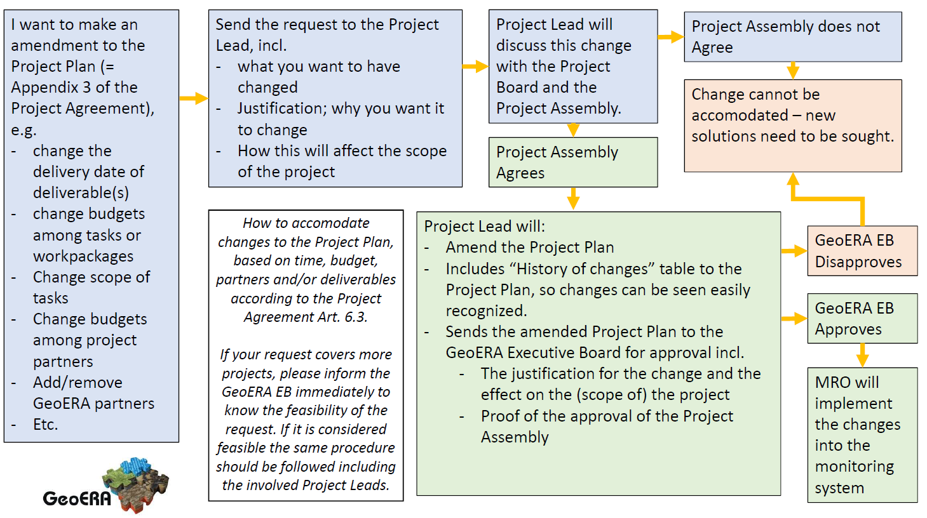

REPORTING procedure
Reporting procedure is described in PI doc. no. 1 Reporting procedures and monitoring indicators. Some specific rules are also described in PI doc. No. 2 Reporting templates & e-tool with annexes.
What are reporting obligations towards GeoERA at the project partner level (Beneficiary)?
All project partners submit Reports on expected expenditures annualy using the PI doc. no. 2A Information on cummulative expenditures to GeoERA coordinator on 15th of December in the year it refers to.
Every Beneficiary should support Project Lead when preparing Project Progress Reports at month 18 and month 36.
What are reporting obligations towards European Commission at the project partner level (Beneficiary)?
At the end of the GeoERA project (M60), every beneficiary submits the cummulative Financial statemet on organisation level for all projects it participated in. The statement is sumbitted through the European Commisions’s Funding & Tenders portal (link: https://ec.europa.eu/info/funding-tenders/opportunities/portal/screen/home ; before: Participants Portal). The deadline for the report is 31.12.2021. More detailes about the report is in Annex 1 of this document.
What is Certificate on the Financial Statement?
Certificate on the Financial Statement at the beneficiary level is required by the EC, when:
- The reimbursement from GeoERA to beneficiary for the direct costs on all projects exceeds 325.000 €;
- The summed reimbursement from GeoERA to beneficiary and it’s linked third party for the direct costs on a project exceeds 325.000 €.
The auditor for the Certificate on the Financial Statement should be subcontracted by the beneficiary. The cost of a required audit report is an eligible cost, even though the cost will incurre after the end of the final period.
The auditor should use template “Annex 5: Model for the certificate on the financial statement (CFS)”, found on https://ec.europa.eu/info/funding-tenders/opportunities/portal/screen/how-to-participate/reference-documents;programCode=H2020 under Templates & Forms Project reporting templates.
What are reporting obligations towards GeoERA at the Project Lead level?
Additionaly to the obligations as beneficiaries, Project Leads submit Project Progress Reports twice during the project lifetime: at M18 using PI doc. no. 2B Midterm Project Progress Report [MPPR] and at M36 PI doc. no. 2C Final Project Progress Report [FPPR]. After the end of the project, Project Lead collects information on costs incurred after the project completion (if foreseen in Project Agreement), and report until the end of September 2021.
Project Leads present the overall project progress at 2 Review meetings: in March 2020 in Ljubljana, Slovenia, and in September 2021 in Brussels, Belgium.
How do we submit the reporting documentation?
It depends on what you are trying to submit:
- PI doc. no. 2A Information on cummulative expenditures GeoERA coordinator (joop.hasselman@tno.nl)
- PI doc. no. 2B Midterm Project Progress Report Monitoring team (monitoring.geoera@geo-zs.si)
- PI doc. no. 2C Final Project Progress Report Monitoring team (monitoring.geoera@geo-zs.si)
- PI doc. no. 2D Costs after Project completion Monitoring team (monitoring.geoera@geo-zs.si)
How do we submit finalized deliverables?
Project Lead can submit the deliverables via SharePoint (http://portal.geo-zs.si/Projekti/GeoERA%20monitoring/Forms/AllItems.aspx) using the credentials provided by the Monitoring team at the begining of the project. Project Lead can also send the deliverables via e-mail to the Monitoring team (monitoring.geoera@geo-zs.si).
You can find detailed instructions about SharePoint in the document “Guidelines_GeoERA monitoring SharePoint”.
Who will check submitted documentation?
Depends on the content of the submitted documentation:
- Deliverables will be evaluated by Scientific Reviewers before the Review meetings;
- Annual reports PI doc. no. 2A Information on cummulative expenditures by GeoERA coordinator
- PPRs by Monitoring and reporting officer, Theme coordinators (with respect to the expected theme impact) and Stakeholders (with respect to overall expected GeoERA impact)
What are obligations of beneficiaries after the project completion?
At the end of the GeoERA project, every beneficiary submits the cummulative Financial statement on organisation level for all projects it participated in. The statement is submitted through European Commisions’s Funding & Tenders portal (link: https://ec.europa.eu/info/funding-tenders/opportunities/portal/screen/home ; before: Participants Portal). The deadline for the report is 31.12.2021. Detailes about the report are in Annex 1 of this document.
In case that the reimbursement from GeoERA for direct costs exceeds 325 000 EUR per beneficiary for all projects, the beneficiary is required to provide Certificate on Financial statement and submit it together with the Financial statement in the Funding & Tenders portal. The deadline for submission is 31.12.2021 – together with the Financial statement for the organisation.
At the end of co-funded projects, Project leads will be asked to complete online questionaire consisting of 10 questions. The aim of this questionaire is to gain an insight on impact project has had on scientific fields (themes) and GeoERA in general. Answers will be used in final impact assessment.
What are the deadlines for the reports?
The deadlines are described in document PI doc. No. 1 Reporting procedures and monitoring indicators. Below you can find summary of deadlines for Beneficiary and Project Lead.
Table 2: Reporting deadlines at the Beneficiary level
Month | Activity | Document | Who | To whom
M6 (15.12.2018) | Report on expenditures | PI doc no 2A: Information on cumulative expenditures | Beneficiaries | GeoERA coordinator
M18 (15.12.2019) | Report on expenditures | PI doc no 2A: Information on cumulative expenditures | Beneficiaries | GeoERA coordinator
M30 (15.12.2020) | Report on expenditures | PI doc no 2A: Information on cumulative expenditures | Beneficiaries | GeoERA coordinator
M41 (15.11.2021) | Report on expenditures | PI doc no 2A: Information on cumulative expenditures | Beneficiaries | GeoERA coordinator
M42 (31.12.2021) | Reporting on organisation level | Reporting through EC’s Funding & Tenders Portal | Beneficiaries | EC
M42 (31.12.2021) | Reporting on organisation level | Certificate on the Financial Statement (Audit Report) | Beneficiaries | GeoERA coordinator

Table 3: Reporting deadlines at the Project Lead level
Month | Activity | Document | Who | To whom
M1 (1.7.2018) | Project start | Project Agreement, Consortium Agreement | Project lead | Monitoring team
M18 (31.12.2019) | End of first reporting period |  | Project lead
M19 (31.1.2020) | Project Progress Reporting | PI doc no 2B: Midterm Project Progress Report | Project lead | Monitoring team
M20 (28.2.2020) | Monitoring and evaluation - Quality assessment | Deliverables with due date M1-M18 (SharePoint) | Project lead | Monitoring team
M21 (31.3.2020) | Review meeting (Ljubljana) | Presentation on work progress | Project lead
M36 (30.6.2021) | Project end | Questionnaire to projects (online - 10 questions) | Project lead | Evaluator
M37 (31.7.2021) | Project Progress Reporting | PI doc no 2C: Final Project Progress Report | Project lead | Monitoring team
M38 (31.8.2021) | Monitoring and evaluation - Quality assesment | Deliverables with due date M19-M36 (SharePoint) | Project lead | Monitoring team
M39 (30.9.2021) | Review meeting (Brussels) | Presentation on work progress | Project lead
M39 / M40 | Reporting on costs after project end | PI doc no 2D: Costs after Project end | Project lead | Monitoring team

What is Project Progress Report (PPR)?
The purpose of a Project Progress Report [also referred to as PPR] is to ensure the effectiveness of the implementation of the Projects in respect to finance, timing, administration and quality of the results. GeoERA’s reporting procedure requires the submission of a midterm PPR (MPPR) in M18 and final PPR (FPPR) at the end of the Project. The reports should be written in the context of the Project with due reference to the progress of all Project partners. Reporting is done through an Excel e-tool, based on the reporting templates, annexed in the document “PI doc no. 2: Reporting templates and e-tool”. Scientific and Professional goals, described in both PPRs, with respective submitted deliverables, are reviewed by GeoZS Reviewers and Theme coordinators.
Where can I find detailed instructions on how to fill out PPR?
In the project implementation document no. 2: Reporting templates & e-tool, chapter 2.
What is a Review meeting?
After submitting the MPPR and the FPPR, the individual project consortia present their progress, results and highlights at Review Meetings, which will be organized in the third month following the end of each reporting period: Midterm Review Meeting in March 2020 and Final Review Meeting in September 2021. The goal of the Midterm Review Meeting is to evaluate the overall progress of the Projects and through recommendations influence and improve its excellence, while the Final Review meeting will target results and conclusions and compare these with the initial ambition of the individual projects and GeoERA expected results.
We have / are expecting deviation from the Project plan. How do we proceed?
Refer to chapter 1: Project changes of this document. Any deviations should be reported in PPR, excel sheet 5. Deviations.

What are the obligations regarding supporting documents?
Each Project partner is obligated to keep records regarding work done for every member of its Project team and all supporting documents for subcontracting and other costs in accordance with Horizon 2020 Rules of Participation. Project timesheets, invoices and other documentation, supporting the costs declared must be kept and archived by every Project partner for a period of five years after the payment of balance of the GeoERA Project. The supporting documents are not submitted with the PPRs but should be available in case of a possible review.
Source: H2020 AMGA, Article 18
For countries out of EU, Euro currency is changing during the year. What is the eligible currency calculation?
All costs shall be reported in Euro. Partners with accounts in currencies other than Euro shall report costs by using the average of the daily exchange rates, published in the C series of the Official Journal of the European Union, calculated over the reporting period. In practice, the exchange rate is found as follows:
- Go to the ECB website:
http://www.ecb.europa.eu/stats/exchange/eurofxref/html/index.en.html
- Click on the chart icon for your currency.
- Insert the start date of the reporting period in the field ‘from’ and the end date of the reporting period in the field ‘to’. The average for the period will appear above the chart.
Source: H2020 AMGA, Article 20, Point 6

Monitoring procedures
Monitoring is considered as an on-going practice of checking activities and their context, inputs, processes and results, and communicating these to the GeoERA monitoring team and storing the information for future use in evaluation. The aim of monitoring is to provide an overview of implemented indicators, deliverables and objectives of the individual Projects in respect to finance, time, administration and quality of results.
Table 4: Four levels of GeoERA monitoring
Level | Monitor/Evaluator | Input | Aim
1 – Monitoring of progress indicators | Monitoring and reporting officer (GeoZS) | MPPR*  FPPR** | Monitoring of the effectiveness of implementation Projects with respect to finance, time and administration.
2 – Scientific review | Reviewers (GeoZS) | Submitted deliverables  MPPR  FPPR | Quality review of the deliverables and review of achieving scientific and professional goals.
3 – Review of the theme progress | Theme coordinators | MPPR  FPPR | Review of achieving theme objectives.
4 – GeoERA Progress evaluation | Stakeholder Council member(s) | Sections 1 and 2 of this report  Review meetings | Overall Project progress and general recommendations.
*MPPR = Midterm Project Progress Report (see PI doc no 2: Reporting templates and e-tool, template 2B)
**FPPR = Final Project Progress Report (see PI doc no 2: Reporting templates and e-tool, template 2C)
How did GeoERA establish the monitoring procedure?
For monitoring and evaluation, the Logical Framework Approach was used, which provides a structured approach looking at the programme. It is based on the idea that there is a linked chain of logic that shows how the activities of an intervention can be expected to produce immediate outputs connected to longer-term effects and eventually the realization of the objectives (impacts). The Logical Framework Approach follows ERA LEARN 2020: Guide for P2P impact assessment, for more information follow the link: https://www.era-learn.eu/publications/other-publications/guide-for-p2p-impact-assessment-1.
What does each monitoring lever represent?
Level 1: Administrative monitoring focuses on indicators, set and defined by the Project consortium within each Project, and described in the DOW. Indicators set in the Project documents will be integrated into monitoring tables of each Project – monitoring indicators. Administrative monitoring follows the progress of the Projects through the achievement of these monitoring indicators.
Level 2: Scientific Review is carried out based on the submitted deliverables and Project Progress Reports by GeoZS Reviewers. Reviewers will compare the Impact statement given in the PPRs to the Expected impact statement in the DOW. Expected impact serves as the scientific indicator, which should be achieved by the Project.
Level 3: Theme coordinators will review the Project progress in accordance with the theme objectives set out in the overall GeoERA Description of Action. The expected impact of each theme is the monitoring indicator.
Level 4: GeoERA’s overall progress evaluation is reviewed by the Stakeholder Council at two Review Meetings. The Stakeholder Council is familiar with GeoERA overall objective: to establish a common European Geological Knowledge Database and to the joint provision of a Geological Service for Europe, focusing on geo-energy resources, groundwater, and raw materials. Stakeholders overall project progress and general recommendations are part of the Technical Review Report. In the report, the stakeholder will first assess the project on a scale from 1 to 5 based on the following criterion: Has the project as a whole been making satisfactory progress according to your own understanding and expectations of the GeoERA project? Then they will be given a chance to comment the overall project progress giving overall recommendations, modifications, corrective actions, or re-tuning the objectives to optimize the impact or keep up with the State of the Art, re-focusing; or give a simple praise.

What is a Technical review report?
Based on administrative monitoring and scientific review, the Technical Review Report is written by designated MRO, Reviewers, Theme coordinators and Stakeholder Council members. The Technical Review Report summarizes the progress of each Project and gives recommendations in case the Project could improve its activities or quality of deliverables. Filled in reports will be sent to Project Leads, any possible discrepancies will be resolved with the consortia. Technical Review reports will be summarized in and annexed to Report on projects’ progress for the ERA NET committee.
The Technical Review Report template is part of the document “Project Implementation doc. no. 2”.
Will the project have any say regarding the content of the Technical Review report?
The Project Leads will be given a chance to analyse the draft Technical review report on the Review meeting and clarify, redefine or resolve any misunderstandings that may have arisen during the review process.

What happens if our project does not meet the goals, set in our Project plan?
When project consortia detect an issue or a delay, the solution must be sought. In any case, we highly recommend timely and open communication with the GeoERA secretariat, since the delay of one project can affect implementation of the other. The GeoERA success depends on achievements of co-funded projects.

FINANCE
Financial rules for costs can be found in H2020 Annotated Model Grant Agreement, Article 6 (https://ec.europa.eu/research/participants/data/ref/h2020/grants_manual/amga/h2020-amga_en.pdf) and summary in PI doc.no.2: Reporting templates and e-tool.

What are eligible costs?
Rules of eligibility for actual costs (based on Article 6; AMGA):

- They must be actually incurred by the beneficiary;
- They must be incurred within the reporting period, with the exception of costs relating to the submission of the final project progress report and participation on the final Review meeting;
- They must be indicated in the original budget plan;
- They must be incurred in connection with the action as described in Project plan and necessary for its implementation;
- They must be identifiable and verifiable, in particular recorded in the beneficiary’s accounts in accordance with the accounting standards applicable in the county where the beneficiary is established and with beneficiary’s usual accounting practices;
- They must comply with the applicable national law on taxes, labour and social security; and
- They must be reasonable, justified and must comply with the principle of sound financial management, in particular regarding economy and efficiency.

Other type of costs recognized by the European Commision are unit costs. Since these are not planned by any of GeoERA beneficiaries, they will not be decribed in this document.

What is the difference between direct and indirect costs?
Direct costs are costs that are directly incurred in connection with the implementation of the project, they are substantively justified, rational, consistent with the beneficiary’s financial policy and confirmed by accounting documents. Direct costs are costs such as remuneration of personnel employed for individual tasks in the project, travel costs related to the project, purchase of equipment, materials for the implementation of research/project, etc.
Direct costs must be verifiable on the basis of accounting documents that explicitly refer to previously planned project activities. They are divided into:

- Direct personnel costs, personnel seconded by a third party against payment.
- Other direct costs,
- Direct costs of subcontracting
- Direct costs of providing financial support to third parties.
Direct costs could be either costs caused in full by the activities of the action or costs that have been caused partly by the project activities. In this case, they can be eligible only if they were attributed to a single action and have been directly measured (i.e. they have not attributed indirectly via an allocation key, a cost driver or a proxy).

Indirect costs are calculated as a 25% flat rate of the eligible direct costs from which the following categories are excluded:

- costs of subcontracting,
- costs of in-kind contributions provided by third parties which are not used on the Beneficiary’s premises.

Indirect costs as opposed to direct costs do not need to be supported by any evidence because they are declared using a flat-rate. However, note that if the beneficiary’s policies traditionally include a cost item among indirect costs, the same approach must be used for GeoERA projects.

What are eligible direct personnel costs?
Personnel costs are eligible, if they are related to personnel working for the beneficiary under an employment contract (or equivalent) and assigned to the action (costs for employees or equivalent).
They must be limited to salaries (including during parental leave), social security contributions, taxes and other costs included in the remuneration, if they arise from national law or the employment contract (or equivalent).
The costs for natural persons working under a direct contract with the beneficiary other than an employment contract are eligible personnel costs, if:
- the person works under the beneficiary’s instructions and, unless otherwise agreed with the beneficiary, on the beneficiary’s premises,
- the result of the work carried out belongs to the beneficiary, and
- the costs are not significantly different from those for personnel performing similar tasks under an employment contract with the beneficiary.
How to calculate personnel costs?
$$Personnel costs=\sum{(individual hourly rate*individual number of actual project hours)}$$

How to calculate hourly rate?
$$Hourly rate=\frac{Actual annual personnel cost for the person (excl.additional remuneration)}{Number of annual productive hours }$$

The personnel costs and the number of productive hours for each full financial year covered by the reporting period concerned must be used. If a financial year is not closed at the end of the reporting period, the beneficiaries must use the hourly rate of the last closed financial year available.

What period for hourly rate calculation should be considered?
Specificaly for GeoERA co-funded projects these periods for hourly rate calculations should be used:

Table 5: Periods for calculating hourly rates on the projects
PERIOD | PERIOD DURATION | PERIOD FOR HOURLY RATE CALCULATION TO BE USED AND REPORTED
Period 1 | 01.07.2018 – 31.12.2019 | 01.01.2019 – 31.12.2019
Period 2 | 01.01.2020 – 30.06.2021 | 01.01.2020 – 31.12.2020

What is “actual annual personnel costs for the person”?
Annual personnel costs consist of: salaries, social security contributions, taxes and other costs included in the remuneration, if they arise from national law or the employment contract (or equivalent appointing act, i.e. holiday allowance).

What is meant by ”annual productive hours”?
There are three options for calculation of annual productive hours:

- Fixed productive hours – 1720 hours for persons working full time (for persons not working full time, the corresponding pro-rata has to be used).
- Standard annual productive hours of the organisation, applied by the Beneficiary with its usual cost accounting practices.
- Individual annual productive hours, using the total number of hours worked for the Beneficiary by each person per year.

In principle, the same option must be applied to all personnel within one organisation and during the project lifetime. However, the Beneficiary may use different options for different types of personnel employed but will have to ensure that the same option is applied at least per group of personnel employed under similar conditions.

We are calculating personnel costs using fixed productive hours 1720 per year. What happens if an employee has more project hours in a year than 1720?
The double ceiling needs to be considered. This is taken from Annotated Model Grant Agreement:

Beneficiaries must ensure that:
- the total number of hours worked declared in EU project for a person for a year is NOT higher than the number of annual productive hours used for the calculation of the hourly rate (see below)

Example: Beneficiary using 1 720 as annual productive hours. According to the time-records, during the financial year 2019 employee Z worked 900 hours in a H2020 action and 900 hours in another EU project. The total hours worked for EU projects by employee Z would therefore be 1 800 (900 + 900). However, the beneficiary cannot declare more than 1 720 hours, since this is the number of annual productive hours it used for the calculation of the hourly rate. Therefore, for 2019, the beneficiary can only charge 820 hours to the H2020 action (i.e. 1 720 – 900 hours declared to other EU grant), even if the person worked 900 hours in the action.

- the total amount of personnel costs declared (for reimbursement as actual costs) in EU project for a person for a year is NOT higher than the total personnel costs recorded in the beneficiary’s accounts (for that person for that year).

Example: The total personnel costs recorded in the 2019 accounts of the beneficiary for employee Z is EUR 18 000. The beneficiary already declared EUR 9 000 to the other EU grant. The hourly rate for employee Z according to the formula in the H2020 Grant Agreement is 11 EUR/hour and employee Z worked 900 hours for the action in 2019. The eligible personnel costs for the H2020 action would therefore be: 11 EUR/hour x 900 hours = EUR 9 900. However, since the beneficiary already declared EUR 9 000 to the other EU grant, the maximum that it can declare to the H2020 action is: EUR 18 000 (total personnel costs for employee Z) – EUR 9 000 (already declared to other EU grant) = EUR 9 000. The beneficiary can therefore declare only EUR 9 000, even if the result of the formula for personnel costs would be EUR 9 900.

How to report personnel costs when annual data for employee is not avaliable (i.e. employment shorter than closed financial year)?
Beneficiaries may calculate the hourly rate per month as follows:
$$Hourly rate=\frac{Actual monthly personnel cost for the person (excl.additional remuneration)}{Number of monthly productive hours (i.e.annual number divided by 12) }$$
For the calculation of the monthly hourly rate, only option 1 (1720 productive hours – fixed number of hours) or option 2 (standard annual productive hours) can be used.
Under Actual Personnel costs, you have to use for the calculation of the cost per hour the personnel cost of the last closed fiscal year. How do you manage to cover your real costs if you have to use costs of a previous year that is much lower?
Indeed if you use the fiscal year calculation and for several months you have to use the previous year's data, it may happen that not all your real costs are covered. However, using the fiscal year calculation requires less time and effort from your administration which saves money. In case you think that your losses are significant with the fiscal year calculation, turn to the monthly calculation.
Are there any rules regarding documents for actual hours worked on the project per employee?
Persons who do not work exclusively for the project and whose personnel costs are declared are obliged to show the number of hours worked on the action with reliable time records. These records can be either on paper or in the form of an electronic system. They must be issued at least on a monthly basis and signed by the person who worked on the action and her/his supervisor.
Persons who work exclusively for the project may either use time records or sign a Declaration on exclusive work for the action available on the Funding & Tenders Portal. Only one declaration per reporting period is allowed. If the person only works several periods during a reporting period exclusively for the action, he/she should use the declaration for the longest period of exclusive work and for the rest of the reporting period he/she must deliver time records; however, it is advisable to use time records for the whole reporting period.
As auditors will check the employment contracts and national labour regulations, this Declaration should be used carefully. Some contracts may contain obligations for e.g. training activities, administrative tasks etc. which would make the persons concerned ineligible for the Declaration on exclusive work for the action.
What are timesheets and when do we submit them?
Beneficiaries can be asked to provide timesheets when submitting Project Progress Reports, or in case a beneficiary is audited. We recommend using the timesheet format, provided by the EC (https://ec.europa.eu/info/funding-tenders/opportunities/portal/screen/how-to-participate/reference-documents;programCode=H2020 under Templates & Forms Project reporting templates). Beneficiary can also use its own time sheets, but they should include the minimum requirements:
- the title and number of the action as specified in the GA;
- the beneficiary’s full name, as specified in the GA;
- the full name, date and signature of the person working for the project;
- the number of hours worked for the project in the period covered by the time record;
- the supervisor’s full name and signature;
- a reference to the action tasks or work packages of Project plan, to which the person has contributed by the reported working hours.
At the project planning phase, we planned XX € and YY person-months. What happens, if Person-months is not exactly as planned?
The basis for payment is XX € - if you spend the planned amount, you will receive the whole payment. We expect the final PM number will differ from the planned YY, due to actual costs being reported, and personnel costs differ in time and per team member. In case of mayor differences, we (or the EC at the final report) will ask for justification of the difference.
Do employee contracts need to contain a reference to the H2020 project tasks?
Not necessarily - follow your own and national rules for this. The employees need to be assigned to the project - but not necessarily via their contract.

is it also possible to calculate and report personnel cost for an administrative person at our institute (a non-researcher)?
Yes, also administrative personnel can work on the project on specific tasks.

Are additional salaries eligible? How do we include 13 and 14 salary in the personnel costs calculation?
If you have 13th and 14th month salaries and it is based on national rules, then just add it to all yearly salary costs. That is if you use fiscal year calculation. In case of monthly calculation, you need to distribute the two extra salaries by months throughout the year. (when the part of these two extra salaries were earned)

What is Additional remuneration?
Beneficiaries that are non-profit legal entities may also declare as personnel costs additional remuneration for personnel assigned to the action (including payments on the basis of supplementary contracts regardless of their nature), if:
- it is part of the Beneficiary’s usual remuneration practices and is paid in a consistent manner whenever the same kind of work or expertise is required;
- the criteria used to calculate the supplementary payments are objective and generally applied by the Beneficiary, regardless of the source of funding used.

“Additional remuneration” means any part of the remuneration which exceeds what the person would be paid for time worked in projects funded by national schemes; whereas “Basic remuneration” is cost for actual salary including other contributions of the person according to the national laws.

Additional remuneration for personnel assigned to the action is eligible up to the following amount:
- if the person works full time and exclusively on the action during the full year: up to EUR 8,000;
- if the person works exclusively on the action but not full-time or not for the full year: up to the corresponding pro-rata amount of EUR 8,000; or
- if the person does not work exclusively on the action: up to a pro-rata amount calculated as follows: {EUR 8,000 divided by the number of annual productive hours, multiplied by the number of hours that the person has worked on the action during the year}.”

Additional remuneration is in practice an issue ONLY for cases where salary is project-based. All other beneficiaries will automatically fall under basic remuneration only and therefore are not concerned by the provisions on additional remuneration.
If beneficiary is eligible for additional remuneration, the following formula should be used:

$$Personnel costs=\sum{(individual hourly rate*individual number of actual project hours+additional remuneration)}$$

What are other direct costs?
Other direct costs include all those eligible costs that can be attributed directly to the project and are identified by the beneficiary as such, in accordance with its accounting principles and its usual internal rules, and do not include personnel costs described above. These costs include the following categories:

- travel costs and related subsistence allowances;
- equipment costs;
- costs of other goods and services.

What can be reported under travel costs?
Travel costs and related subsistence allowances include travel tickets, accommodation etc. that are related to the project or specific task. The costs can relate to both personnel of the Beneficiary and experts that participate on ad-hoc basis (must be foreseen in the Project plan). There is no special calculation method: the costs must correspond to the eligible costs that actually took place and must follow the usual regulations of the beneficiary’s policy on travel.

The costs are eligible if they are in line with the beneficiary’s usual practices on travel (the national and/or internal rules of the Beneficiary) and fulfil the general conditions for actual costs, i.e. they are incurred during the action, limited to the needs of the action, reasonable, necessary for and linked to the action, and adequately recorded in the accounts of the beneficiary. It is important to always provide a satisfactory description of travel: researcher name, venue, dates, and reason. If a paper/poster has been presented, it is recommended to always provide its title.
What can be reported under equipment cost?
This cost category includes either the full purchase cost of the equipment or other or depreciation costs of those. In addition, it includes costs of renting or leasing the equipment, infrastructure and other assets and costs of those contributed in-kind against payment. In some cases, equipment costs may also include the costs necessary to ensure that the asset is in good condition for its intended use (e.g. site preparation, delivery and handling, installation, etc.).
Are there special rules regarding the purchase of the equipment?
The main principles for eligibility of costs:
- The equipment is eligible (must be foreseen in Project plan).
- The best-value-for-money principle (or if appropriate, the lowest price) is respected and there is no conflict of interest.
- The equipment is written off in accordance with the accounting principles of the beneficiary and international accounting standards.

In order to ensure that the best-value-for-money principle is met, a beneficiary should use competitive selection procedures (lowest price is an important factor, but it is not always automatic that the offer with the lowest price has to be selected); should take into account existing framework contracts and should follow national laws on public procurement.
How to calculate depreciation cost?
The depreciation costs must be calculated according to the following principles:
- The depreciable amount (purchase price) of the equipment must be allocated on a systematic basis over its useful life (i.e. the period during which the equipment is expected to be usable). If the equipment’s useful life is more than a year, the beneficiary cannot charge the total cost of the item in a single year.
- Depreciated equipment costs cannot exceed the equipment’s purchase price.
- Depreciation cannot be spread over a period longer than the equipment’s useful life.
- If the beneficiary does not use the equipment exclusively for the project, only the portion used on the action may be charged. The amount of use must be auditable.
- The beneficiary cannot charge depreciation for periods before the purchase of the equipment.
What can be reported under other goods and services?
This category refers to the costs related to purchase of minor goods and services necessary (but not crucial) to implement the project. They are eligible if they fulfil the general conditions for actual costs.
They include:
- Consumables and supplies (e.g. raw materials etc.).
- Dissemination costs related to website, open access to peer-reviewed scientific publications or to research data and conference fees for presenting project-related research.
- Costs for Certificates on Financial Statements (CFS).
- Costs related to intellectual property rights (IPR) as costs to protect the results or royalties paid for access rights needed to implement the project.
- Other services as translation, catering or renting meeting rooms for a project event (the best-value-for-money rule applies).

What can be reported under subcontracting?
If necessary, to implement the action the beneficiaries may award subcontracts covering the implementation of certain action tasks described in Project plan. Subcontracting may cover only a limited part of the beneficiary’s tasks. The beneficiaries must award the subcontracts ensuring the best value for money or, if appropriate, the lowest price. In doing so, they must avoid any conflict of interests.
Subcontracts are excluded from the calculation of the indirect costs.
What is the difference between Other goods and services and subcontracting?
Table 6: The diference between category Other goods and services and Subcontracting
Other goods and services | Subcontracting
These contracts do not cover the implementation of project tasks, but they are necessary to implement project tasks by beneficiaries | Subcontractors concern the implementation of project; they imply the implementation of specific tasks which are part of the project and are described in Project plan.
Do not have to be indicated in Project plan. | Must be indicated in Project plan.
They will be taken into account for the application of the flat-rate for indirect costs. | They will not be taken into account for the application of the flat-rate for indirect costs.

What is a third party?
A third party is a legal entity that has not signed the Grant Agreement and provides external support to any of the beneficiaries.

Table 7: Different kinds of third parties
TYPE | CHARATERISTICS
 | Works on project tasks? | Provides resources and services? | What is eligible? | Must be indicated in Project plan? | Indirect costs? | Selecting the third party
Linked third party | YES | NO | Costs | YES | YES | Must be affiliated or have a legal link and be eligible for funding
International partners | YES | NO | N/A | YES | N/A | Must not be eligible for funding
Subcontractor | YES | NO | Price | YES | NO | Must be best value for money, avoid conflict of interest
Third party providing in-kind contribution | NO | YES | Costs | YES | YES | May not be used to circument the rules
Contractor (equipment, good of service) | NO | YES | Price | NO | YES | Must be best value for money, avoid conflict of interest
Third parties receiving financial support | The third party participates in the project as recipient |  | Amount of support given | YES | NO | Accoring to the conditions in Project plans  Article 15

In all of these cases, the beneficiaries retain sole responsibility towards the Commission/GeoERA and the other beneficiaries for implementing the project.

What is a linked third party?
The Beneficiary may have a legal link with a third party which is not limited to the project and not based on a contract for the purchase of goods, works or services or the implementation of specific action tasks. In H2020, a linked third party is a legal entity that has a pre-existing legal link with a beneficiary. The link can be a contract, or a written collaboration agreement, or membership in the same body, like an association. The link should not have been created only for the participation in the project.
The linked third party has to report its costs following the eligibility rules of Horizon 2020 with a separate cost statement that will be included in the cost statement of the beneficiary. They can use the same cost categories (including indirect costs) and need to provide Certificate on Financial Statement if the threshold of EUR 325,000 is reached. The beneficiary must provide this certificate, if the sum of reimbursement for the beneficiary and third liked party is reached, even if separately they do not reach it.
The beneficiary has to ensure that in case of an audit, the linked third party can be audited as well.
Is VAT eligible cost?
In case of a deductible VAT, it is not eligible. In case VAT is not deductible, then it is eligible, but be careful – in case of an audit you’ll need to prove it.

‘Deductible VAT’ means VAT that is recoverable under the national ‘VAT system’ (i.e.
the system of collection and deduction under the national VAT legislation). Such VAT
is not a genuine and definitive cost and, according to accounting standards, should
not be recorded as such. Therefore, it is not actually incurred by the beneficiary.

When can we expect payments from the GeoERA?
The payment timeline is:

- 50% at the beginning of year 2019
- 30% at mid-term (first half of the year 2020)
- 20% at the end of the project (balance payment in case project has not spent 100% of its’ budget)

Audits
The Commission, during the implementation of the project or upon completion, checks, reviews, investigates and audits the proper implementation of the project and its compliance with the Grant Agreement. Subject of the audit can be any subject that received EC funding. The audit can happen up to 2 years after the balance payment. The beneficiaries must keep all records and supporting documents for this period.
The different types of control foreseen for each beneficiary, the Consortium as a whole, third parties and subcontractors (via beneficiary), in accordance with Article 22 of the H2020 Annotated Model Grant Agreement, are described in the following table:
Table 8: Types of audits in Horizon 2020
TYPE | ACTION | EXAMPLE | Possible (negative) outcomes
CHECKS | Inspects the implementation of the action.  Verifies compliance with legal obligations.  Assesses deliverables and reports.  Can relate to any aspect of the grant.  Usually includes desk review and is carried out remotely.  May be carried out during the project and upon completion.  Inquiry usually through Lead partner. | Justification of the report: detailed description of work carried out; justification of Use of resources (financial part).  Plagiarism check.  IP rights. | Deducting the ineligible amounts or return of payments for the ineligible amount.  Further audits can base on these findings.
REVIEWES | Mainly concerns technical, scientific, ethical aspects.  Can include financial and budgetary aspects.  May include on-the-spot visits or review meetings.  Review report and 30 days “contradictory review procedure”.  Up to 2 years following the payment of the balance. | Progress review / completion of deliverables.  Objective relevance.  Consumption of resources based on the results achieved; resources spent economically, efficiently and successfully.  Partner contribution to the project.  Expected scientific, technological, economic and social impact and dissemination. | If (major) errors are identified, they may (temporarily) suspend the project, request reimbursement, reduction of contractual funds, exclusion of the partner and financial penalties.
AUDITS | Mainly concerns the financial implementation of the action.  Can include technical and other aspects.  Audit report and 30 days “contradictory audit procedure”.  May be initiated up to 2 years following the final payment.  Usually includes on-the-spot visit and desk review. | Consumption of resources; resources spent economically, efficiently and successfully.  Auditors should have access to the premises where the project activities were carried out (e.g. laboratories), to all project team members and to subcontractors.  Cross-checks between EU projects and/or other (national) projects. | If (major) errors are identified, they may (temporarily) suspend the project, request reimbursement, reduction of contractual funds, exclusion of the partner and financial penalties.  They may additionally approve the costs reported by the partner that were not initially approved.
INVESTIGATIONS | Carried out in order to discover fraud, corruption or illegal activities.  Includes on-the-spot checks and inspections at any moment during and upon completion of the action.  May be initiated up to 2 years following the final payment. | OLAF – European Anti-Fraud Office conducts investigations. | In case of finding illegal activities, they can (temporarily) suspend the project, request a refund, contract reduction, exclusion of the partner and financial penalties, as well as criminal prosecution of those responsible.

Is Certificate on Financial Statement also one type of audit under H2020?
The CFS is part of CHECKS. The CFS is a factual report prepared by an independent auditor who verifies that the costs declared in the financial statements are eligible. It is compulsory whenever a Beneficiary/linked third party requests a total EC contribution of EUR 325,000 or more as reimbursement of eligible actual costs and unit costs (without indirect costs).
Who conducts the checks, reviews, audits or investigations?
The checks are usually carried out by the EC’s own staff, reviews and audits by external persons or bodies appointed by the EC, and investigations by OLAF.
What is the worst-case-scenario of an audit outcome?
If systematic errors are found, the Commission may extend the findings of the audit to non-audited Grant Agreements or non-audited periods. This means that if the auditor suspects the errors are institution-wide, the Commission can extend the audit to other Beneficiary’s projects funded by the same funding programme, or even other programmes funded by the EC.
Is there a procedure for reviews, audits and investigations?
The audit is initiated by a letter sent to the beneficiary concerned. In the letter the date of the on-the-spot visit and a list of required documentation to be provided to the auditor is proposed. The auditors will request access to a wide range of records and documentation (e.g. payslips, labour contracts, timesheets, invoices and procurement documents, complete statutory accounts, etc.) and will indicate how and when it must be provided (and in which format). The beneficiary must provide the auditors with all requested information, records and supporting documents (in the format and within the deadline specified). Objections based on data protection or confidentiality will NOT be accepted.
For on-the-spot audits, the beneficiary must allow access to its premises and ensure that all
records and supporting documentation are readily available. This includes granting access to
research facilities and interviewing the researchers that worked on the action. The results of the audit will be recorded in an audit report.
The draft audit report will be sent to the beneficiary concerned for comments within 30 days
(contradictory audit procedure). The audit procedure will be closed (by the Commission/Agency auditors) with the final audit report and the letter of audit conclusions (LoC) — and the file will then be passed on to the Commission/Agency operational services (authorising officers) for the follow-up, if any.
Is monitoring team going to conduct any checks or reviews of the beneficiaries?
No financial checks or reviews are planned by the GeoERA monitoring team. Our monitoring is “desk based”, meaning we will check the financial reports and ask for explanations if necessary. Throughout the project implementation we will support GeoERA partners in administrative / financial part and give guidelines on how to manage supporting documentation.

REFERENCES
How to complete your financial statement - general (Horizon 2020 guidelines) https://webgate.ec.europa.eu/fpfis/wikis/display/ECResearchGMS/How+to+complete+your+financial+statement+-+general#Howtocompleteyourfinancialstatement-general-3.Financialstatements

H2020 Indicative Audit Programme (H2020 guidelines) https://ec.europa.eu/research/participants/data/ref/h2020/other/gm/audit/h2020-iap_en.pdf

Reporting and payment (H2020 guidelines) https://ec.europa.eu/research/participants/data/ref/h2020/other/events/2018-11-29/6_reporting-payments-bp-it_en.pdf

H2020 reference documents and templates (H2020 guidelines)
https://ec.europa.eu/info/funding-tenders/opportunities/portal/screen/how-to-participate/reference-documents;programCode=H2020

Funding & Tenders portal (link to the portal)
https://ec.europa.eu/info/funding-tenders/opportunities/portal/screen/home

H2020 Annotated Model Grant Agreement (H2020 document) https://ec.europa.eu/research/participants/data/ref/h2020/grants_manual/amga/h2020-amga_en.pdf

Financial Management of H2020 Projects: Guide to Best Practice – Based on BESTPRAC Members’ Experience
https://bestprac.eu/fileadmin/mediapool-bestprac/documents/Outputs/Learning_materials/Financial_Matters/1_Main_documents/2019-04-01_BESTPRAC_Financial_Management_of_H2020_projects_-_Guide_to_Best_Practice

Basic mistakes in H2020 personnel cost calculation and reporting (EurpoaMedia guidelines) https://europamediatrainings.com/api/documents/download/57

Project implementation document no. 1 Monitoring indicators and procedures and no 2 Reporting templates and e-tool
https://geoera.eu/deliverables/

Reporting, Monitoring and Impact Assessment of projects (+ppt named “For communication and support use monitoring.geoera@geo-zs.si”)
http://portal.geo-zs.si/Projekti/GeoERA%20monitoring/Forms/AllItems.aspx

Presentation H2020 o revizijah (B. Simić) (GeoZS internal document)

Questions from our projects (e-mails to geoera.monitoring@geo-zs.si)

ANNEX 1: reporting to the European commission
Where can we submit the financial statement?
When all beneficiaries receive a notification that the reporting is opened on the Funding & Tenders Portal, they must fill in their own financial statement, electronically sign it and submit it to the Coordinator.

Visit Funding and Tenders Portal (https://ec.europa.eu/info/funding-tenders/opportunities/portal/screen/home) My area My projects action Manage project:

Figure 1: Selecting action Manage project
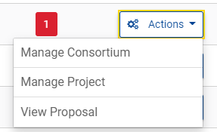
New window will open, the upper part dedicated to reporting, click on the Financial statement.

Figure 2: Reporting in the Funding & Tenders portal
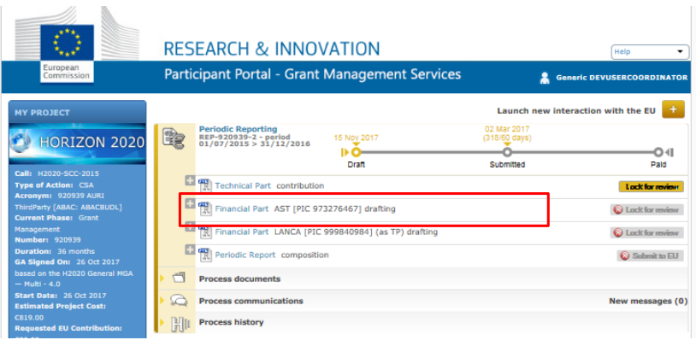

Figure 3: Financial statement for organisation
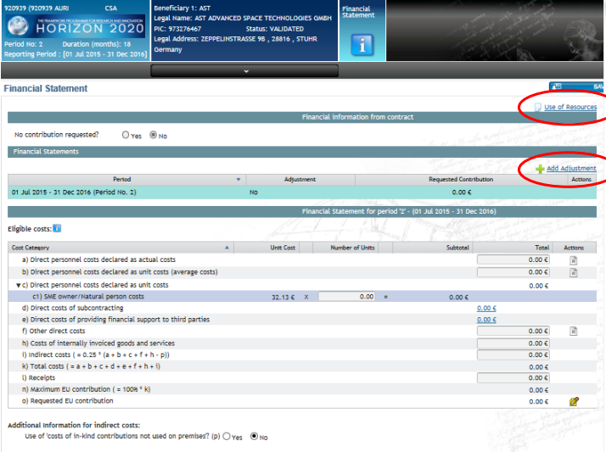
Who has access to the reporting in my organisation?
- Users who can fill in the statement are: Participant Contacts, Project Financial Signatories (PFSIGN) and Task Managers (to see who has access, select Manage Consortium in the actions drop down menu find your organisation Edit roles)
- Users who can electronically sign & submit the statement are Project Financial Signatories only.

How to fill in the personnel costs?
First, insert the amount of personnel costs in the a) Direct costs declared as actual costs. When the amount of personnel costs is entered into the portal, click to add use of resources. Click "Add detail" to add the person/month per Work Package and the use of the in-kind contribution from third party
Since April 19, 2018, a new supporting tool is available on the Funding & Tenders Portal: the “personnel costs calculation wizard”. With the aim to facilitate the reporting obligations on actual direct personnel costs, this wizard is available on the financial statement screen. Its use is not obligatory, but it can help in the calculation of personnel cost.
Figure 4: Direct personnel costs declared by actual costs
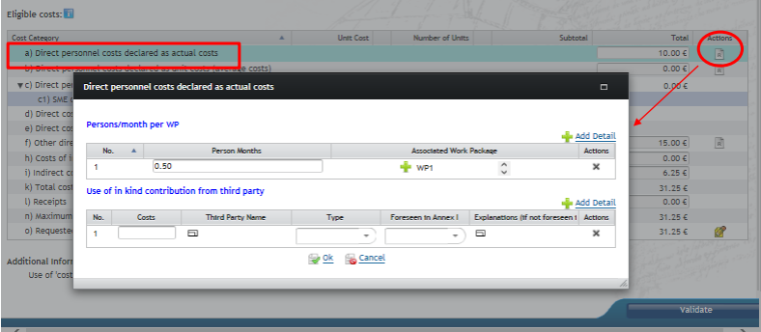

How to fill in the subcontracting?
First, insert the amount of subcontracting costs in the d) Direct costs of subcontracting. When the amount is entered into the portal, click “Add detail” to add the amounts and corresponding details of the costs.
Figure 5: Add detail for the subcontracting costs
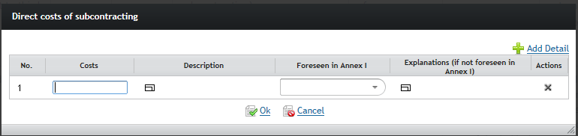

How to fill in the Other direct costs?
First, insert the amount of total other direct costs in the f) Other direct costs. Click to add the use of resources. The amounts filled out here, won't be added to the total costs. Click "Add detail" to add the costs per Work Package and the use of the in-kind contribution from third party.
Figure 6: Add detail for the other direct costs
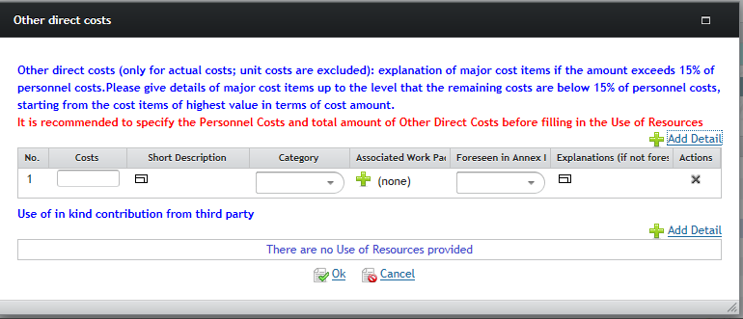
How to fill in the direct costs of providing financial support to third parties?
Complete the total costs in line e) Direct costs of providing financial support to third parties. Click "Add detail”.
Figure 7: Add detail for the direct costs of providing financial support to third parties
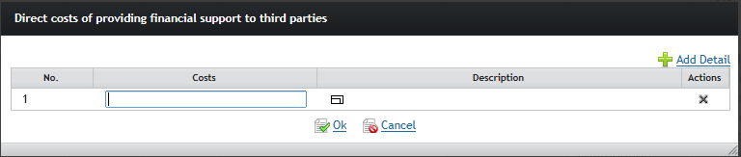
How to report indirect costs?
The amount of indirect costs is automatically calculated, but still editable for legal entities which also have an operating grant with indirect costs for the same period.
The contribution from the EC for my organization exceeds 325.000 € for total direct costs. How do we upload the Certificate on Financial statement?
If a CFS needs to be provided, a warning is displayed in the application and a validation error appears if the user saves the data without providing the requested CFS.
Figure 7: Adding the Certificate on Financial statement
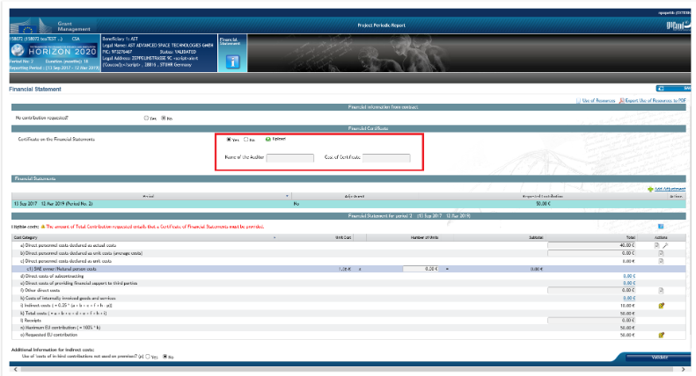

Our report is complete and correct. How do we proceed?
After saving the financial statement, close the window and go back to reporting. Next to financial statement the button “Lock for review” will appear. After selecting the lock for review, the financial statement will be locked, your Legal financial signatory will be asked to sign the statement. After that, the GeoERA coordinator will be informed about your completion.

