Deliverable  Scope – Terms and definitions – Literature review on pathways – Pilot areas and data collection plans |  | Authors and affiliation:  Willem Zaadnoordijk (TNO-GSN), Ágnes Szalkai (MBFSZ), Koen Beerten (SCK●CEN), Dan Mallin Martin (BGS), Rob Ward (BGS), M. Bowes (BGS), A. Newell (BGS), P. Smedley (BGS), Hans Peter Broers (TNO-GSN), Cis Slenter (VMM), Sian Loveless (BGS)  Technical Report 1, WP 3  E-mail of lead author:  willem_jan.zaadnoordijk@tno.nl  Version: 28-06-2019
Change Date Version  setup Jan. 2019 1  pilot descriptions March 2019 2  Data collection plans April 2019 3  Literature review May 2019 4  Final June 2019 5 |  | This report is part of a project that has received funding by the European Union’s Horizon 2020 research and innovation programme under grant agreement number 731166.
Deliverable Data
Deliverable number | D3.1
Dissemination level | Public
Deliverable name | Technical report on evidence for potential pathways for groundwater contamination from subsurface energy activities and investigation/ data collection plan technical report
Work package | WP3, Process Understanding
Lead WP/Deliverable beneficiary | TNO – Geological Survey of the Netherlands
Deliverable status
Submitted (Author(s)) | 28/6/2019 | Willem Zaadnoordijk
Verified (WP leader) | 28/6/2019 | Willem Zaadnoordijk
Approved (Coordinator) | 19/07/2019 | Marco Bianchi (BGS)

GENERAL INTRODUCTION
This report is the first deliverable for Work Package 3 of the VoGERA project (Vulnerability of Shallow Groundwater Resources to Deep Sub-surface Energy Related Activities). This work package seeks to better understand processes and pathways that may be associated with impacts on groundwater resources from energy-related activities in the subsurface. The report introduces the topic and provides a literature review. It describes the pilot areas that will be used to evaluate possible pathways in detail for several geological settings across Europe, identifies information gaps and presents a data collection plan for the following phase of the work package.

List of abbreviations & acronyms
BGS | British Geological Survey (part of UKRI)
DINO | National database of information on the shallow Dutch subsurface (available at: http://www.dinoloket.nl)
DMP | Data Management Plan
EGDI | European Geological Data Infrastructure
GSO | Geological Survey Organisation
MBFSZ | Magyar Bányászati és Földtani Szolgálat (Mining and Geological Survey of Hungary)
NLOG | National database of information on the deep Dutch subsurface (available at: http://www.nlog.nl)
SCK●CEN | Belgian Nuclear Research Centre
TNO-GSN | Geological Survey of the Netherlands (part of TNO)
VMM | Vlaamse Milieu Maatschappij (Flanders Environment Agency)
VoGERA | Vulnerability of shallow Groundwater resources to deep sub-surface Energy-Related Activities

TABLE OF CONTENTS
List of abbreviations & acronyms 4
0 Introduction 7
1 Scope 8
2 Definitions 9
3 Relevant processes and pathways 10
3.1 Introduction 10
3.2 Consequences from energy-related activities 11
3.3 Pathways 12
3.4 Extraction activities 12
3.5 Injection activities 14
3.6 Pressure neutral activities 14
3.7 Summary of pathways 15
4 Pilot Pannonian Basin 16
4.1 Introduction of the pilot 16
4.2 Available infrastructure 17
4.3 Available information 18
4.4 Information gaps 18
4.5 Data collection plan 19
5 Pilot Vale of Pickering 20
5.1 Introduction of pilot 20
5.2 Available infrastructure 26
5.3 Available information 29
5.4 Information gaps 29
5.5 Data collection plan 30
6 Pilot Peel Boundary Fault Near Veghel 31
6.1 Introduction of pilot 31
6.2 Available infrastructure 33
6.3 Available information 34
6.4 Information gaps 37
6.5 Data collection plan 37
7 Pilot Rauw Fault 39
7.1 Introduction of pilot 39
7.2 Available infrastructure 40
7.3 Available information 43
7.4 Information gaps 43
7.5 Data collection plan 43
8 Concluding Remarks 44
9 REFERENCES 45

Executive Summary

This report is the first deliverable for Work Package 3 of the VoGERA project, “Vulnerability of Shallow Groundwater Resources to Deep Sub-surface Energy-related Activities”. This project is part of the Groundwater Theme of the EU’s Horizon 2020 research and innovation programme “GeoERA” project, under grant agreement No 731166. The VoGERA project contributes to societal challenges recognised as part of the Horizon 2020 programme; 3: Secure, clean and efficient energy and 5: Climate action, environment, resource efficiency and raw materials.
The VoGERA project is gathering scientific evidence to investigate the relationship between industrial activity in the deep sub-surface and shallow groundwater resources, in a European context. The project considers the possible impacts on groundwater from a range of sub-surface energy activities (geothermal energy, conventional oil and gas, unconventional oil and gas exploitation, sub-surface energy storage and disposal of energy-related waste such as CO₂) in a consistent manner. An approach to evaluating groundwater vulnerability from sub-surface activities that can be applied across Europe will be developed using this evidence, and the in-depth understanding gained will be used to improve awareness of these issues with decision makers and the public. This will aid better sub-surface spatial planning and policy development for deep sub-surface energy-related activities in relation to groundwater, thus allowing for the simultaneous protection of groundwater for future generations whilst recognizing the need for economic development. A strong link with stakeholders will ensure an approach that is fit for purpose and has maximum impact.
This work package, “process understanding” uses four case study examples to demonstrate and understand particular processes and pathways between deep energy activities. This report, “Technical report on evidence for potential pathways for groundwater contamination from subsurface energy activities and investigation/ data collection plan technical report” is the first technical report for WP3 and includes review of processes and pathways from deep sub-surface energy activities to shallow groundwater, including assessing the infrastructure and data available at the pilot areas. Based on this review, further data collection and hydrogeological and geophysical investigations have been planned for the pilot sites over the following year (2019/20). The results will be combined with the existing data at the end of this period in an analysis of the processes and pathways. Following this, groundwater vulnerability assessments illustrated with maps/geological models to show shallow groundwater vulnerability at the pilot study sites, will be produced.

This report first summarises the pathways and processes that are occurring in the subsurface associated with different energy activities. It includes natural pathways such as faults, and anthropogenic pathways such as boreholes. In addition, it recognizes that the specific processes being undertaken with each energy activity – injection, abstraction, or a combination of both, influence subsurface pressures and are therefore important to consider for potential drivers for groundwater contamination. Each pilot study – Pannonian Basin (Hungary), Vale of Pickering (UK), Peel Boundary fault, Veghel (the Netherlands), Rauw Fault (Belgium) is then described with an overview of the geology and hydrogeology, existing infrastructure and available information, and the data collection plan for the following year.

Introduction
The overall aim of the VoGERA project is to provide data for the development of conceptual models of shallow groundwater vulnerability to deep sub-surface energy activities using existing data, information and experience of GeoERA partners and from previous projects. The models will be validated at a number of pilot study sites.
Understanding and managing hazards and risks associated with potentially harmful activities in order to meet the environmental objectives of the EU Water Framework Directive (2000/60/EC) and Groundwater Directive (2006/118/EC) is a prerequisite for protecting groundwater for future generations. Groundwater protection has traditionally focused on safeguarding water resources from hazards at (or near) the surface. As a result, the risks from near-surface activities are relatively well understood and managed. The controversy surrounding the shale gas industry development in Europe has highlighted the lack of information and systematic practices across the EU for managing a range of hazards to groundwater from energy-related activities in the deep sub-surface.

Work Package 3 “Process understanding” focuses on improving understanding of the potential pathways between deep sub-surface energy activities and shallow groundwater. This will be achieved through analysis of hydrogeological, physical, chemical, isotopic, and geophysical information for four pilot sites. The pilots are in different hydrogeological settings across Europe.

This technical report is the first deliverable of Work Package 3 and includes:
- The literature review of processes and pathways from deep sub-surface energy activities to shallow groundwater;
- The data review of the pilot areas, including assessing the infrastructure and data available at the pilot areas;
- Inventory of data gaps and planning of further data collection.
The pilots will be used to test the conceptual models of shallow groundwater vulnerability to deep sub-surface energy activities, which will be developed in Work Package 4 of the VoGERA project (Loveless et al., 2019).
The scope and definitions of key terms are given in Chapter 1 and 2. The results of the literature review and description of relevant pathways and processes are summarised in Chapter 3. The pilots are described in the Chapters 4 (Pannonian Basin, Hungary), 5 (Vale of Pickering, United Kingdom), 6 (Peel Boundary Fault, the Netherlands), and 7 (Rauw Fault, Belgium).

Scope
The focus of the VoGERA project is understanding pathways for negative impacts of energy-related activities on groundwater resources, which are relevant for European settings. Shallow aquifer thermal energy storage systems and nuclear waste storage are excluded (as energy-related activities) because they are common practice and well-regulated or the focus of dedicated research programmes. The considered energy-related activities are:
- extraction (oil, gas, coal possibly via subsurface gasification, thermal energy);
- injection (CO₂, oil or gas for temporal storage/buffering);
- solid waste storage (no net addition of mass);
- combined injection and extraction without net extraction (geothermal doublets);
- changing properties (enhancing permeability / fracking);
- drilling .
The subsurface water resources include all groundwater with a potential of being used e.g. for drinking water, nature, industry, nature, and reserves for possible future use. In order to protect these groundwater resources from risks from subsurface energy-related activities, field based hydrogeological research is needed to provide baseline concentrations and information on pathways (Jackson et al. 2013).
The GeoERA call document (GeoERA, 2017) asked for “Substantiating the relation between deep industrial activities (e.g. geothermal energy and unconventional hydrocarbon exploitation) and shallow groundwater resources”. However, it is unnecessarily limiting to specify “deep” and “shallow” for both the activities and the groundwater resource. The distinction may seem logical from the fact that the base of the British groundwater bodies is set at 400 meters and that the Dutch mining law applies to depths greater than 500 meters. However, in the Pannonian basin, there are important water resources below these depths and in the Roer Valley Graben deeper groundwater is considered in the search for strategic groundwater water resources. Another example is the main spring of the thermal water in Bath (UK), which is fed by meteoric water from a distance of 15 km reaching depths between 2.7 and 4.3 km on its way to the spring (Andrews et al., 1982).

Definitions
Contaminant – compound which negatively impacts groundwater quality
Energy-related activities – human interference in the subsurface below or within the depth of groundwater resources related to storing or extracting energy resources (excluding shallow aquifer thermal energy storage and activities related to subsurface storage of nuclear waste)
Effect – synonym of impact
Groundwater resource – water in the subsurface with the potential to be used
Impact – change of groundwater quality (assuming quantity does not change), e.g. through:
- migration of deep formation water
- contamination from substances used/injected
Influence – synonym of impact
Pathway – physical route through which contaminants travel toward the groundwater resource caused by an energy-related activity. Pathways can be:
- natural
  - matrix transport
  - fracture transport
  - natural faults
- anthropogenic
  - infrastructure (wells, mines, . . .)
  - induced fractures
  - fault modification
Risk – combination of likelihood of occurrence of and severity of adverse impact
Susceptibility – synonym of intrinsic vulnerability (see Vulnerability)
Vulnerability – size of risk (depending on available data and knowledge either a relative dimensionless property (qualitative) or a quantitative property which can be determined objectively)
- intrinsic – based on subsurface conditions and groundwater system only
- specific – intrinsic vulnerability combined with energy-related activity and contaminant
- qualitative – relative risk labelled with descriptive term like “high” or “low”
- quantitative – absolute numerical quantification of risk

Relevant processes and pathways

Introduction

The variety of energy-related activities in subsurface has grown in recent years and is expected to continue to grow, because of further development of carbon capture and sequestration; exploitation of unconventional oil and gas; usage of geothermal energy and the temporary storage (buffering) of hydrogen or heat. Moreover, the usage of conventional oil and gas will not be terminated very soon and the aging of existing infrastructure raises new concerns about the long term integrity of wells and the measures needed after decommissioning.

New energy-related activities are related to several Societal Challenges which are the subject of a number of EU programmes, including;
- Horizon 2020: Secure, Clean and Efficient Energy to support the transition to a reliable, sustainable and competitive energy system; Climate Action, Environment, Resource Efficiency and Raw Materials to increase European competitiveness at the same time as assuring environmental integrity.
- SET-Plan: To accelerate the development and deployment of low-carbon technologies.
- The EU Water Framework Directive – integrated river basin management for Europe Directive 2000/60/EC (WFD) and its daughter Groundwater Directive (GWD) 2006/118/EC on the protection of groundwater against pollution and deterioration.

There are a number of EU projects which address an energy technologies and cover linked environmental impacts:
- Projects in the Energy Theme of GeoERA;
- 2018-2021 EU H2020 SECURe project (Sub-surface Evaluation of Carbon capture and storage and Unconventional Risk);
- FP7-EU-project HyUnder (large scale underground hydrogen storage in Europe);
- 2015-2018 H2020 FracRISK (Furthering the Knowledge Base for Reducing the Environmental Footprint of Shale Gas Development);
- 2015-2018 EU H2020 SHEER project (Shale gas Exploration and Exploitation induced Risks);
- 2015-2017, EU H2020 M4ShaleGas (Measuring, Monitoring, Mitigating, Managing the Environmental Impact of Shale Gas);
- 2011-2013, EU 7th Framework CO2CARE (CO2 Site Closure Assessment Research);
- 2017-2019 Interreg Danube Transitional Programme DARLINGe (Danube Region Leading Geothermal Energy) project;
- 2009-2011 EU Interreg V-A Slovenia – Hungary T-JAM; 2010 to 2013 EU CENTRAL EUROPE/ERDF Transenergy (Transboundary Geothermal Energy Resources of Slovenia, Austria, Hungary and Slovakia);
- 2013-2017 TOPS (Technology Options for Coupled Underground Coal Gasification and CO2 Capture and Storage) project also considered impacts on groundwater;
- 2017-2021 Geothermica ERA NET: overall aim of this collaborative action is to accelerate the deployment of geothermal energy in Europe.

Consequences from energy-related activities

Subsurface energy-related activities generally target formations outside of aquifers containing groundwater resources. Therefore pathways are needed for the energy-related activities to become a potential hazard to groundwater resources. Threats or hazards include the introduction of new chemicals (potential pollutants), disturbing or mobilising existing natural contaminants, and changing the permeability structure of the subsurface (introducing new pathways). Besides a pathway, a driving force is needed to propagate the effect into the groundwater resource. Pressure changes due to the energy-related activity are important for the driving force. Because of this, it is useful to distinguish between injection, extraction and pressure-neutral activities.

Groundwater contamination can occur throughout the different phases of energy-related subsurface activities. We distinguish:
- Exploration;
- Installation;
- Exploitation;
- Decommissioning;
- Post-operation.

The exploration and installation phases generally include drilling and finishing boreholes as physical disturbance of the subsurface. The installation phase may also consist of the enhancement of permeability by hydraulic fracturing. This is relatively new and therefor the risks and mitigation measures are less well understood. The potential effects in the exploitation phase depend strongly on the pressure effect of the activity, whether the exploitation is injection (increasing pressure), extraction (decreasing pressure) or pressure neutral (no or combined injection and extraction). Decommissioning should include measures which make sure that installed infrastructure and other subsurface changes do not cause risks in the post-operation phase when they are not monitored anymore and have no further economic use.

The regulations for subsurface energy-related activities include regulations for prevention of contamination of the subsurface. The long history of usage of conventional coal, oil and gas in many European countries means that there usually is sufficient regulation for the activities for these energy sources. The installation and the (long term) integrity of the subsurface infrastructure will pose the main threat for groundwater resources from other subsurface energy-related activities also. They are the easiest to regulate and usually do receive proper attention (e.g. SODM, 2019).

Even though in the subsurface, well casing integrity is the major concern, there is a need to better characterize other potential pathways for influences on the groundwater, especially from field pilots (Ladevèze et al., 2019). This holds especially for activities that involve (temporary) storage, like CO₂ injection and buffering for temporal variations in demand for gas or oil, because this increases the pressure at depth, creating a gradient toward the surface. In the search for efficient buffering of electrical energy from renewable sources (sun, wind) storage of compressed air (Finkenrath et al., 2009) and hydrogen are considered (Luo et al., 2015). An important aspect for the buffering of hydrogen is that the permeation properties are different from natural gas and fluids so that cap rock of exploited gas reservoirs may be relatively permeable.

Pathways
In the context of the VoGERA project, pathways convey influences of deep subsurface energy-related activities to groundwater resources. Depending on the local geological setting natural pathways may be present. In addition to the natural pathways, anthropogenic pathways may be important. The anthropogenic pathways may have been created in the past or may be a side-effect of the energy-related activity itself. The groundwater resource will be influenced by the activity if there is not only a pathway but also a driving force that propagates the effect into the groundwater resource. Pressure changes due to the energy-related activity are important for the driving force.

Natural pathways
Faults are candidates for preferential pathways (Bense et al., 2013). Lu & Hu (2019) provide evidence for vertical transport along a fault. Grasby et al. (2016) analysed temperatures and isotopes in groundwater to evaluate crustal scale fluid movement and found connections of deep groundwater systems to the surface along major faults. Fairly et al. (2003) report the existence of local high permeability zones to large depth in the damage zones along a fault. The fault zone itself is mostly poorly conductive. Llewellyn (2014) reports vertical migration of brines in the Appalachian region in North-eastern Pennsylvania (USA). This is consistent with the findings of Warner et al. (2012). Fractures are less likely to provide a pathway over large distances because of their limited extent. Matrix flow offers even less migration potential, because of the low permeability. And when flow is limited, diffusion and osmosis may play a more significant role (Griffioen et al., 2017).
Some rock types have potential to seal pathways. Salt and some clays display such self-sealing behaviour. This is one advantage when using salt caverns for storage of oil and gas (e.g. van Gessel et al. 2018, Lord et al. 2011).

Anthropogenic pathways
Boreholes drilled as part of a subsurface energy-related activity are major candidates for pathways (e.g. Ladevèze et al., 2019; SODM, 2017; US EPA, 2016). They pose a risk not only for the current activity, but also for future activities. Abandoned wells are long known to be a major risk for groundwater resources (Gass et al., 1977) and have been documented as migration pathways from energy-related activities (e.g. Sherwood et al., 2016, US EPA, 2016). King & Valencia (2014) discuss the risks associated with well plugging and abandonment.
Besides subsurface infrastructure such as boreholes and mines, anthropogenic influence may create pathways by induced fractures or modification of faults.

Extraction activities
Extraction activities are generally involved in all subsurface energy uses, with the exception of CO₂ storage. Subsurface energy-related activities with predominantly extraction activities include coal bed methane, and conventional and unconventional oil and gas exploitation. Conventional oil and gas exploitation have a long history, but exploitation of unconventional hydrocarbons is relatively unknown and there is a lack of available data (e.g. Council of Canadian Academies, 2014).

Davies et al. (2014) evaluated oil and gas databases from around the world and found varying percentages of well integrity failures up to 75%. They also address the issue of orphaned wells, which are not monitored. This evaluation is based on conventional oil and gas wells and not valid for unconventional oil and gas (Thorogood & Younger, 2015).

For shale gas, while surface activities during the preparation of the exploitation phase are the main risk for the groundwater (e.g. Jacobsen et al., 2015; Jackson, 2014; Soeder, 2018, Lefebvre, 2017, there can also be subsurface pathways for groundwater contamination. In the subsurface, the most likely pathways for contamination are the wells (e.g. Ladevèze et al., 2019). Shale gas wells drilled between the year 2000 and 2012 in Pennsylvania (USA) had six times more integrity problems due to casing or cement impairment than the conventional wells drilled in the same period (Ingraffea et al., 2014). The horizontal parts of unconventional gas wells can be damaged as well, e.g. by slip of the shale, which leads to exploitation problems (Zhonglan et al., 2015). Younger (2016) argues that shale gas exploitation will not be successful when pathways are created. This ignores the fact that not all development is successful and that small concentrations of contaminants may already be harmful.

Reagan et al. (2015) performed numerical simulations to evaluate contamination from hydraulic fracturing and shale gas exploration. They concluded that the threat of gas escape incidents diminishes quickly in time following fracking and is counteracted by gas production, which lowers the pressure in the reservoir. Taherdangkoo et al. (2017) also conclude from numerical modelling that the probability of contamination of shallow groundwater from fracking fluid is low, focusing on a conductive fault. Birdsell et al. (2015) report a low probability for this both from literature and numerical simulations. However, DiGulio & Jackson (2016) documented chemicals from a fracking operation in nearby drinking water wells. Moritz et al. (2015) assessed baseline methane concentrations in Quebec and concluded that hydraulic fracturing should be planned at a safe distance from natural faults to avoid groundwater contamination. Molofsky et al. (2013) investigated methane in groundwater in Northern Pennsylvania (USA) and could explain the variations with topography and geochemistry, without migration of shale gas from the subsurface. Hydraulic fracturing fluid may permanently be sequestered by capillary imbibition and this aspect is more important than buoyancy except when the separation distance is small and the permeability high (Birdsell et al., 2015).

Llewellyn et al. (2015) investigated the contamination of drinking water wells with natural gas and foam. They found that the contamination was most likely due to migration of stray natural gas together with drilling or hydraulic fracturing fluid over 1 to 3 km along shallow to intermediate depth fractures, although part of the contamination could have been due to waste water leakage from a pit at the site of a gas well where hydraulic fracturing had been carried out.
Hydraulic fracturing of tight shales is unlikely to create groundwater contamination from hydraulic fracturing fluids or brines (Flewelling & Sharma, 2014). According to Fisher & Warpinski (2011), the fractures are more likely to grow laterally than vertically. Investigations at a shale gas operation in Greene County, Pennsylvania (USA) showed no evidence of induced fractures leading to the top of the Marcellus shale or gas contamination in more shallow formations (Hammack et al., 2014).

The in-situ gasification (or burning) of coal (coal gasification) can make coal seams economically exploitable and is supposed to have environmental advantages over mining the coal and using it above ground (Blinderman & Jones, 2002; Friedmann et al., 2009). Gasification in the burn chamber can form contaminants in the subsurface. Collapse of the burn chamber can produce fractures around it and increase the hydraulic conductivity around the collapse structure by fracturing. Heat from the process can induce convection and potentially upward flow, the effects of which can be increased by the pressure in the burn chamber (Burton et al., 2007). The pressure can be kept below the hydrostatic pressure in order to prevent the outwards spreading of these contaminants. This may lead to groundwater depletion (Perkins, 2018). Bhutto et al. (2013) report extensive groundwater contamination and state that therefore regular monitoring of the groundwater near the underground coal gasification site is necessary.
It has been suggested to combine underground coal gasification with subsurface CO₂ storage (Self et al., 2012, Rosen et al., 2018), which would increase pressures again.

Injection activities
Energy-related injection activities include subsurface CO₂ disposal and underground gas storage. The former leads to a permanent increase in pressure. The latter has a variable pressure as it alternates in time between injection and extraction for the purpose of buffering gas demand such that the extraction from the gas reservoir can be performed at a more constant level. Enhanced oil recovery also consists of injection of fluid or gas. Geothermal operations usually reinject the extracted water, which leads to local increase of pressure but this is compensated by the extraction so pressure changes in the subsurface are localised. Hydraulic fracturing increases pressures for a limited time to create permeability for exploitation of e.g. shale gas.

Gas storage in underground reservoirs may cause movement of the subsurface (Teatini et al., 2019), which is not directly a risk for groundwater resources. However, this may lead to the creation of preferential pathways by associated fault activation or fracturing in the subsurface. The propagation of pressure changes may induce seismicity, which in turn could increase fractures leading to increased permeability (Ortiz et al., 2019). Zang et al. (2014) provide an overview of induced seismicity in geothermal reservoirs, however, risks to groundwater resources from geothermal operations are rarely addressed (e.g. Huenges et al., 2006).

Koornneef et al. (2011) evaluated the environmental consequences of carbon dioxide capture, transport in pipelines, and subsurface storage. They found the main knowledge gaps are related to subsurface storage. Rinaldi et al. (2014) evaluate the short-term integrity of the sealing cap rock related to faults for CO₂ storage and the likelihood of either brine or CO₂ reaching the groundwater during active injection. Rutqvist et al. (2016) recommend siting CO₂ storage away from crystalline basement and brittle sedimentary rocks to avoid leakage along faults. Nicol et al. (2017) address the permeability of faults for CO₂. They report a large range of fault permeabilities and conclude that the understanding of fault hydraulic properties needs to be improved for the inclusion of faults in risk assessment.

Pressure neutral activities
Geothermal operations usually combine extraction of hot water and reinjection of the water at a similar depth so that there is no net extraction or injection and no pressure change at some distance. Geothermal energy gets much attention in the transition to sustainable energy production. The Geothermic sector has not yet matured and needs to improve safety practice and awareness of risks (SODM, 2017). Because of the lower economic value of the heat compared to oil or gas, there is a tendency to use less durable well material and single walled construction instead of the dual wall wells common for oil and gas (SODM, 2017; 2019). In the installation phase fracking may be used to increase permeability, albeit on a smaller scale than for shale gas. The high temperature of the well may cause convection in the (shallower) subsurface that can salinize fresh groundwater overlying brackish or saline groundwater (van Lopik, 2015).
There are geothermal systems using abandoned mines instead of wells (Kallesøe & Vangkilde-Pedersen, 2019).

Summary of pathways
Pathways in reducing likeliness:
- Surface contamination during installation;
- Failing subsurface infrastructure;
- Natural faults;
- Fractures;
- Matrix flow.
The importance of the pathways is larger for energy-related activities, which increase the pressure in the subsurface.

Pilot Pannonian Basin

Introduction of the pilot
The pilot area is situated in the Little Hungarian Plain, which lies between the Eastern Alps and the Transdanubian Range as the western part of the Pannonian Basin. The studied territory is mainly a lowland area of the Kisalföld Basin surrounded by the Eastern Alps in the west and the Transdanubian Range in the east (Figure 1).
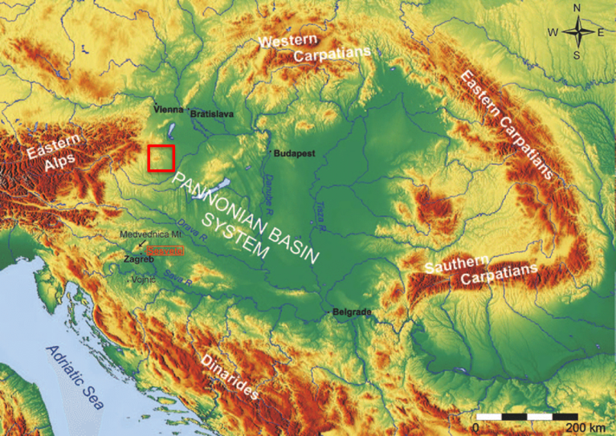
Figure 1 Location of the pilot area in the Pannonian Basin
The basement formations consist mainly of metamorphosed crystalline rocks of the Lower to Upper Austroalpine nappe units. The structure is characterised by nappes, thrust sheets, strike slip structures and normal fault systems. The deep sedimentary basin is divided by basement highs forming different sub-basins (Figure 2).
The basin fill consists of Neogene sediments. Sedimentation began during the Karpatian with terrestrial deposits, while deep and shallow marine sediment layers were formed in the Middle Miocene with thickness of about 200 m.
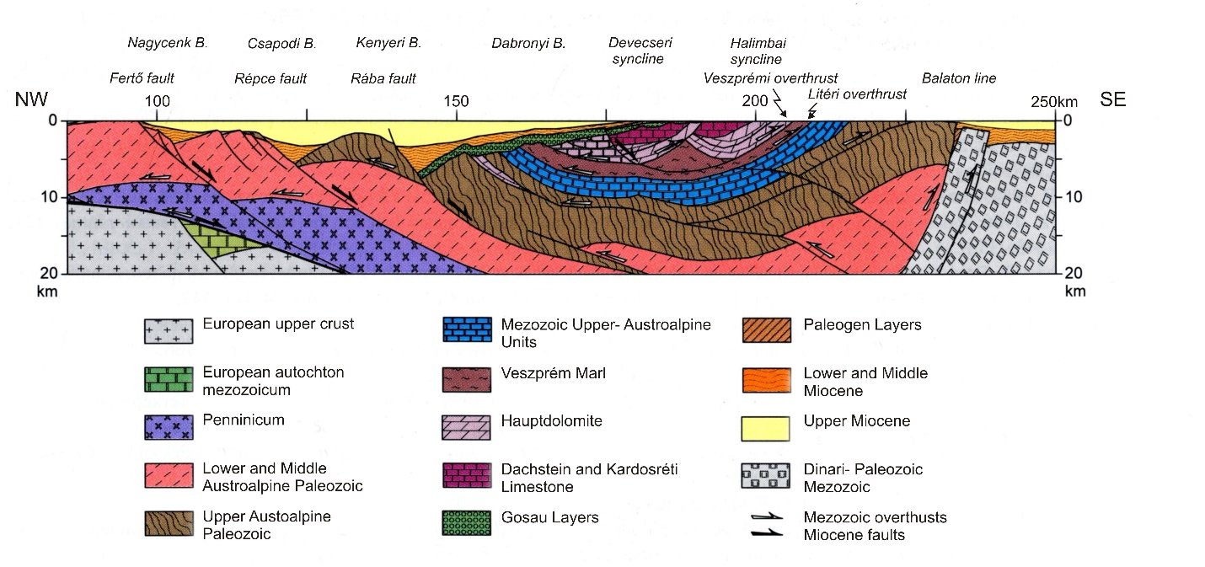
Figure 2 Deep geological cross-section across the Kisalföld Basin and the Transdanubian Range (Tary and Horvath 2010)
The Pannonian basin was gradually ﬁlled mostly by forward accretion of sediment packages during the Late Miocene and Early Pliocene, originating in the surrounding uplifting Alpine and Carpathian mountain belts. The resulting siliciclastic sequences can be as thick as several thousand meters in the deepest sub-basins. Its lower part is composed mainly of bathyal shales, marls and calcareous marls, delta-front siltstones interbedded with delta slope turbidites, and sand-rich delta plain sediments deposited in the brackish Lake Pannon.
Within the several thousand meters thick porous Upper Miocene-Pliocene basin-fill complex the lower delta slope sequences mainly consist of clay, or sandy clay therefore act as regional aquicludes. In contrast, the delta front and delta plain sedimentary succession is built up of altering sand and sandy clay layers, large lenses reflecting the former shelf front, shelf and alluvial plain sedimentary environment. These sediments are characterized by a strong anisotropy Kh/Kv often higher than 5000 (Tóth et al., 2016) at a regional scale due to the frequent alternation of the sand, silt and clay layers. Although the permeability of the clayey-marl strata is one to two orders of magnitude lower than that of the sandy units, hydraulic connection is still possible between the sand layers, therefore the entire Upper Pannonian sedimentary succession one hydrostratigraphic unit characterized by an almost uniform hydrostatic pressure.
The Pannonian delta sediment series are covered by thin (0-200 m) Quaternary layers. These fluvial sediments represent the most important drinking water aquifers of the region. Due to the lack of a regional aquitard layer, a hydraulic connection exists between the Quaternary formations and the Upper Miocene-Pliocene sediment series.

Available infrastructure
Petroleum exploration has a long history in the Kisalföld Basin. The first exploration drilling began in 1935. Several boreholes were drilled, and geophysical measurements were undertaken resulting borehole logs, seismic sections and gravitational maps. Important hydrocarbon reservoirs were not discovered, but some natural CO₂ gas reservoirs and gaseous hydrocarbons was identified. A large part of the CO₂ has a mantle origin (Vető et al. 2014).
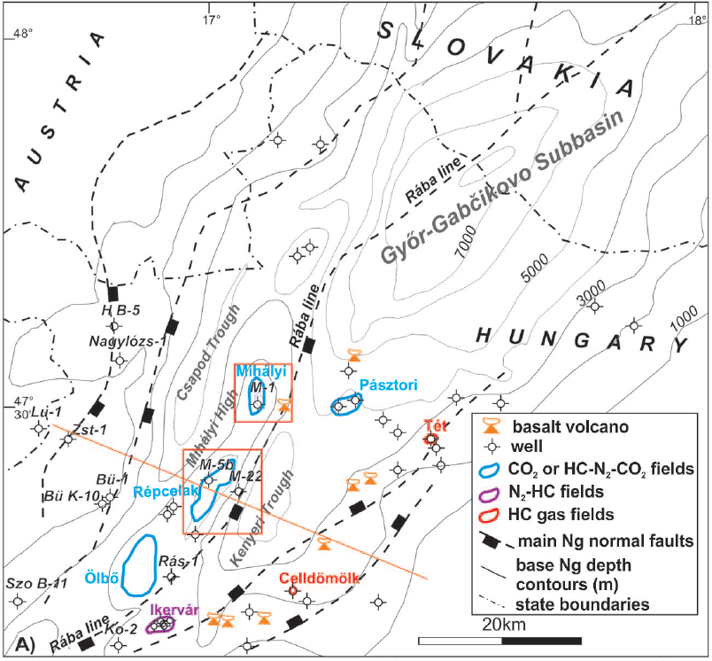
Figure 3 Neogene basement of the southern Danube Basin and the location of the main gas fields (Rotar-Szalkai et al. 2018).

The Mihályi-Répcelak natural CO₂ reservoir can serve as basis to study the potential effects of artificial CO₂ storage systems. As a result, detailed surveys have been carried out, including water-rock interaction studies (Király et al. 2016, Szamosfalvi et al. 2017).
Due to its positive geothermal anomaly (with heat ﬂow density between 32 and 115 mW/m², (mean: 77.6 mW/m²) and geothermal gradients between 21 and 55 °C/km (mean 32.3 °C/km) thermal waters exist in the Upper Miocene aquifer layers and are used in several locations, mainly for balneological purposes (Goetzl et al., 2012).
In addition to the nearly 100 boreholes with borelog descriptions, tens of drinking water supply and thermal wells are situated in the region, providing further information about the hydrogeological conditions. Monitoring wells are operated by MBFSZ and the West-Transdanubian Water Directorate and observe the groundwater heads both in the cold and thermal groundwater bodies. Industrial monitoring systems are operated by Linde and MOL connected to their subsurface activities.

Available information
Based on the detailed investigations and research of the last decades great deal of information was collected in different institutes and industrial companies. As the result of regional, national and also international projects, detailed geological maps, cross-sections and models exist at different scales and resolutions. Borehole and well databases have been developed which contain geological profiles, hydrogeological, geophysical and geochemical information. 3D geological and 3D regional hydrogeological flow models have also been developed in the frame of the TRANSENERGY project (see http://www.eurogeosurveys.org/projects/transenergy/).

Information gaps
Although research has already been carried out in this area, the vulnerability of shallow groundwater to deep subsurface energy-related activities has not been yet been assessed. Integrated evaluation of the abundant information is required in addition to a uniform methodology to characterize the 3D vulnerability of the aquifer layers of this region. The re-evaluation of some older borehole geological profiles, geophysical measurements and basic data are required.

Data collection plan
To fill the gaps of knowledge we plan to collect available geological, geophysical and hydrogeological information about the pilot area. Existing data is available in this region from earlier research projects. Due to intensive hydrocarbon exploration work there are tens of geological and geophysical borehole logs. Detailed geological mapping and evaluation of the western part of the Pannonian Basin geological horizons exist, which includes the entire pilot site. The results of the detailed hydrogeological model developed to study the hydraulic connections between cold water and thermal water aquifer systems will be used to understand connecting pathways. The region was studied as natural analogy of CCS systems and several geochemical investigations were carried out for the basin-fill sediments.
Potential contamination pathways from a potential deep activity to shallow groundwater will be defined and characterized based on existing data (geological and geophysical borehole logs, seismic sections, geochemical and hydro-geochemical analysis) and the above mentioned studies (geological maps and horizons, hydrogeological modes and tectonic studies) We will reinterpret existing information, using geophysical, hydrogeological data and models within this context.

Pilot Vale of Pickering

Introduction of pilot
The Vale of Pickering is one of the regions in the UK where exploration for shale gas has been proposed. The BGS, Universities of Birmingham, Bristol, Manchester and York, and Public Health England began an environmental baseline survey of the region in 2015, before significant subsurface activity commenced. This baseline study includes development of 3D geological models of the superficial and bedrock geology, water quality (groundwater and surface water), seismicity, ground motion, air quality, radon and soil gas. Groundwater and surface water are monitored regularly and a number of new boreholes have been drilled into the shallow aquifer for this purpose. This project will use information generated by the ongoing BGS-led Vale of Pickering project to investigate potential pathways from deep hydrocarbon exploration targets to the shallow aquifer units described below.

Geographical setting and land use
The Vale of Pickering is a broad flat plain, situated in Yorkshire, northeast England. The pilot area covers approximately 20 km north to south, and 60 km east to west, surrounded by higher ground comprising the North York Moors in the north, Howardian and Hambleton Hills in the west and Yorkshire Wolds in the southeast. The vale is part of the catchment of the River Derwent. Land use is primarily rural and dominated by arable farming with some livestock; clay soils support dominantly cereal crops in the western part of the vale and root crops and oil seed rape in the east (Bearcock et al., 2015; Ward et al. 2017). There are also two urban centres in the Vale; Malton (population 4900) and Pickering (population 6800).

Geology and hydrogeology
There are two main aquifers important for groundwater resources in the Vale of Pickering. Superficial Quaternary sediments, of mainly glaciolacustrine origin with marginal alluvial fan deposits, forms a shallow aquifer across the valley floor. Much of this material was the product of a former proglacial lake, Lake Pickering (Evans et al. 2017). Borehole records show that these sediments are of variable thickness, typically less than 40 m thick, but are relatively thin or absent in the north and western part of the vale, and close to Kirby Misperton in the centre of the vale.
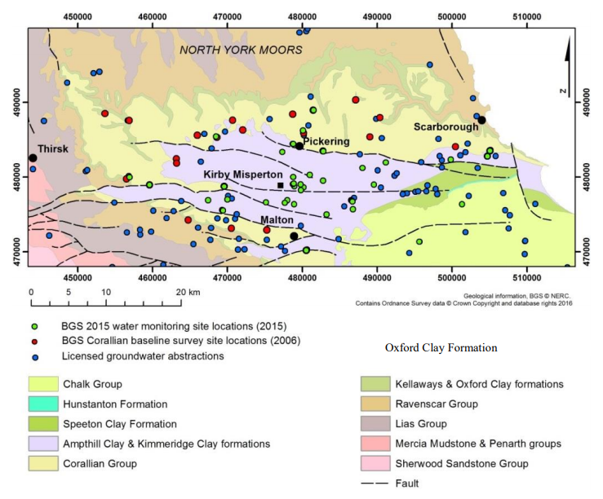
Figure 4 Regional bedrock geology map of the Vale of Pickering, showing water abstraction boreholes and past groundwater investigations (from Ward et al., 2017). Geological information, BGS @ NERC. Contains Ordnance Survey data © Crown Copyright and database rights 2016.

The Quaternary deposits overlie a thick sequence of Jurassic Ampthill & Kimmeridge Clay which, though clay-dominant and poorly permeable, contain some sandy horizons (Figure 4). Sandy horizons and weathered upper sections can contain locally significant amounts of groundwater. The Quaternary and upper Ampthill/Kimmeridge deposits have been termed collectively the “Superficial” aquifer (Ward et al., 2017).
The Jurassic Corallian (Limestone) Group is the second aquifer of interest for groundwater resources in the area. It is designated as a Principal Aquifer and provides a source of water for both public and private supply, though is only exploited along the margins of the vale (Figure 4). Within the vale itself, the Corallian Limestone is not used as a water resource because of its depth (typically >200 m in the central area) and elevated salinity. The Corallian aquifer is recharged from the outcrop area along margins of the Vale of Pickering (Figure 4) and groundwater flows downgradient towards the confined section. The upper reaches of the River Derwent provide recharge to the Corallian aquifer in the northeast, although further downstream, the river is groundwater fed (Ward et al., 2017).

Hydrogeochemistry
The Vale of Pickering has been studied extensively for its hydrogeochemistry as part of the ongoing baseline monitoring project, as well as earlier baseline groundwater investigations (Bearcock et al., 2015). Ward et al. (2017) defined groundwater in the superficial aquifer as Na-HCO₃ in character, whilst the unconfined Corallian Limestone aquifer is Ca-HCO₃ dominated and the confined Corallian in the central part of the vale is Na-HCO₃ dominated. Groundwater in the superficial aquifer is anoxic in character, while that in the marginal Corallian aquifer has varied redox character as a result of it differing levels of confinement. Throughout the region, confined groundwater has notably high concentrations of dissolved CH₄. This is most likely of biogenic origin (Smedley et al., 2016; Ward et al., 2017).
Further sampling for dissolved methane was conducted in the area as part of a wider UK Methane Baseline survey conducted by Bell et al. (2016). Samples were collected from the Corallian Group and West Walton Group (situated stratigraphically below the Corallian Group). Methane concentrations above detection limit were recorded, but were not at significant enough concentrations to be above the lower explosion limit if it was to degas (LEL – 1600 µg/l).

Structural Setting
Investigations of the deeper geology of the Vale of Pickering, focussed on the post-Permian structure (Newell et al., 2015), have provided support for a strong structural control on the geometry of the Corallian aquifer and adjacent strata (, Figure 6, Figure 7, Figure 8, and Figure 9). Relatively abundant faults, with a predominant east-west orientation, have dissected the Corallian into numerous blocks. This faulting may disrupt the flow of groundwater in the confined sections of the aquifer, leading to likely compartmentalisation of the aquifer. One of the remaining questions is whether the faults are listric within the Zechstein/Permian or through-going (Newell et al., 2015) which would have implications for continuation of potential pathways from the target to shallow groundwater.

Geology of interest for deep energy-related activities
The target formation for shale gas extraction within the Vale of Pickering is the Bowland Shale formation, of the Craven Group, Carboniferous Age (Loveless et al., 2018). It is a dark grey siliciclastic to calcareous mudstone, with limestone packstone and wackestone beds (BGS Lexicon, n.d.). The upper surface is situated at a depth between 1700 m (south of the vale) and 2200 m (north of the vale), at the contact with the overlying Millstone Grit Group. The thickness of the Bowland Shale in the Vale of Pickering is undefined, as there is no drilled evidence through the entire sequence. Conventional gas resources are extracted from the Zechstein group above, which has an upper surface between 1400 m (north) and 1000 m (south) below ground level, and a total thickness of approximately 350 m (Loveless et al. 2018).
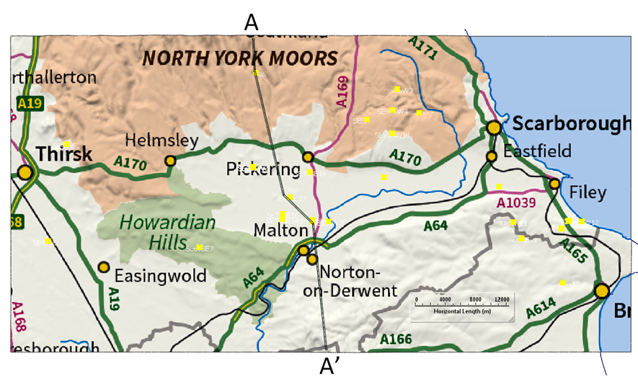
Figure 5 Northnorthwest – Southsoutheast cross-section through the Vale of Pickering, showing evidence of E-W faulting, and compartmentalisation of Corallian Group aquifer.

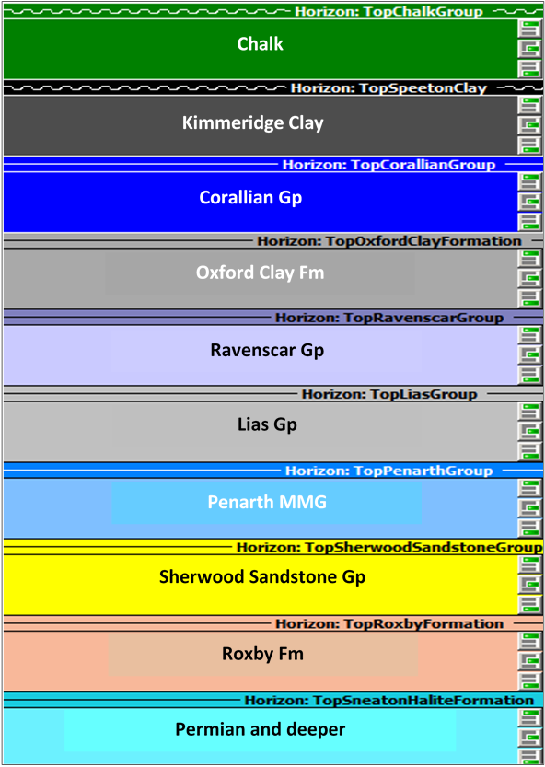
Figure 6 Stratigraphic key (for sections A-A’ and B-B’)

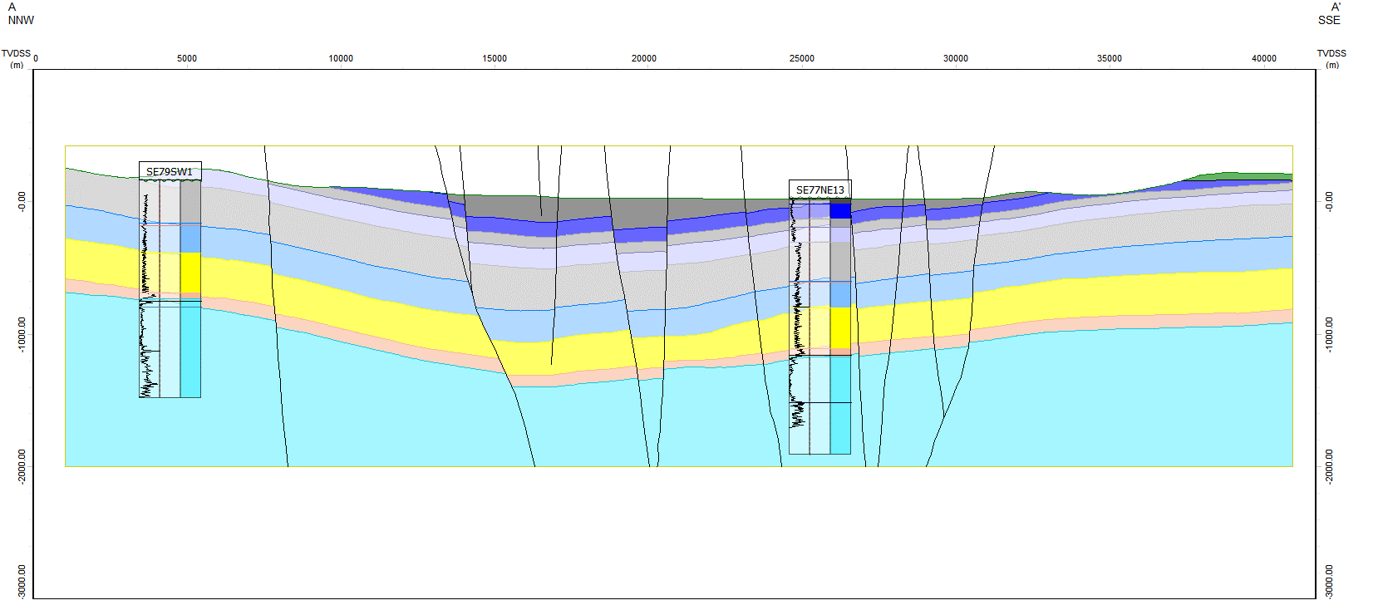
Figure 7 NNW – SSE cross-section through the Vale of Pickering, showing evidence of E-W faulting, and compartmentalisation of Corallian Group aquifer. (after Newell et al. (2016).

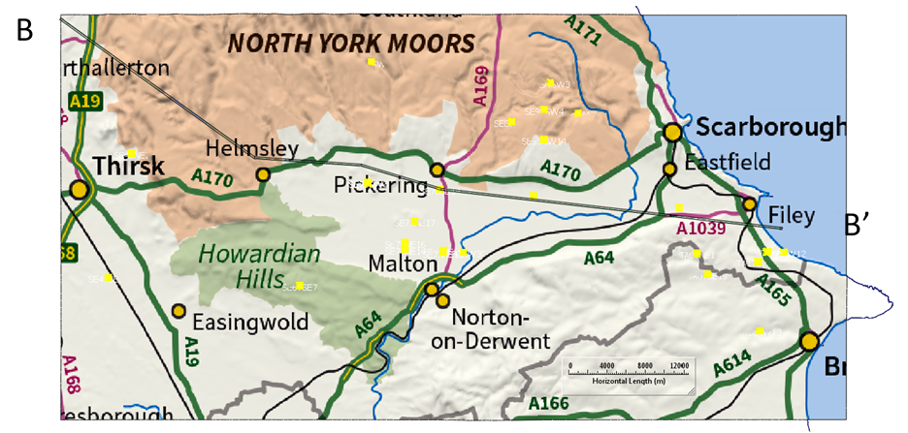
Figure 8 Map showing W-E line of cross-section (B-B’) for Figure 9

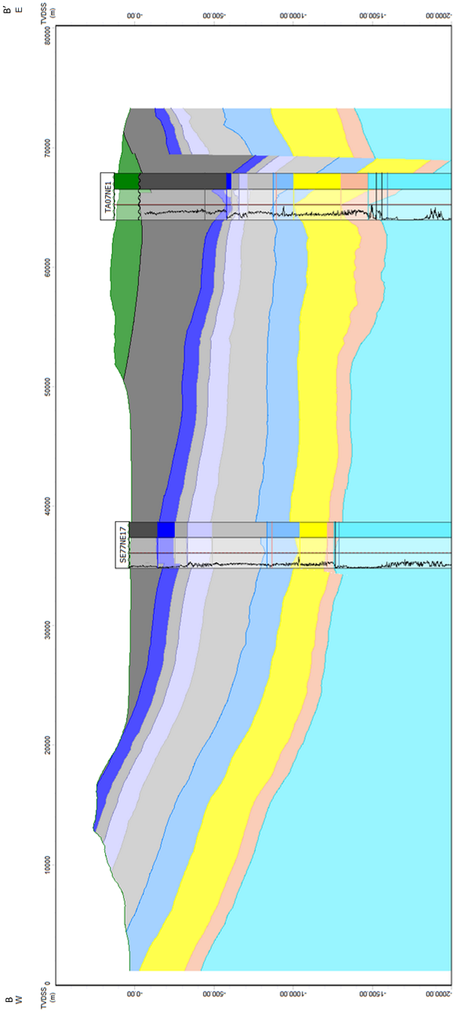
Figure 9 W-E cross-section, showing laterally continuous units, which slope towards the east. Derived from work by Newell et al. (2016).

Available infrastructure

Deep Infrastructure
The Vale of Pickering has a number of conventional oil and gas wells (approximately 40 adjacent to the environmental monitoring area, Figure 10), along with an exploratory shale gas well in the centre of the site. The shale gas well was drilled in 2013, and permission to hydraulically fracture was granted in 2016. However, no hydraulic fracturing activity has taken place to date. The BGS-led partnership has an ongoing operation of environmental monitoring surrounding the unconventional well site, details of which can be found in Smedley et al. (2015) and Ward et al. (2017).
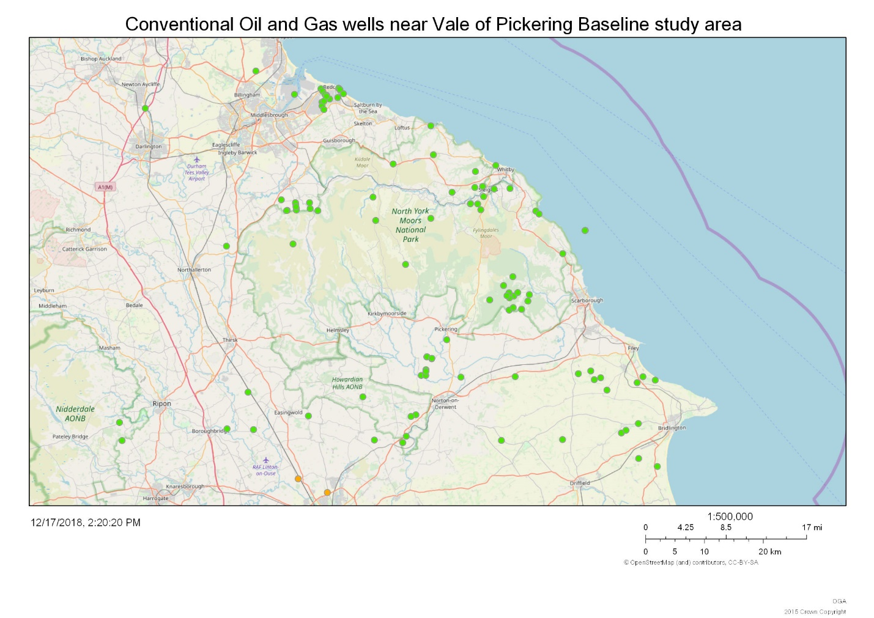
Figure 10 Map from OGA interactive map, showing locations of Conventional Oil and Gas (COG) wells (green points). Black outline highlights approximate extent of Vale of Pickering Environmental Baseline study area. There are approximately 40 COG wells contained within this boundary. © OpenStreetMap (and) contributors, CC-BY-SA. Data from (OGA, n.d.).

Existing groundwater use
Abstractions from the superficial aquifer can only sustain small-scale private supplies, predominantly for agricultural and domestic use; none is used for drinking water. Groundwater is abstracted from the Corallian Limestone around the periphery of the vale for public supply, agriculture and industry (Bearcock et al., 2015).

Environmental Baseline monitoring information
The groundwater monitoring network established for the environmental baseline monitoring programme uses many of the existing boreholes across the Vale of Pickering. The network comprises 35 - 40 groundwater sites from the Quaternary/Kimmeridge Clay and Corallian aquifers (where unconfined or at the margins of confinement). These sites consist of 28 - 33 existing boreholes/wells, and 7 new groundwater monitoring points installed by BGS near the exploratory shale-gas well (Figure 11). Groundwater monitoring at these sites has been conducted regularly (monthly or quarterly) since September 2015. The ongoing environmental baseline monitoring has also included five groundwater-monitoring boreholes installed by the operator on the exploratory wellsite. These have been monitored by BGS since spring 2016.
In January 2017, two multi-level monitoring and sampling boreholes were also installed as part of the new BGS monitoring network. One consisted of a continuous multi-channel tubing (CMT) installation to 25 m depth and the second a Solinst ® multi-level sampler (MLS) to 74 m depth. Sampling of these multi-level installations has been ongoing since June 2017. Piezometers are also installed in the deeper Kimmeridge Clay, at c.115 m and c.165 m below surface.

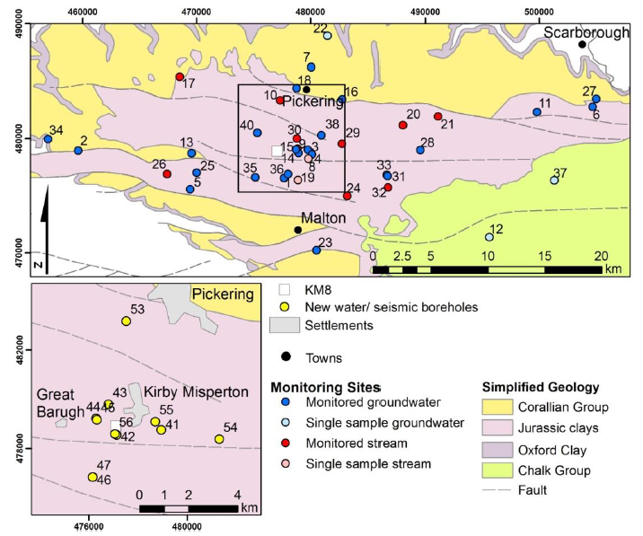
Figure 11 Network of water monitoring boreholes used for ongoing BGS Environmental Baseline Monitoring in the Vale of Pickering (from Ward et al., 2017). Geological information, BGS @ UKRI.

Available information

Overview of monitoring
Detailed procedures relevant to sampling procedures for groundwater and surface water can be found in Ward et al. (2017). Below is a list of analytes/parameters collected during the environmental baseline monitoring programme:
- In-situ parameters; pH, temperature, redox potential (Eh), specific electrical conductance (SEC), dissolved oxygen (DO)
- Major cation, anion and trace element analysis by ICP-MS and IC
- Dissolved gas (CH₄, C₂H₆, CO₂)
- Polyaromatic hydrocarbons (PAH)
- Semivolatile organic compounds (SVOC) and volatile organic compounds (VOC)
Additional analytes include:
- Stable isotopes, including δ¹⁸O/δD, ¹³C (including for Methane specifically) ³⁴S
- Total Petroleum Hydrocarbons (TPH)
- Semi-quantitative, target based screening for “emerging contaminants”, e.g. some pesticides, plasticisers, perfluorinated compounds, pharmaceutical drugs and chlorinated solvents, identified using GC-MS and LC-MS.
Sampling and analysis has been ongoing since 2015, so a dataset of over three years has been collated for the monitoring points.

Other datasets
Alongside the extensive inorganic and organic hydrogeochemical dataset collected in the Vale of Pickering as part of the ongoing monitoring programme, the British Geological Survey has access to a number of other information sources that are relevant to the region. Geological information is robust, in the form of a 3D geological model for post-Permian sequences, as described by Newell et al. (2015), and interpretation of Quaternary deposits as described by Ford et al. (2015). There is also an extensive library of seismic information held by the UK Onshore Geophysical Library (UKOGL), which have provided the basis for previous geological interpretations.

Information gaps
One of the main challenges for understanding subsurface pathways and processes for contamination from depth in the Vale of Pickering, is being able to define, and then relate geochemical evidence to, the subsurface structure. The 3D geological model created by Newell et al., (2015) provides a strong basis with which to begin to identify potential pathways and processes in the region. However, due to a lack of available information and an initial focus on the shallower geological environment, this model was not extended below the Permian Zechstein Group evaporites. It is not clear, therefore, whether or not the identified faults in the area extend below this to the Namurian-aged hydrocarbon source rocks, or are listric (curve towards horizontal) along the relatively ductile evaporites in this unit. If the faults extend below the Zechstein, they could potentially be important contaminant pathways between the deep hydrocarbon source rocks and the shallower groundwater system. If they are shown not to be present below the Zechstein, this unit could potentially provide an effective barrier for upward migration of any mobilised contaminants.

Data collection plan
The current 3D geological model will be extended below the Namurian-aged source rocks in the Vale of Pickering, with a focus on geological structure. In order to do this, existing seismic data will be re-interpreted to better define the structure and key stratigraphic horizons, and combined with deep borehole logs in the area. The model will be built in the geological modelling software SKUA-GOCAD (https://www.pdgm.com/resource-library/brochures/skua-gocad/skua-gocad/).

The extended geological model will be attributed with physical properties available from existing BGS databases such as propbase and the aquifer properties database, information from borehole logs in the area and published literature. Properties will include porosity, permeability/hydraulic conductivity/transmissivity and storage. They will be collected for all geological formations and fault zones within the modelled area. In addition, head/pressures in the subsurface will be collected from borehole logs in the region and other databases, in order to understand driving forces between, and within, the deep and shallow groundwater system.

The 3D geological model and collected data will be used to inform the development of the conceptual model as the basis for contaminant transport modelling. This will take into account the hydrogeological conditions in the subsurface and identification of pathways in order to assess the potential for contaminant migration from the deep to shallow subsurface. The contaminant transport model will then be used to investigate contaminant travel times and concentrations that could be expected at particular locations in the shallow subsurface.

Finally, the 3D geological model, and the results from the contaminant transport model will be compared with water quality data collected from across the area as part of a BGS environmental monitoring programme (http://www.bgs.ac.uk/valeofpickering). Data from this programme include a range of inorganic and organic parameters, stable isotope data, noble gas concentrations and residence time indicators.

Pilot Peel Boundary Fault Near Veghel

Introduction of pilot
The Peel boundary fault is part of a major fault system in the Netherlands separating the Peel Block and the Roer Valley Graben (Figure 12). Currently, there are no deep energy-related activities near the fault, but the groundwater abstraction Veghel of water company Brabant Water is located nearby. The rationale for the choice of this area as pilot is that the decrease of the groundwater heads due to the pumping will induce upward transport along the fault from the deep subsurface if there is a significant hydraulic connection.

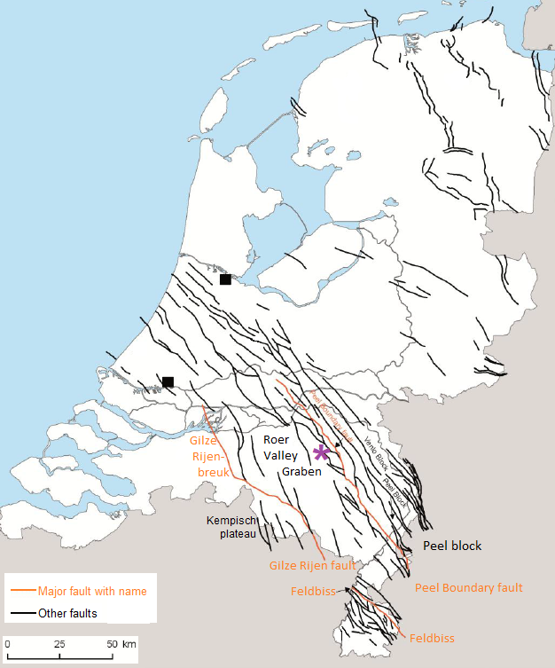
Figure 12 Faults in the Netherlands with the Peel Boundary Fault as major fault in the fault system on the Northeastern edge of the Roer Valley Graben (pilot marked with purple star)

The Veghel pilot is located on the Northwestern edge of the Roer Valley Graben, while the Belgian Rauw fault pilot is located on the opposite side of the Graben (compare Figure 19). Both pilots lie within the area of the cross boundary demonstration project H3Oplus, which is part of the GeoERA project Resource, also within the Groundwater theme.
Figure 13 shows the topography in the vicinity of the Veghel pilot, which has coordinates (with respect to the “Amersfoort” national Dutch coordinate system): X from 165 000 to 175 000 and Y from 397 000 to 409 000.

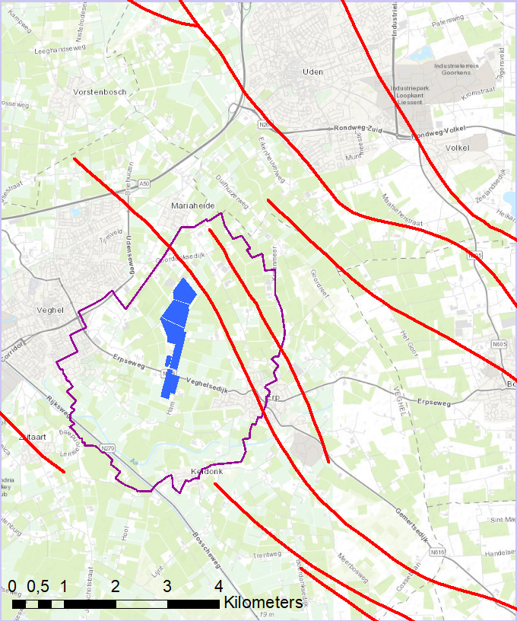
Figure 13 Topographical map of Pilot area with faults (red lines) drinking water abstraction (blue) and its groundwater protection area (purple)

Available infrastructure
In the shallow subsurface, there are abstraction wells for the production of drinking water and groundwater monitoring wells, from a local dedicated monitoring network and the provincial groundwater monitoring network. Both groundwater heads and groundwater quality are monitored. The quality of the abstracted water is also monitored. Groundwater is also abstracted for agricultural purposes in the area.

Currently there are no energy-related activities in the subsurface. Within the pilot area, there is a single abandoned oil exploration well specified in the database of oil, gas and geothermal energy exploration and production in the Netherlands and the Dutch sector of the North Sea continental shelf (http://www.nlog.nl). This well, KDK-01, was drilled in 1992 to a depth of 2.2 kilometers (Figure 14). No further activities have been employed and no hydrocarbon field has been identified.

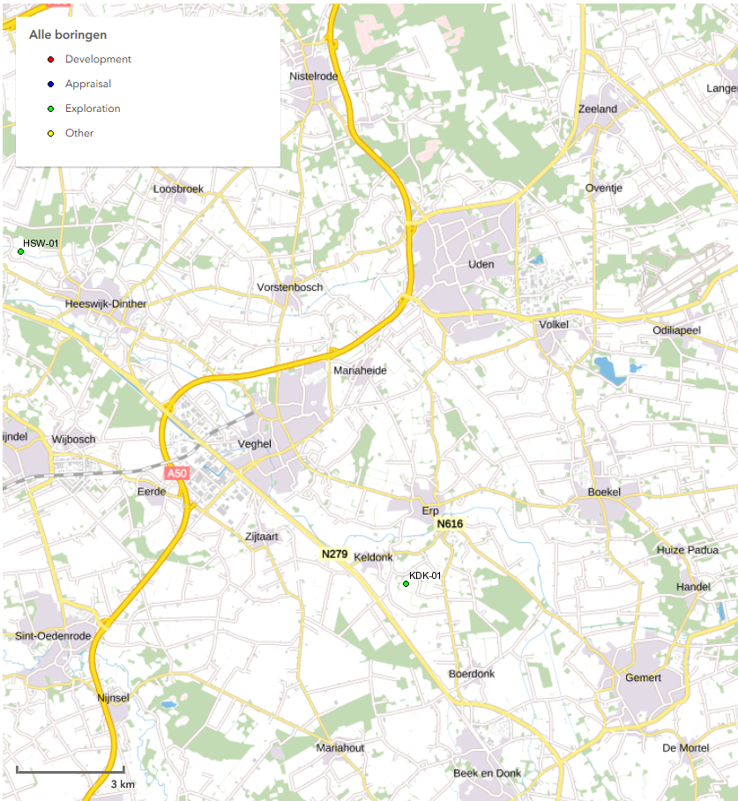
Figure 14 Abandoned hydrocarbon exploration well KDK-01 located in pilot area

Available information
REGIS II is a model of the regional hydrogeology of the part of the subsurface relevant for the groundwater resources (available at http://www.dinoloket.nl). Figure 15 shows a cross section.

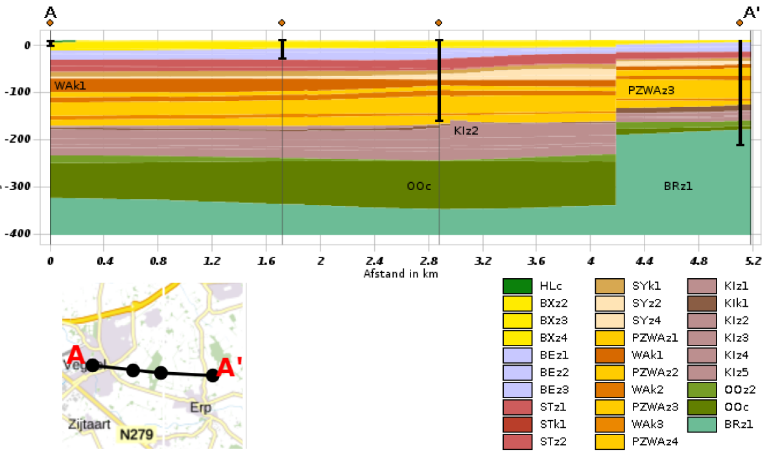
Figure 15 REGIS II hydrogeological cross section with Formation (first 2 letters of codes) and hydrogeological units (‘z’ for aquifer, ‘k’ for aquitard)

The subsurface has been modelled to a greater depth in the geological model DGMdiep (see Figure 16). Some 2D seismic surveys have been carried out in the area (see http://www.nlog.nl) (Figure 20).

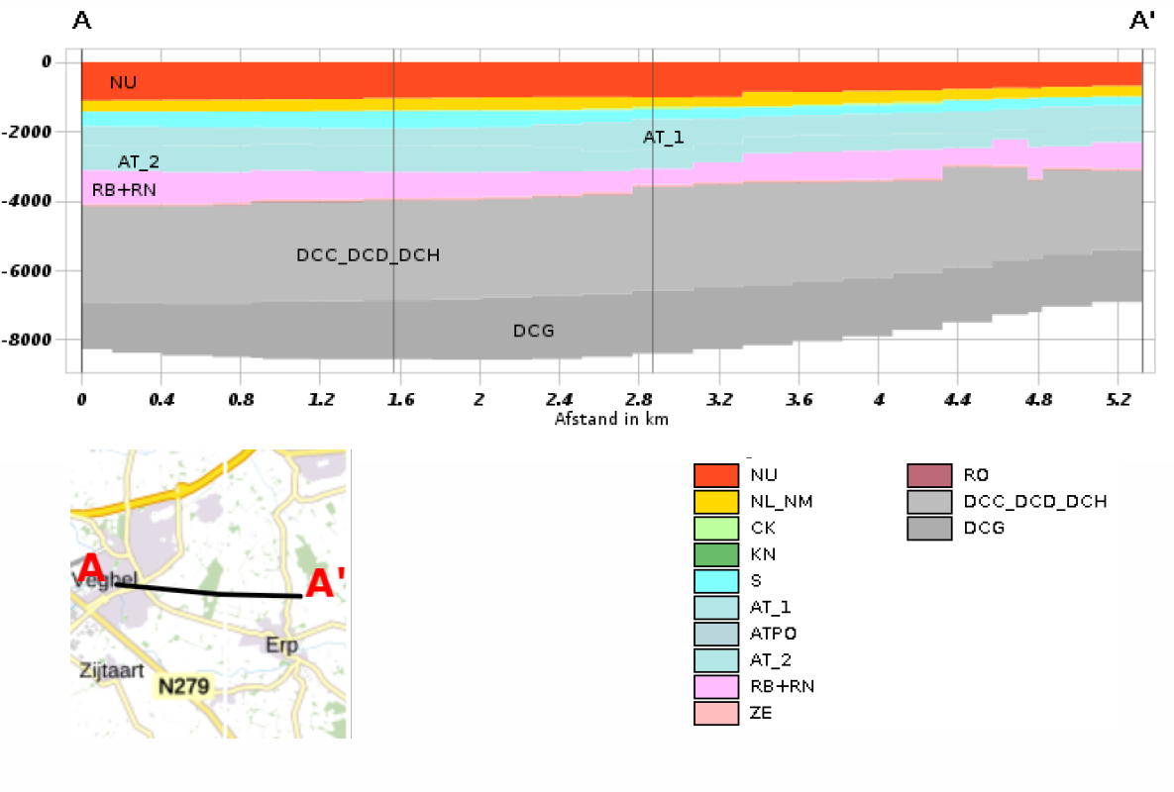
Figure 16 Geological cross section from the deep Digital Geological Model of the Netherlands (DGMdiep) with geological groups (N = North Sea, C=Chalk, ZE=Zechstein, see further https://www.dinoloket.nl/nomenclature-deep)

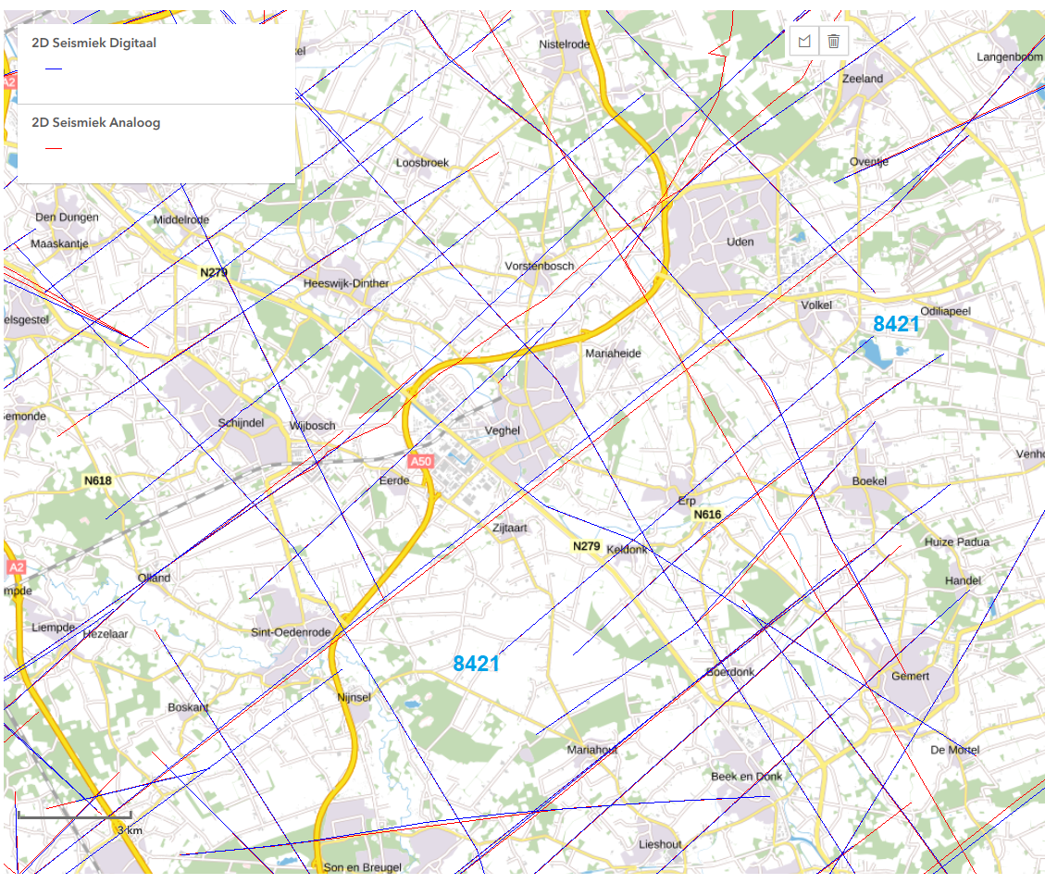
Figure 17 Seismic surveys in NLOG around the Veghel pilot

Figure 18 shows the seismic line crossing the strike of the Peel Boundary Fault which is indicated in Figure 17. It is unclear how much of the structure of the Peel Boundary Fault and its damage zone can be detected from the available seismic data.
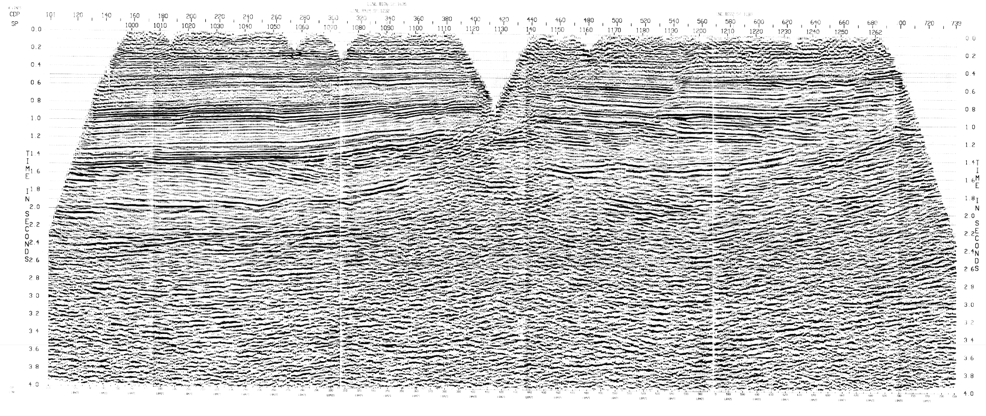
Figure 18 Seismic survey 8421 from NLOG (for location see Figure 17)

In the shallow subsurface, the Peel Boundary Fault has a large resistance to flow across the fault. This has been mentioned in many publications (e.g. de Ridder et al., 1967; van den Berg et al., 2002). Much less attention has been paid to the vertical hydraulic conductivity in the damage zone along the fault, although it has been suggested this may be an important pathway for vertical groundwater flow (Bense et al., 2003).

Information gaps
One of the key questions for this pilot is whether or not drawdown from groundwater abstraction for drinking water causes upwelling of deep groundwater. This can be determined by identifying:
- The age of groundwater present;
- Presence of thermogenic methane;
- Helium ratio, ³He/⁴He which may indicate a mantle connection.

Another key question that remains is the structure of the fault and the vertical hydraulic conductivity of the damage zone along the fault.

Data collection plan
Data collection will focus on an assessment of groundwater quality which will help to determine existing connections between the shallow groundwater and the deep subsurface. Other information will be derived from other projects and existing data:
- Hydraulic parametrisation of fault from the cross border harmonization project H3O+ which is carried out as a work package in the GeoERA Groundwater project RESOURCE.
- The available seismic data will be evaluated to assess whether it can provide relevant new information, possibly through reprocessing.
- Characterization of faults from the information for the European Fault Database which will be developed in the GeoERA Energy project HIKE.

The water quality data collection can be separated in sampling the quality of the water of the Veghel abstraction and regional sampling to establish a baseline of the shallow groundwater. The Veghel water will be analysed for: ³He/⁴He, ³⁹Ar, other noble gases, and methane isotopes. The regional baseline will be established for: ³He/⁴He, gases, and methane isotopes.

Pilot Rauw Fault

Introduction of pilot
The Rauw fault is one of the westernmost border faults of the Roer Valley Graben, a tectonic structure that became more or less permanently active from the Oligocene onwards (Geluk et al., 1994). This structure runs in a Southeast-Northwest direction from the outcropping Rhenohercynian Massif in Germany down to the Southern North Sea Basin (Figure 19a). In a NW European context, the Campine Basin is a subsiding structure, sandwiched in between the Brabant Massif in the south and the Roer Valley Graben in the north-east. The Campine Basin is a potential host for several deep subsurface activities such as geological disposal of radioactive waste and mining of geothermal energy.
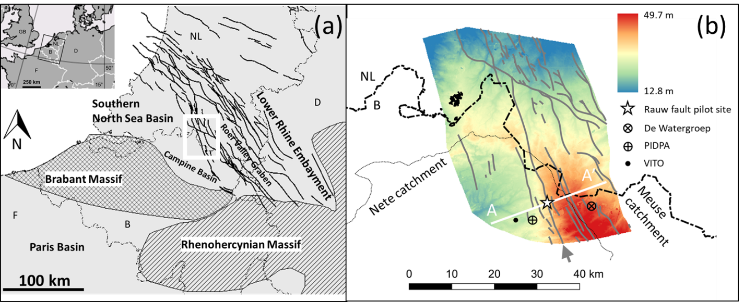
Figure 19 – (a) Structural setting of the Rauw fault pilot site in a Northwestern European context. White rectangle refers to the area depicted in (b). Relevant references for the compilation of this figure can be found in Beerten et al. (2013). (b) Topography of the H3O-De Kempen model area (Vernes et al., 2018). Grey lines indicate faults that are visible in the base of the Boom Formation. Rauw fault is indicated by grey arrow. Thin black line is the outline of the Nete catchment. The profile line A-A’ refers to the cross-section in Figure 20. Circles indicate the location of major groundwater abstraction.

Recently, the cross-border (hydro)stratigraphy of the region has been modelled in de H3O-De Kempen project (Vernes et al., 2018). The model area is outlined in Figure 19b. The Rauw fault can be identified as a major fault (grey arrow), running through the entire model area. The geological cross-section (Figure 20) shows an offset of about 50-100 m along the fault, the eastern part being downthrown, as might be expected for a synthetic normal fault. The amount of displacement decreases towards the surface. Palaeoseismological investigations identified that the fault has not been active for the last 500 ka (Verbeeck et al., 2017). It is reaching the surface due to the fact that overlying sediment has been removed by subsequent erosion. There are several minor faults east and west of the Rauw fault. Overall, the geological formations dip towards the Roer Valley Graben due to tectonic tilting. Several km to the east of the Rauw fault, the water divide between the Meuse and Nete catchments marks the highest topographical point in the profile. The water flow direction in the aquifers has a strong component towards the west, up-dip (Gedeon et al., 2007; Vandersteen et al., 2014). Modelling of both the shallow and deep aquifers has identified that there is only a very weak downward hydraulic gradient over the Boom Clay, due to the pressure gradient, as the site is located in the upper part of the Nete catchment. However, these models never treated the hydraulic role of the Rauw fault explicitly. Moreover, potential contact or decreased hydraulic resistance between the two aquifers was not considered up to now.
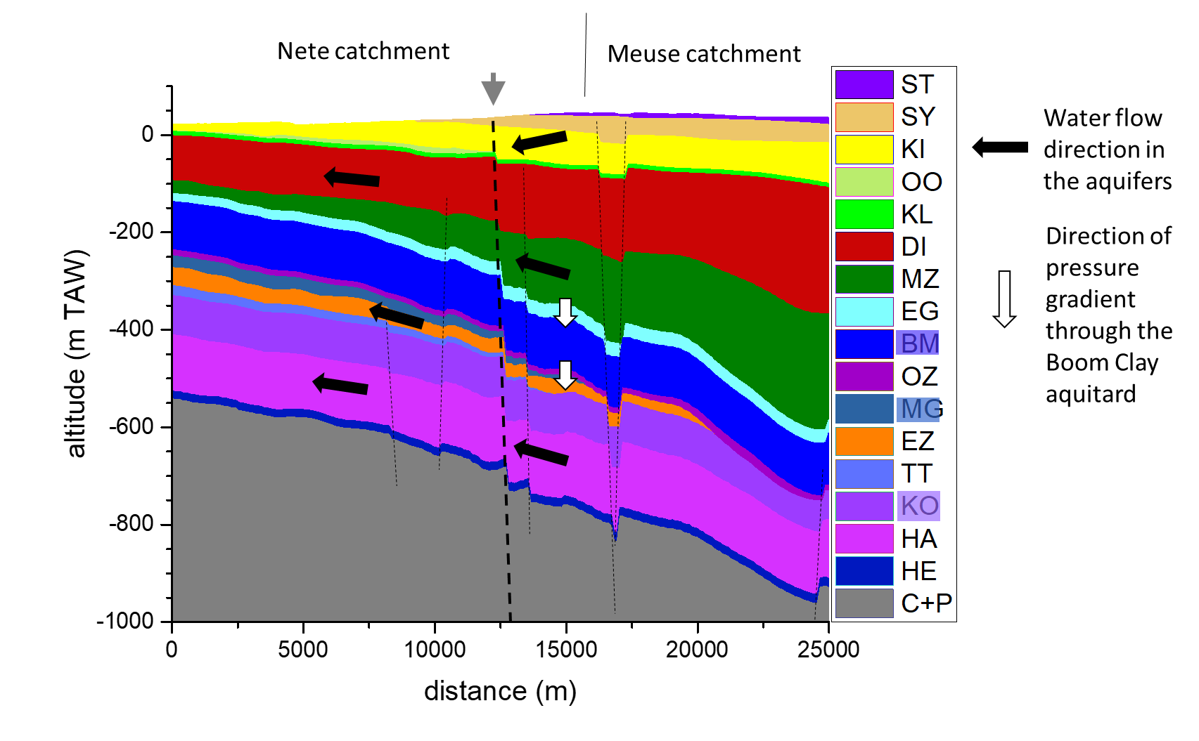
Figure 20 – Geological cross-section according to profile line A-A’ in Figure 19b. The Rauw fault is indicated with grey arrow and thick dashed line, minor faults are indicated by thin dashed lines. Water divide between the Nete and Meuse catchment is given, as well as the direction of water flow in the aquifers, and leakage through the Boom Clay. ST = Sterksel Formation, SY = Stramproy Formation, KI = Kiezelooliet Formation, OO = Oosterhout Formation, KL = Kasterlee Formation, DI = Diest Formation, MZ = Late Oligocene to Middle Miocene sands, EG = Eigenbilzen Formation, BM = Boom Formation, OZ = Early Oligocene sands, MG = Maldegem Formation, EZ = Early to Late Eocene sands, TT = Tielt Formation, KO = Kortrijk Formation, HA = Hannut Formation, HE = Heers Formation, C+P = Cretaceous and Palaeozoic bedrock. Formations with aquitard properties are shaded in the legend.

Available infrastructure
In the region around the Rauw fault there is limited deep subsurface activity. There is one deep geothermal well (see Figure 19b and Table1), and two drinking water wells. The geothermal well reaches the Lower Carboniferous Limestone Group at a depth of 4250 m. The two drinking water wells are pumping the Miocene aquifer, at a depth of ca. 100 and 200 m.

Table 1 – Coordinates, depth, licensed discharge and purpose of the major wells in an area of ca. 10 km surrounding the Rauw fault pilot site.
Owner | X^{(a)} | Y^{(a)} | Depth^{(b)} | Licensed discharge^{(c)} | Purpose | HCOV code | Aquifer
De Watergroep | 216382 | 215005 | 202 | 8.0E+06 | Drinking water | 0252 | Diest Formation
PIDPA | 204400 | 212459 | 124 | 3.65E+06 | Drinking water | 0250 | Miocene aquifer system
VITO | 201794 | 212948 | 4250 | 6.75E+06 | Geothermal | 1320 | Lower Carboniferous Limestone Group
- m Lambert 72
- m
- m³/year

The Rauw fault pilot site consists of a series of piezometers, all but one located on the western side (footwall block) of the fault (Figure 21 and Table 2). Piezometer R-54a is located in the hanging wall, and its filter reaches a depth of ca. 100 m, i.e. the Diest Formation (Miocene aquifer). Piezometer R-54b is located west of the fault and its filter reaches a depth of ca. 120 m (Diest Formation). The filters of piezometers R-54c and R-54d are located in the sands directly overlying the Boom Clay (i.e., the Eigenbilzen Formation), at a depth of ca. 300 m. Finally, piezometer filters of R-54e and R-54f are located in the aquifers below the Boom Clay, the Lede/Brussel Formation and the Hannut Formation respectively. The latter reaches a depth of ca. 600 m.

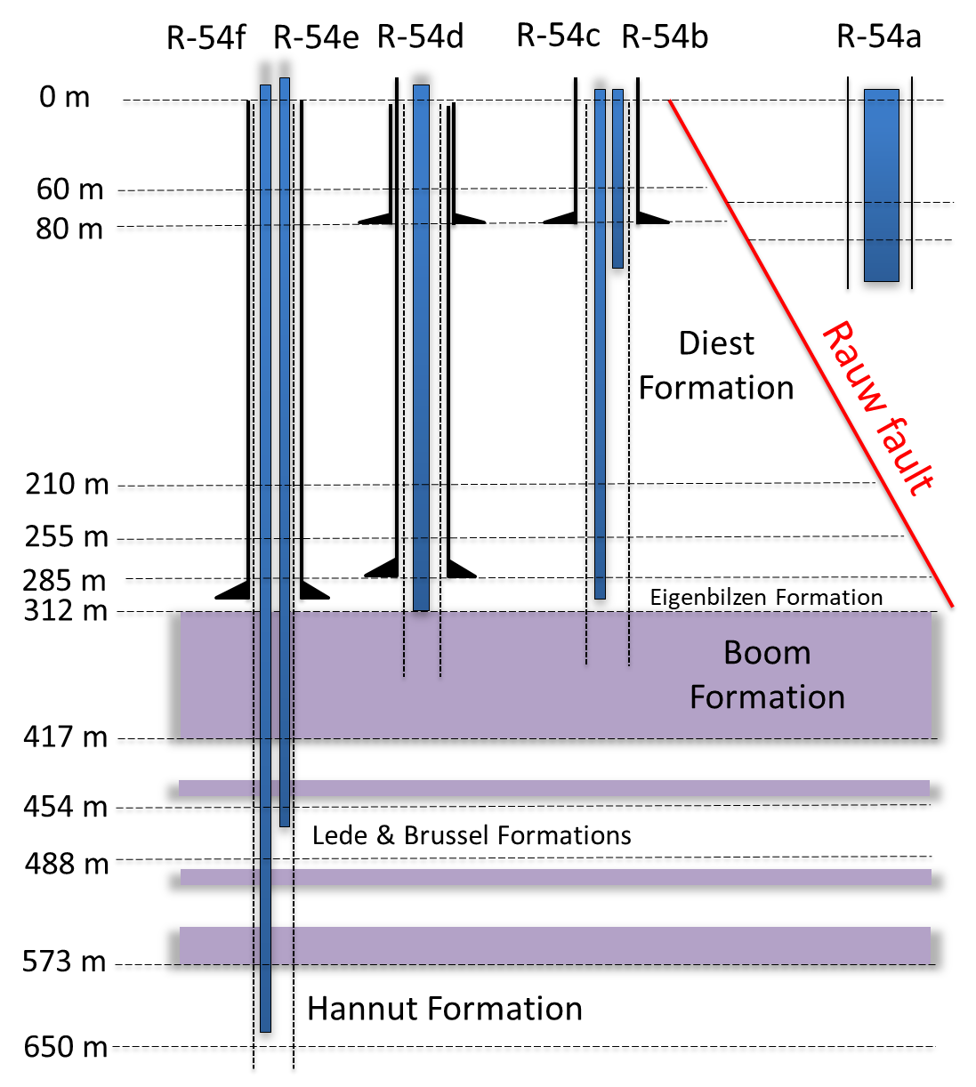
Figure 21 – The Rauw fault pilot site showing the location of 6 piezometers and the position of the fault (Verbeeck et al., 2017). Aquitards are coloured purple.

Table 2 – ID, installation date, coordinates, filter depth and filter stratigraphy of the Rauw fault pilot site. Used with permission from ONDRAF-NIRAS, the Belgian National Agency for Radioactive Waste and enriched Fissile Material.
ID | Owner | Installation date | X^{(a)} | Y^{(a)} | Z^{(b)} | Diameter^{(c)} | Filter top^{(b)} | Filter bottom^{(b)} | HCOV code | Stratigraphy
R-54a | Niras | 2014-10-27 | 208017.43 | 215705.55 | 37.59 | 0.16 | -57.43 | -76.48 | 0252 | Diest
R-54b | Niras | 2015-01-17 | 207957.85 | 215711.77 | 37.67 | 0.06 | -72.33 | -96.33 | 0252 | Diest
R-54c | Niras | 2015-01-17 | 207957.88 | 215711.88 | 37.59 | 0.06 | -247.41 | -267.41 | 0256 | Eigenbilzen
R-54d | Niras | 2014-11-28 | 207948.09 | 215708.56 | 37.56 | 0.06 | -247.44 | -267.44 | 0256 | Eigenbilzen
R-54e | Niras | 2015-01-18 | 207939.95 | 215709.89 | 37.7 | 0.06 | -379.3 | -395.3 | 0600 | Brussel/Lede^{(d)}
R-54f | Niras | 2015-01-18 | 207939.83 | 215709.88 | 37.6 | 0.06 | -537.4 | -573.4 | 1010 | Hannut^{(d)}
- m Lambert 72
- m TAW (Tweede Algemene Waterpassing = m above average sea level)
- m
- tentative assignment

Available information
There is no specific information for the Rauw fault site in relation to pathways from deep energy activities to shallow groundwater. The objective of the study is to investigate the impact of the fault on the local and regional groundwater flow. The shallow geometry of the fault has recently been investigated by Verbeeck et al. (2017). The deep geometry and hydrostratigraphy were mapped during the H3O – De Kempen project (Vernes et al., 2018). In addition, the available hydrogeological models provide a good starting basis for simulating flow and transport (e.g., Gedeon et al., 2007; Vandersteen et al., 2014). Detailed hydraulic properties of the clay smearing within the fault itself are available from air permeability measurements performed when the fault was exposed in the palaeoseismological trench in 2014 (see supplementary material in Verbeeck et al., 2017; Verbeeck, 2019).

Information gaps
There is no detailed information on groundwater flow patterns in the immediate vicinity of the fault (see Figure 20). This is mainly due to the lack of detailed physico-chemcial state variable information in the surrounding area. Groundwater head observations on either side of the fault only started in 2015 while hydrochemical data, groundwater ages and other tracing information are lacking all together.

Data collection plan
In order to fill this information gap, the piezometer nest will be subjected to a sampling campaign for groundwater tracing. This is done in the framework of a PhD study (UGent-SCK•CEN), and financially supported by ONDRAF/NIRAS (Casillas-Trasvina, 2019). As foreseen in March 2019, samples will be taken for hydrochemical analysis and groundwater dating (¹⁴C, ⁴He, ³H) and temperature profiling will be performed. Meanwhile, the groundwater head observations in the wells will continue.

Concluding Remarks
The data collection plans for the pilots are the basis for acquiring further information which will be combined with the existing knowledge to evaluate the potential pathways in the subsurface that could connect energy related activities to groundwater resources. The results from the pilot studies will be evaluated using the conceptual framework for vulnerability characterisation which will be developed in work package 4 of VoGERA (Loveless et al., 2019).
The insights will be brought together to generalize the assessments about subsurface contamination pathways from deep sub-surface energy activities to groundwater resources in a range of different hydrogeological environments. This will fill in the VoGERA objectives to elucidate process understanding and provide a basis for assessment of the vulnerability of groundwater resources from energy-related activities.

REFERENCES
Al-Jubori, Ahmed; Johnston, Sean; Boyer, Chuck; Lambert, Stephen W.; Bustos, Oscar A.; Pashin, Jack C.; Wray, Andy (2009) Coalbed Methane: Clean Energy for the World, Oilfield Review, Volume 21, Number 2, Pages 4-13.
Aller, Linda; Bennett, Truman; Lehr, Jay H.; Petty, Rebecca J. (1985) DRASTIC: A Standardized System for Evaluating Ground Water Pollution Potential Using Hydrogeologic Settings, EPA/600/2-85/018, United States Environmental Protection Agency, Robert S. Kerr Environmental Research Laboratory, Ada OK, USA.
Andrews, J. N.; Burgess, W. G.; Edmunds, W. M.; Kay, R. L. F.; Lee, D. J. (1982) The thermal springs of Bath, Nature, Volume 298, Pages 339-343.
BEARCOCK, J.B., SMEDLEY, P.L., MILNE, C.J (2015) Baseline groundwater chemistry: the Corallian of the Vale of Pickering, Yorkshire. BGS Open Report, OR/15/048.
Beerten, K., De Craen, M., Wouters, L. (2013) Patterns and estimates of post-Rupelian burial and erosion in the Campine area, north-eastern Belgium. Physics and Chemistry of the Earth 64, 12–20.
BELL, R.A., DARLING, W.G., Manamsa, K., Dochartaigh. B. É. Ó. (2016) The Baseline Concentrations of Methane in Great British Groundwater - the National Methane Baseline Survey. British Geological Survey Open Report, OR/15/071. 45pp
Bense, V.F., van Balen, R.T., de Vries, J.J. (2003) The impact of faults on the hydrogeological conditions in the Roer Valley Rift System: an overview, Netherlands Journal of Geosciences, Vol. 82, No. 1, Pages 41-54.
BENSE, V., GLEESON, T., LOVELESS, S., BOUR, O., SCIBEK, J. (2013) Fault zone hydrogeology, Earth-Science Reviews, Vol. 127, Pages 171-192.
Bhutto, Abdul Waheed; Bazmi, Aqeel Ahmed; Zahedi, Gholamreza (2013) Underground coal gasification: From fundamentals to applications, Progress in Energy and Combustion Science Vol. 39, Pages: 189-214.
Birdsell, D. T.; Rajaram, H.; Dempsey, D.; Viswanathan, H. S. (2015) Hydraulic fracturing fluid migration in the subsurface: A review and expanded modeling results, Water Resources Research, Volume 51, Pages 7159–7188, doi:10.1002/2015WR017810.
Blinderman, M.S.; Jones, R.M. (2002) The Chinchilla IGCC Project to Date: UCG and Environment, 2002 Gasification Technologies Conference, San Francisco, USA, October 27-30, 2002.
Burton, E.; Friedmann, J.; Upadhye, R. (2007) Best Practices in Underground Coal Gasification. Lawrence Livermore National Laboratory, USA.
CASILLAS-TRASVINA, A. (2019) Joint inversion of physical and chemical state variable data within a multi-model subsurface hydrology framework. PhD Research Plan. Universiteit Gent, 21 pp.
Council of Canadian Academies (2014) Environmental Impacts of Shale Gas Extraction in Canada. Ottawa (ON): The Expert Panel on Harnessing Science and Technology to Understand the Environmental Impacts of Shale Gas Extraction, Council of Canadian Academies, Ottawa, Canada.
Davies, Richard J.; Almond, Sam; Ward, Robert S.; Jackson, Robert B.; Adams, Charlotte; Worrall, Fred; Herringshaw, Liam G.; Gluyas, Jon G.; Whitehead, Mark A. (2014) Oil and gas wells and their integrity: Implications for shale and unconventional resource exploitation, Marine and Petroleum Geology, Volume 56, Pages 239-254, http://dx.doi.org/10.1016/j.marpetgeo.2014.03.001.
Davies, Richard J.; Almond, Sam; Ward, Robert S.; Jackson, Robert B.; Adams, Charlotte; Worrall, Fred; Herringshaw, Liam G.; Gluyas, Jon G.; Whitehead, Mark A. (2015) Reply: “Oil and gas wells and their integrity: Implications for shale and unconventional resource exploitation”, Marine and Petroleum Geology, Volume 59, Pages 674-675, http://dx.doi.org/10.1016/j.marpetgeo.2014.07.014.
De Ridder, N.A., Hondius, P., Hellings, A.J. (1967) Hydrogeological Investigations of the Peel Region and Its Environs, Technical Bulletin 48, Institute for Land and Water Management Research, Wageningen, the Netherlands.
DiGulio, Dominic C.; Jackson, Robert B. (2016) Impact to Underground Sources of Drinking Water and Domestic Wells from Production Well Stimulation and Completion Practices in the Pavillion, Wyoming, Field, Environmental Science & Technology, Volume 50, Number 8, Pages 4524-4536, https://doi.org/10.1021/acs.est.5b04970.
ENVIRONMENT AGENCY, n.d. 2017. Aquifer Designations [Online]. http://apps.environment-agency.gov.uk/wiyby/117020.aspx. Accessed (11/12/18).
EVANS, D. J., BATEMAN, M.D., ROBERTS, D.H., MEDIALDEA, A. , HAYES, L. , DULLER, G.A., FABEL, D., CLARK, C.D. (2017), Glacial Lake Pickering: stratigraphy and chronology of a proglacial lake dammed by the North Sea Lobe of the British–Irish Ice Sheet. J. Quaternary Sci., 32: 295-310. doi:10.1002/jqs.2833.
Fairley, Jerry; Heffner, James; Hinds, Jennifer (2003) Geostatistical evaluation of permeability in an active fault zone, Geophysical Research Letters, Volume 30, Number 18, 1962, doi:10.1029/2003GL018064.
Finkenrath M, Pazzi S, D’Ercole M. (2009) Status and technical challenges of advanced Compressed Air Energy Storage (CAES) technology. In: Int. workshop on environment and alternative energy; 2009.
Fisher, Kevin; Warpinski, Norm (2011) Hydraulic Fracture-Height Growth: Real Data, SPE 145949, Society of Petroleum Engineers Annual Technical Conference and Exhibition, Denver, Colorado, USA, 30 October–2 November 2011.
Flewelling, S.A.; Sharma, M. (2014) Constraints on upward migration of hydraulic fracturing fluid and brine. Groundwater, Volume 52, Number 1, Pages 9–19, DOI:10.1111/gwat.12095.
FORD, J.R., HUGHES, L., BURKE, H.F., LEE, J.R. (2015) The Vale of Pickering: an initial summary of the Quaternary/superficial geology and data holdings. BGS Open Report, OR/15/064.
Friedmann, S. Julio; Upadhye, Ravi; Kong, Fung-Ming (2009) Prospects for underground coal gasification in carbon-constrained world, Energy Procedia, Volume 1, Pages 4551-4557, doi:10.1016/j.egypro.2009.02.274.
Gass, T.E.; Lehr, J.H.; Heiss Jr., H.W. (1977) Impact of abandoned wells on ground water, EPA-600/3-77-095, Robert S. Kerr environmental research laboratory, U.S. Environmental Protection Agency, Ada OK, USA, August 1977.
Gedeon, M., Wemaere, I., Marivoet, J. (2007) Regional groundwater model of north-east Belgium. Journal of Hydrology 335, 133-139.
Geluk, M.C., Duin, E.J.T., Dusar, M., Rijkers, M.H.B., van den Berg, M.W., van Rooijen, P. (1994) Stratigraphy and tectonics of the Roer Valley Graben. Geologie en Mijnbouw 73, 129–141.
GeoERA (2017) Call Announcement and Scientific Scope: Stage Two – Project Proposals, Joint call document no.9, available at: http://geoera.eu/wp-content/uploads/2016/11/GeoERA-Call-Document-No.-9-SRTs-20171017.pdf, accessed at 27 May 2019.
GOETZL, G., ZEKIRI, F., LENKEY, L., RAJVER, D., SVASTA, J. (2012) Geothermal Models at Supra-regional Scale, Summary report. Transenergy Project. (http://transenergy eu.geologie.ac.at).
Grasby, S.E.; Ferguson, G.; Brady, A.; Sharp, C.; Dunfield, P.; McMechan, M. (2016) Deep groundwater circulation and associated methane leakage in the northern Canadian Rocky Mountains, Applied Geochemistry Volume 68, Pages 10-18.
GRIFFIOEN, J., KOENEN, M., MEEUSSEN, H., CORNELISSEN, P., PETERS, L., JANSEN, S. (2017) Geochemical interactions and groundwater transport in the Rupel Clay. A generic model analysis, report OPERA-PU-TNO522, available at: https://covra.nl/downloads/opera/OPERA-PU-TNO522.pdf, accessed at 4 April 2019.
Hammack, R.; Harbert, W.; Sharma, S.; Stewart, B.; Capo, R.; Wall, A.; Wells, A.; Diehl, R.; Blaushild, D.; Sams, J.; Veloski, G. (2014) An Evaluation of Fracture Growth and Gas/Fluid Migration as Horizontal Marcellus Shale Gas Wells are Hydraulically Fractured in Greene County, Pennsylvania, NETL-TRS-3-2014; EPAct Technical Report Series; U.S. Department of Energy, National Energy Technology Laboratory: Pittsburgh, PA, USA.
House of Commons Energy and Climate Change Committee (2011) Shale Gas - Fifth Report of Session 2010–12. HC 795, Stationary Office Limited, London UK.
HUENGES, ERNST; TRAUTWEIN, UTE; LEGARTH, BJÖRN; ZIMMERMANN. GÜNTER (2006) Fluid Pressure Variation in a Sedimentary Geothermal Reservoir in the North German Basin: Case Study Groß Schönebeck, Pure and Applied Geophysics, Volume 163, Pages 2141–2152, DOI 10.1007/s00024-006-0122-2.
Ingraffea, Anthony R.; Wells, Martin T.; Santoro, Renee L.; Shonkoffd, Seth B. C. (2014) Assessment and risk analysis of casing and cement impairment in oil and gas wells in Pennsylvania, 2000–2012, PNAS, Volume 111, Number 30, Pages 10955-10960, https://doi.org/10.1073/pnas.1323422111.
Jackson, R.E.; Gorody, A.W.; Mayer, B.; Roy, J.W.; Ryan, M.C.; Van Stempvoort, D.R. (2013) Groundwater Protection and Unconventional Gas Extraction: The Critical Need for Field-Based Hydrogeological Research, Issue Paper, Groundwater, Volume 51, Number 4, Pages 488-510, doi: 10.1111/gwat.12074.
JACKSON, R.B., VENGOSH, A., CAREY, J.W., DAVIES, R., DARRAH, T.H., O’SULLIVAN, F., PéTRON, G. (2014) The Environmental Costs and Benefits of Fracking, Anny. Rev. Environ. Resour. 39:327-362, doi 10.1146/annrev-environ-031113-144051
JACOBSEN, O.S., JOHNSEN, A.R., GRAVESEN, P., SCHOVSBO, N.H. (2015) Risk Assessment of Impacts on Groundwater quantity and Quality (online). M4ShaleGas Consortium. Available from: http://www.m4shalegas.eu/downloads/M4ShaleGas%20-%20D8.1%20-%20Risk%20assessment%20of%20impacts%20on%20groundwater%20-%20Nov.%202015.pdf, accessed: 5 April 2019.
Kallesøe, A.J. & Vangkilde-Pedersen, T. (eds). 2019: Underground Thermal Energy Storage (UTES) – state-of-the-art, example cases and lessons learned. HEATSTORE project report, GEOTHERMICA – ERA NET Cofund Geothermal.
King, G.E.; Valencia, R.L. (2014) Environmental Risk and Well Integrity of Plugged and Abandoned Wells, SPE-170949-MS, SPE Annual Technical Conference and Exhibition, Amsterdam, the Netherlands, 27-29 October 2014.
KIRÁLY, C.S., SZAMOSFALVI, Á., ZILAHI-SEBESS, L., KONYA, P., KOVÁCS, I., SENDULA, E., SZABÓ, C.S., FALUS, G.Y. (2016) Caprock analysis from the Mihályi-Répcelak natural CO2 occurrence, Western Hungary. Environ Earth Science.
Koornneef, Joris; Ramírez, Andrea; Turkenburg, Wim; Faaij, André (2011) The environmental impact and risk assessment of CO2 capture, transport and storage -an evaluation of the knowledge base using the DPSIR framework, Energy Procedia, Volume 4, Pages 2293-2300, doi:10.1016/j.egypro.2011.02.119.
LADEVÈZE, P., RIVARD, C., LAVOIE, D., SéJOURNé, S., LEFEBVRE, R., BORDELEAU, G., (2019) Fault and natural fracture control on upward fluid migration: insights from a shale gas play in the St. Lawrence Platform, Canada, Hydrogeology Journal 27:121–143, https://doi.org/10.1007/s10040-018-1856-5.
Levebvre, René (2017) Mechanisms leading to potential impacts of shale gas development on groundwater quality, WIREs Water 2017, 4:e1188. doi: 10.1002/wat2.1188.
LLEWELLYN, GARTH T. (2014) Evidence and mechanisms for Appalachian Basin brine migration into shallow aquifers in NE Pennsylvania, USA, Hydrogeology Journal, Volume 22, Pages 1055–1066, DOI 10.1007/s10040-014-1125-1.
Llewellyn, Garth T.; Dorman, Frank; Westland, J. L.; Yoxtheimer, D.; Grieve, Paul; Sowers, Todd; Humston-Fulmer, E.; Brantley, Susan L. (2015) Evaluating a groundwater supply contamination incident attributed to Marcellus Shale gas development, PNAS, Volume 112, Number 20, Pages 6325–6330.
LORD, A.S., KOBOS, P.H., KLISE, G.T. AND BORNS, D.J. (2011) A Life Cycle Cost Analysis Framework for Geologic Storage of Hydrogen: a User’s Tool, Sandia Report SAND2011-6221, Sandia National Laboratory, Albuquerque NM, USA, September 2011.
LOVELESS, S; LEWIS, M A; BLOOMFIELD, J P; TERRINGTON, R; STUART, M E; WARD, R S. (2018) 3D Groundwater Vulnerability, Internal Report OR/18/12, British Geological Survey, 201pp.
Loveless, S; Mallin-Martin, D.; Szalkai, Á; Zaadnoordijk, W.J.; Slenter, C.; Beerten, K; Ward, R.S. (2019) D4.1 Expanded diagrams of conceptual models identifying potential pathways for energy activity in the deep sub-surface and shallow groundwater vulnerability, VoGERA Report 1, WP 4.
LU, G., HU, B.X. (2019) Steady State Non-isothermal Well Flow in a Slanted Aquifer: Mathematical formulation and Field Application to a Deep Fault in the Xinzhou Geothermal Field in Guangdong, China, Hydrol. Earth Syst. Sci. Discuss., https://doi.org/10.5194/hess-2018-624.
Luo, Xing; Wang, Jihong; Dooner, Mark; Clarke, Jonathan (2015) Overview of current development in electrical energy storage technologies and the application potential in power system operation, Applied Energy, Volume 137, Pages 511–536, http://dx.doi.org/10.1016/j.apenergy.2014.09.081.
Machiwal, Deepesh; Jha, Madan Kumar; Singh, Vijay P.; Mohan, Chinchu (2018) Assessment and mapping of groundwater vulnerability to pollution: Current status and challenges, Earth-Science Reviews, Volume 185, Pages 901–927.
Molofsky, Lisa J.; Connor, John A.; Wylie, Albert S.; Wagner, Tom; Farhat, Shahla K. (2013) Evaluation of Methane Sources in Groundwater in Northeastern Pennsylvania, Groundwater, Volume 51, Number 3, Pages 333–349, doi: 10.1111/gwat.12056.
Moritz, Anja; Hélie, Jean-Francois; Pinti, Daniele L.; Larocque, Marie; Barnetche, Diogo; Retailleau, Sophie; Lefebvre, René; Gélinas, Yves (2015) Methane Baseline Concentrations and Sources in Shallow Aquifers from the Shale Gas-Prone Region of the St. Lawrence Lowlands (Quebec, Canada), Environmental Science & Technology, Volume 49, Pages 4765-4771.
Newell, A.J.; Ward, R.S.; Fellgett, M.W. (2015) A preliminary 3D model of post-Permian bedrock geology in the Vale of Pickering, North Yorkshire, UK. Nottingham, UK, British Geological Survey, 23pp. (OR/15/068). Available at: http://nora.nerc.ac.uk/id/eprint/520795/, accessed 27 May 2019.
Nicol, Andy; Seebeck, Hannu; Field, Brad; McNamara, David; Childs, Conrad; Craig, James; Rolland, Alex (2017) Fault permeability and CO2 storage, Energy Procedia, Volume 114, pages 3229-3236.
Ortiz, John P.; Person, Mark A. ; Mozley, Peter S. ; Evans, James P.; Bilek, Susan L. (2019) The Role of Fault-Zone Architectural Elements on Pore Pressure Propagation and Induced Seismicity, Groundwater , Vol. 57, No. 3, pages 465–478.
Oil and Gas Authority (n.d.). Interactive Map Viewer [Online]. https://ogauthority.maps.arcgis.com/apps/webappviewer/index.html?id=29c31fa4b00248418e545d222e57ddaa. Accessed (10/12/18).
Perkins, Greg (2018) Underground coal gasification – Part I: Field demonstrations and process performance, Progress in Energy and Combustion Science, Volume 67, pages 158-187.
Reagan, M. T.; Moridis, G. J.; Keen, N. D.; Johnson, J. N. (2015) Numerical simulation of the environmental impact of hydraulic fracturing of tight/shale gas reservoirs on near-surface groundwater: Background, base cases, shallow reservoirs, short-term gas, and water transport, Water Resources Research, Volume 51, Pages 2543–2573, doi:10.1002/2014WR016086.
Rinaldi, Antonio Pio; Rutqvist, Jonny; Cappa, Frederic (2014) Geomechanical effects on CO2 leakage through fault zones during large-scale underground injection, International Journal of Greenhouse Gas Control, Volume 20, Pages 117-131, DOI: 10.1016/j.ijggc.2013.11.001.
Rosen, M.A.; Reddy, B.V.; Self, S.J. (2018) Underground coal gasification (UCG) modeling and analysis, in: Underground Coal Gasification and Combustion, Elsevier, https://doi.org/10.1016/B978-0-08-100313-8.00011-6.
ROTÁR-SZALKAI, Á., CSIZMEG, J., VETŐ, I., KIRÁLY, C.S. (2018) Oil Accumulation, Regional Groundwater Flow and Inert Gas Risk In The Southern Danube Basin, Hungary. Interpretation 6 (1), pp. 1-35.
Jonny Rutqvist, Antonio P. Rinaldi, Frederic Cappa, Pierre Jeanne, Alberto Mazzoldi, Luca Urpi, Yves Guglielmi, Victor Vilarras (2016) Fault activation and induced seismicity in geological carbon storage - Lessons learned from recent modeling studies, Journal of Rock Mechanics and Geotechnical Engineering, Volume 8, Pages 789-804.
SCHOUT, G., HARTOG, N., HASSANIZADEH, S.M. & GRIFFIOEN, J. (2017) Impact of an historic underground gas well blowout on the current methane chemistry in a shallow groundwater system, PNAS, doi: 10.1073/pnas.1711472115
Self, Stuart J.; Reddy, Bale V.; Rosen, Marc A. (2012) Review of underground coal gasification technologies and carbon capture, International Journal of Energy and Environmental Engineering, Volume 3, Number 1, Article 16, http://www.journal-ijeee.com/content/3/1/16.
Shafirovich, Evgeny; Varma, Arvind (2009) Underground Coal Gasification: A Brief Review of Current Status, Industrial & Engineering Chemistry Research, Volume 48, Pages 7865–7875.
Sherwood, O. A.; Rogers, J. D.; Lackey, G.; Burke; T. L.; Osborn, S. G.; Ryan, J. N. (2016) Groundwater methane in relation to oil and gas development and shallow coal seams in the Denver-Julesburg Basin of Colorado. Proceedings of the National Academy of Sciences of the United States of America, 113(30), 8391–8396. doi:10.1073/pnas.1523267113.
SMEDLEY, P.L.; WARD, R.S.; ALLEN, G.; BAPTIE, B.; DARAKTCHIEVA, Z.; JONES, D.G.; JORDAN, C.J.; PURVIS, R.M.; CIGNA, F. (2015) Site selection strategy for environmental monitoring in connection with shale-gas exploration: Vale of Pickering, Yorkshire and Fylde, Lancashire. BGS Open Report, OR/15/067.
SODM (2017) Staat van de Sector Geothermie (status of the geothermics sector, in Dutch), Dutch regulatory agency for activities in the deep subsurface, The Hague, available at: https://www.sodm.nl/onderwerpen/aardwarmte/documenten/rapporten/2017/07/13/staat-van-de-sector-geothermie, accessed 4 June 2019.
SODM (2019a) Eindrapport de integriteit van de onshore putten in Nederland (Integity of onshore wells in the Netherlands), Dutch regulatory agency for activities in the deep subsurface, The Hague, available at: https://www.sodm.nl/documenten/rapporten/2019/02/07/de-integriteit-van-onshore-putten-in-nederland, accessed 4 June 2019.
SODM (2019b) Dutch regulatory agency for activities in the deep subsurface, https://www.sodm.nl/sitemap, accessed 4 April 2019.
SOEDER, D.J. (2018) Groundwater Quality and Hydraulic Fracturing: Current Understanding and Science Needs, Issue Paper, Groundwater, Vol. 56, No. 6, pages 852–858, November-December 2018.
SZAMOSFALVI, Á., ZILAHI-SEBESS, L., KIRÁLY, C.S., JOBBIK, A., SZALAI, Z., FALUS, G.Y. (2017) New investigation of old well-logs and core samples in a natural CO2 occurrence. Energy Procedia 114, pp. 4477 – 4485.
Taherdangkoo, Reza; Tatomir, Alexandru; Taylor, Robert; Sauter, Martin (2017) Numerical investigations of upward migration of fracking fluid along a fault zone during and after stimulation, Energy Procedia, Volume 125, Pages 126-135.
TARI, G. AND HORVÁTH, F. (2010) Eo-Alpine evolution of the Transdanubian Range in the nappe system of the Eastern Alps: revival of a 15 years old tectonic model. Földtani Közlöny, 140/4, pp.483–510.
TEATINI, P., ZOCCARATO, C., FERRONATO, M., FRANCESCHINI, A., ISOTTON, G., FRIGO, M., CARLO JANNA, C. (2019) Safe Operational Bandwidth of Gas Storage Reservoirs, WP7 Report, Phase 1 & Phase 2 Final Report, Department of Civil, Environmental and Architectural Engineering, Università degli Studi Di Padova, Padova, Italy, January 2019.
Thorogood, J.L.; Younger, P.L. (2015) Discussion of “Oil and gas wells and their integrity: Implications for shale and unconventional resource exploitation” by R.J. Davies, S. Almond, R.S., Ward, R.B. Jackson, C. Adams, F. Worrall, L.G. Herringshaw, J.G. Gluyas and M.A. Whitehead. (Marine and Petroleum Geology 2014), Marine and Petroleum Geology, Volume 59, Pages 671-673.
US EPA. 2016. Hydraulic Fracturing for Oil and Gas: Impacts from the Hydraulic Fracturing Water Cycle on Drinking Water Resources in the United States (Final Report). U.S. Environmental Protection Agency, Washington, DC, EPA/600/R-16/236F.
van den Berg, M., Vanneste, K., Dost, B., Lokhorst, A., van Eijk, M., Verbeeck, K. (2002) Paleoseismic investigations along the Peel Boundary Fault: geological setting, site selection and trenching results, Netherlands Journal of Geosciences, 81 (1) pp.39-60.
Van Lopik, Jan.H.; Hartog, Niels; Zaadnoordijk, Willem Jan; Cirkel, D. Gijsbert, Raoof, Amir (2015) Salinization in a stratified aquifer induced by heat transfer from well casings, Advances in Water Resources, Volume 86, Part A, Pages 32-45, https://doi.org/10.1016/j.advwatres.2015.09.025.
VERBEECK, K. (2019) Deterministic seismic hazard assessment in the Belgian Campine Basin at the Mol/Dessel site: from seismic source to site effect. Dissertation presented in partial fulfilment of the requirements for the degree of Doctor of Science (PhD): Geology, KULeuven, 398 pp.
Vandersteen, K., Gedeon, M., Marivoet, J., Wouters, L. (2014) Regional groundwater flow modelling of the confined aquifers below the Boom Clay in NE Belgium. Geological Society, London, Special Publications 400, 163-177.
VAN GESSEL, S.F., BREUNESE, J., JUEZ LARRé, J., HUIJSKES, T.D., REMMELTS, G. (2018) Ondergrondse Opslag in Nederland - Technische Verkenning (subsurface storage in the Netherlands - a technical survey; in Dutch), TNO report 2018 R11372, TNO Utrecht, the Netherlands, 1 November 2018.
Verbeeck, K., Wouters, L., Vanneste, K., Camelbeeck, T., Vandenberghe, D., Beerten, K., Rogiers, B., Schiltz, M., Burow, C., Mees, P., De Grave, J., Vandenberghe, N. (2017) Episodic activity of a dormant fault in tectonically stable Europe : the Rauw fault (NE Belgium). Tectonophysics 699, 146-163.
Vernes, R.W., Deckers, J., Bakker, M.A.J., Bogemans, F., De Ceukelaire, M., Doornenbal, J.C., den Dulk, M., Dusar, M., Van Haren, T.F.M., Heyvaert, V.M.A., Kiden, P., Kruisselbrink, A.F., Lanckacker, T., Menkovic, A., Meyvis, B., Munsterman, D.K., Reindersma, R., ten Veen, J.H., van de Ven, T.J.M., Walstra, J., Witmans, N. (2018) Geologisch en hydrogeologisch 3D model van het Cenozoïcum van de Belgisch-Nederlandse grensstreek van Midden-Brabant / De Kempen (H3O – De Kempen). Studie uitgevoerd door VITO, TNO-Geologische Dienst Nederland en de Belgische Geologische Dienst in opdracht van Vlaams Planbureau voor Omgeving, Vlaamse Milieumaatschappij, TNO, Geologische Dienst Nederland, Nederlandse Provincie Noord-Brabant, Brabant Water, Programmabureau KRW/DHZ Maasregio.
WARD, R.S.; SMEDLEY, P.L.; ALLEN, G.; BAPTIE, B.J.; DARAKTCHIEVA, Z.; HORLESTON, A.; JONES, D.G.; JORDAN, C.J.; LEWIS, A.; LOWRY, D.; PURVIS, R.M.; RIVETT, M.O.. 2017 Environmental Baseline Monitoring Project. Phase II, final report. British Geological Survey, 163pp. (OR/17/049) (Unpublished).
Warner, Nathaniel R.; Jackson, Robert B.; Darrah, Thomas H.; Osborn, Stephen G.; Down, Adrian; Zhao, Kaiguang; White, Alissa; Vengosh, Avner (2012) Geochemical evidence for possible natural migration of Marcellus Formation brine to shallow aquifers in Pennsylvania, PNAS, Volume 109, Number 30, Pages 11961-11966, doi:10.1073/pnas.1121181109.
Younger, Paul L. (2016) How can we be sure fracking will not pollute aquifers? Lessons from a major longwall coal mining analogue (Selby, Yorkshire, UK), Earth and Environmental Science Transactions of the Royal Society of Edinburgh, Volume 106, Pages 89–113.
Zang, Arno; Oye, Volker; Jousset, Philippe; Deichmann, Nicholas; Gritto, Roland; McGarr, Art; Majer, Ernest; Bruhn, David (2014) Analysis of induced seismicity in geothermal reservoirs – An overview, Geothermics, Volume 52, Pages 6-21, https://doi.org/10.1016/j.geothermics.2014.06.005.
Zhonglan, Tian; Lin, Shi; Lei, Qiao (2015) Problems in the wellbore integrity of a shale gas horizontal well and corresponding countermeasures, Natural Gas Industry B, Volume 2, Pages 522-529, http://dx.doi.org/10.1016/j.ngib.2015.12.006.

Principal Aquifer – “These are layers of rock or drift deposits that have high intergranular and/or fracture permeability - meaning they usually provide a high level of water storage. They may support water supply and/or river base flow on a strategic scale. In most cases, principal aquifers are aquifers previously designated as major aquifer.” – (Environment Agency, 2017)

