Deliverable  D4.1 Expanded diagrams of conceptual models identifying potential pathways for energy activity in the deep sub-surface and shallow groundwater vulnerability |  | Authors and affiliation:  Sian Loveless (BGS), Dan-Mallin-Martin (BGS), Ágnes Szalkai (MBFSZ), Willem Zaadnoordijk (TNO-GSN), Cis Slenter (VMM), Koen Beerten (SCK●CEN), Rob Ward (BGS)  Report 1, WP 4  E-mail of lead author:  sian@bgs.ac.uk  Version: 10-07-2019
Change Date Version  Final v1 10/07/2019 1 |  | This report is part of a project that has received funding by the European Union’s Horizon 2020 research and innovation programme under grant agreement number 731166.
Deliverable Data
Deliverable number | D4.1
Dissemination level | Public
Deliverable name | Expanded diagrams of conceptual models identifying potential pathways for industrial activity in the deep sub-surface and shallow groundwater vulnerability
Work package | WP4, Conceptual framework for vulnerability characterisation
Lead WP/Deliverable beneficiary | BGS – British Geological Survey
Deliverable status
Submitted (Author(s)) | 10/07/2019 | Sian Loveless (BGS)
Verified (WP leader) | 10/07/2019 | Sian Loveless (BGS)
Approved (Coordinator) | 10/07/2019 | Sian Loveless (BGS)

GENERAL INTRODUCTION
This report is the first deliverable for Work Package 4 of the VoGERA project, “Vulnerability of Shallow Groundwater Resources to Deep Sub-surface Energy Related Activities”. This project is part of the Groundwater Theme of the EU’s Horizon 2020 research and innovation programme “GeoERA” project, under grant agreement No 731166.
This work package firstly sets out the conceptual framework for vulnerability characterisation of shallow groundwater to deep sub-surface energy activities – summarised in this report. Conceptual models are presented for a range of sub-surface energy activities, and a range of geological and hydrogeological settings across Europe. The conceptual models will be used to communicate potential contamination pathways and groundwater vulnerability to stakeholders and decision-makers. The second work package phase will build on these conceptual models to produce a common methodology for characterising the vulnerability of shallow groundwater to deep sub-surface energy related activities.

List of abbreviations & acronyms
BGS | British Geological Survey (part of UKRI)
MBFSZ | Mining and Geological Survey of Hungary (Magyar Bányászati és Földtani Szolgálat)
SCK●CEN | Belgian Nuclear Research Centre
TNO-GSN | Geological Survey of the Netherlands (part of TNO)
VMM | Vlaamse Milieu Maatschappij (Flanders Environment Agency)
VoGERA | Vulnerability of Shallow Groundwater Resources to Deep Sub-surface Energy Related Activities

TABLE OF CONTENTS
List of abbreviations & acronyms 4
0 Introduction 7
1 Conceptualisation of Geology and hydrogeology 9
1.1 Geology 9
1.2 Groundwater and other geofluids 12
1.3 Groundwater contamination 13
2 Conventional oil and gas 15
2.1 Background and extraction activities 15
2.2 Geological and hydrogeological setting 15
2.3 Contamination pathways 15
3 Shale Gas 18
3.1 Background and extraction activities 18
3.2 Geological and hydrogeological setting 18
3.3 Contamination pathways 19
4 Coal bed methane (CBM) 23
4.1 Background and extraction activities 23
4.2 Geological and hydrogeological setting 23
4.3 Contamination pathways 24
5 Geothermal energy 26
5.1 Background and activities 26
5.2 Geological and hydrogeological setting 26
5.3 Contamination pathways 26
6 Energy and gas storage 31
6.1 Background and activities 31
6.2 Geological and hydrogeological setting 31
6.3 Contamination pathways 31
7 Concluding remarks 34
8 REFERENCES 35

Executive Summary
This report is the first deliverable for Work Package (WP) 4 of the VoGERA project, “Vulnerability of Shallow Groundwater Resources to Deep Sub-surface Energy Related Activities”. This project is part of the Groundwater Theme of the EU’s Horizon 2020 research and innovation programme “GeoERA” project, under grant agreement No 731166.
The VoGERA project is gathering scientific evidence to investigate the relationship between industrial activity in the deep sub-surface and shallow groundwater resources, in a European context. The project considers the possible impacts on groundwater from a range of sub-surface energy activities (geothermal energy, conventional oil and gas, unconventional oil and gas exploitation, sub-surface energy storage and disposal of energy related waste such as CO₂) in a consistent manner. An approach to evaluating groundwater vulnerability from sub-surface activities that can be applied across Europe will be developed using this evidence, and the in-depth understanding gained will be used to improve awareness of these issues with decision makers and the public. This will aid better sub-surface spatial planning and policy development for deep sub-surface energy-related activities in relation to groundwater, thus allowing for the simultaneous protection of groundwater for future generations whilst recognizing the need for economic development. A strong link with stakeholders will ensure an approach that is fit for purpose and has maximum impact.
This work package (WP4) firstly sets out the conceptual framework for vulnerability characterisation of shallow groundwater to deep sub-surface energy activities with a focus on contamination pathways – summarised in this report. Conceptual models are presented for a range of sub-surface energy activities, and a range of geological and hydrogeological settings across Europe. This is the first time potential groundwater contamination pathways for sub-surface energy activities have been compared in this context. Conceptual models indicate many similarities between contamination pathways, such as borehole integrity and presence of permeable fault zones. However, there are some key differences in processes, many of which relate to the pressure changes introduced as a result of injection/and abstraction throughout the life of the energy activities which may impact the overall vulnerability of groundwater. In addition, there may be some differences in terms of the typical locations an activity may be expected to be found, such as in the shallow versus deep sub-surface, or close to or far away from known aquifers. The conceptual models also highlight the importance of understanding the structure of the sub-surface as it is now, taking into account historical infrastructure.
The conceptual models will also be used to communicate potential contamination pathways and groundwater vulnerability to stakeholders and decision-makers. The second phase will build on these conceptual models to produce a common methodology for characterising the vulnerability of shallow groundwater to deep sub-surface energy related activities.

Introduction
This report is the first deliverable for Work Package 4 of the VoGERA project, “Vulnerability of Shallow Groundwater Resources to Deep Sub-surface Energy Related Activities”. This project is part of the Groundwater Theme of the EU’s Horizon 2020 research and innovation programme “GeoERA” project, under grant agreement No 731166.
Understanding and managing hazards and risks associated with potentially harmful activities to goundwater is key in order to meet the environmental objectives of the EU Water Framework Directive (2000/60/EC) and Groundwater Directive (2006/118/EC) and to protect groundwater for future generations. Groundwater protection has traditionally focused on safeguarding water resources from hazards at (or near) the surface. As a result, the risks from near-surface activities are relatively well understood and managed. The controversy surrounding the shale gas industry development in Europe has highlighted the lack of information and systematic vulnerability and risk assessment practices across the EU for managing a range of hazards to groundwater from energy-related activities at depth.
The VoGERA project is gathering scientific evidence to investigate the relationship between energy-related activities in the deep sub-surface and shallow groundwater resources, in a European context. The project considers the possible impacts on groundwater from a range of sub-surface energy activities (geothermal energy, conventional oil and gas, unconventional oil and gas exploitation, sub-surface energy storage and disposal of energy related waste such as CO₂) in a consistent manner. An approach to evaluating groundwater vulnerability from sub-surface activities that can be applied across Europe will be developed using this evidence, and the in-depth understanding gained will be used to improve awareness of these issues with decision makers and the public. It is foreseen that this will aid better sub-surface spatial planning and policy development for deep sub-surface energy-related activities in relation to groundwater, thus allowing for the simultaneous protection of groundwater for future generations whilst recognizing the need for economic development. A strong link with stakeholders will ensure an approach that is fit for purpose and has maximum impact.
This work package firstly sets out the conceptual framework for vulnerability characterisation of shallow groundwater to deep sub-surface energy activities with a focus on contamination pathways – summarised in this report. Deep activities in this context are considered as “human interference in the subsurface below or within the depth of groundwater resources”, practically this will include virtually all activities except shallow geothermal. Conceptual models will be used to communicate potential contamination pathways and groundwater vulnerability to stakeholders and decision-makers. The second phase will build on these conceptual models to produce a common methodology for characterising the vulnerability of shallow groundwater to deep sub-surface energy related activities.
The conceptual models have been developed for a range of sub-surface energy activities and their typical geological and hydrogeological settings across Europe. Potential contamination pathways and groundwater vulnerability associated with the typical activities and setting are described and illustrated. They are viewed in the source-pathway-receptor framework of the Water Framework Directive (2000). While contamination pathways have been considered for certain sub-surface activities, such as hydrocarbons (Loveless et al., 2018) and now geothermal energy (H2020 GEOENVI), and many of the potential contamination pathways are similar across the sub-surface energy uses, these have not until now been compared and contrasted.
The conceptual models are based within a single, hypothetical geological setting which represents possible geological contexts for these sub-surface energy uses, and occurrences of groundwater, within Europe. Potential contamination pathways and driving forces related to the specific sub-surface activities taking place are presented and summarised for each energy technology.
The conceptual models will be validated at a number of pilot study sites in different hydrogeological settings across Europe (UK, the Netherlands, Belgium and Hungary) using a range of physical, chemical, isotopic and intercalibrated geophysical methods to identify and characterize contaminant pathway properties and their influence on groundwater vulnerability. Further details are included in Zaadnoordijk et al. (2019), WP3, deliverable 3.1.

Conceptualisation of Geology and hydrogeology

Geology
The sub-surface is made up of many different rock types. A range of possible rock types that may be encountered across Europe are shown in the conceptual model in Figure 1, and their characteristics are described in Tables 1 and 2. This conceptual model will be used as a framework to show typical geological and hydrogeological settings of specific sub-surface energy activities, related potential contamination pathways and driving forces for contamination of groundwater. 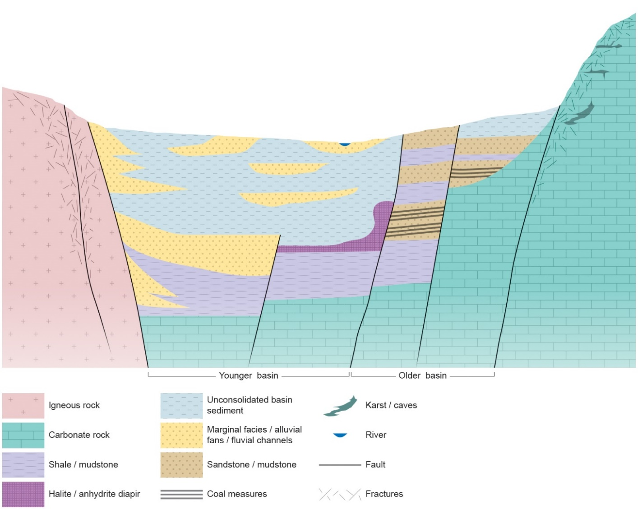
Figure 1 Conceptual model showing a range of geological environments across Europe. NOTE this is a hypothetical model not likely to occur in reality. The basin is bound to the left by crystalline igneous rock. The left side of the basin is a young, subsiding basin, and as a result it is filled with deep, unconsolidated sediments. The right side of the basin is older and has been uplifted and inverted during different geological periods. Rocks in this part of the basin are well consolidated and over-consolidated in places. The basin is bound to the right and below by carbonate basement rocks which have reacted with groundwater over time to create a karst and cave network. Characteristics of the rocks are described in Table 1 and Table 2.
Table 1 Unconsolidated sediment types in deep sedimentary basins, with aquifer, tectonic and hydrogeological characteristics. Sediments shown on the left hand side of the basin in Figure 1, above the limestone basement.
Rock type |  | Aquifer type | Tectonic elements | Hydrogeological characteristics | Example
Limnic (lake) sediment |  | Porous with variable permeability and anisotropy | Less significant role of tectonic elements within the sediment series - however, may affect geometry of basin. | Parallel alternating clay and sand layers. Moderate hydraulic conductivity and high anisotropy at unit-scale. | Great lakes, such as Pannon Lake in Central Europe.
(terrestrial) Fluvial deposits |  |  |  | Alternating clay and sand layers in sedimentary sequences (typically fining-upwards). Wider lateral variability due to changing location of the river channel. Sand and clay bodies often form lenses. | Roer Valley Graben
Delta systems | Delta plain |  |  | Frequently altenating clay and sand/gravel layers. Individual river channels can be identified in lenses. Moderate hydraulic conductivity and high anisotropy at unit-scale.. | South side of the Gulf of Corinth, Greece.
 | Delta front |  |  | Mostly sand/gravel, steeply dipping beds. Sand bodies are usually extensive and have a higher hydraulic conductivity. | South side of the Gulf of Corinth, Greece
 | Delta slope |  |  | Mostly silty layers, lower hydraulic conductivity. | South side of the Gulf of Corinth, Greece
 | Delta slope - deep basin with turbidity fans |  |  | Mostly silty layers with some individual sand bodies from slope movements and turbidites. Due to the restricted connection between the sand bodies the whole unit has moderate hydraulic conductivity. | South side of the Gulf of Corinth, Greece
Marine sediments | Near-shore and reef sediments | Porous and dual porosity |  | Due to the high energy of the environment grain size of sediments are usually bigger and hydraulic conductivity is high. Carbonates often have dual porosity with high conductivity. | Southern North Sea Basin (Cretaceous reefs and Cenozoic near-shore)
 | Offshore sediments | Mainly aquitard |  | Clay and silty layers. Lower hydraulic conductivity. | Cenozoic Southern North Sea Basin

Table 2 Consolidated rock types, with aquifer, tectonic and hydrogeological characteristics, as shown on the right hand side of the basin in Figure 1, above the limestone basement. Due to their older age they may greatly affected by multiple phases of tectonics.
Rock types |  | Aquifer type | Hydrogeological characteristics | Example
Volcanic rocks |  | Fracture flow or aquitard. | Typically fracture flow with preferential flow directions based on fracture orientation and connectivity. Low storage/porosity but possible fast flow rates depending on fracture aperture. | Iceland
Crystalline rocks |  |  |  | Southwest England
Consolidated shales |  |  |  | Northwest England
Consolidated sediments, non-shale |  | Dual-porosity - fracture and intergranular flow. Anisotropic, with a preference towards bedding parallel flow, lower vertical conductivity.  Vertical heterogeneity in hydraulic parameters over both small and regional scale depending on original depositional environment.  Can have overlapping sedimentary settings (see Table 1), e.g. progression from delta to deep marine system | Hydrogeological behaviour can vary greatly depending on the tectonic conditions, lithology and structural features.  Fracture/karst dominated flow will have high flow rates in places, such as close to the surface or fault zones, but limited in other places.  Dual-porosity systems will have preferential flow along fractures, with storage/retardation in the porous and permeable lithology around fractures.  Intergranular flow dominated system will result in lower permeabilities and will be controlled by lithology (e.g. proportion of sand vs clay).  The wider stratigraphic sequence may isolate/confine certain aquifer units - restricting recharge, affecting hydrogeochemistry. May also stack multiple aquifer units on top of each other for a larger aquifer system comprised of different units. | Cheshire Basin, Northwest England
Carbonates | Non karstified
 | Karstified | Predominantly fracture flow, with large or distributed conduits. |  | Peak District, Central England
Tectonic structures can be superimposed on rocks and sediments, which can influence the hydraulic properties. Older rocks and sediments are more likely to have been subjected to tectonic deformation (e.g. faulting/folding). Faults in particular can act as preferential flow pathways since they often fracture rock, although faulting can create a fine-grained rock called fault gouge or clay smear, which has a low permeability. Over time, all faults can seal with minerals and be characterized by lower hydraulic conductivity. Younger, or currently active structural features are more likely to have higher hydraulic conductivity. Tectonic structures may impact the preferential flow direction (anisotropy).

Groundwater and other geofluids
Many rocks and sediments in the sub-surface contain pores or fractures filled with water (groundwater), or other geofluids (e.g. oil and gas). It is important to understand the distribution of groundwater, its hydraulic head, quality, and presence of other geofluids in the sub-surface in order to understand its vulnerability. Good quality, fresh groundwater will be viewed as more vulnerable than highly saline groundwater with fewer uses that is separated from the surface and hydraulically isolated from other aquifers.
While the distribution of groundwater and its quality are highly variable, depending on geology and hydrogeology, there are some common trends. In general, in about the upper few hundred meters of the sub-surface, pore spaces are generally filled with fresh water, originating from recent rainfall (years to hundreds of years) that can be used for public supply, agriculture or industry, or that can rise to the surface as springs or in wetlands which support ecosystems (Figure 2). At these depths, groundwater can flow quickly, particularly if driven by topography in areas with significant relief gradients. Groundwater generally becomes more saline with depth since it flows more slowly (on the order of tens of thousands of years) and has had longer to react with the rocks and accumulate chemical constituents. At a certain point this water becomes as saline as seawater, and can even be more saline in places, known as brine. In addition, due to the geothermal gradient, groundwater temperatures increase with depth in the sub-surface which means that deep groundwater can provide a geothermal resource.
Other geofluids such as oil and methane gas can be found in places in the sub-surface. These are less dense than water and will rise through rocks until they are trapped by low permeability rocks (seals). Other gases such as CO₂ may also exist in the sub-surface.
While there is often a focus on protecting shallower groundwater, the conceptual model in Figure 2 acknowledges that groundwater is continuous through the sub-surface. While the UK uses a 400 m cut-off for shallow groundwater, the variation in groundwater quality and perception of groundwater value means that in Hungary and the Netherlands shallow/fresh water can be found at greater depths. Therefore, shallow groundwater is defined in this project as “part of the subsurface that contains groundwater resources that requires protection from deeper energy related activities”.

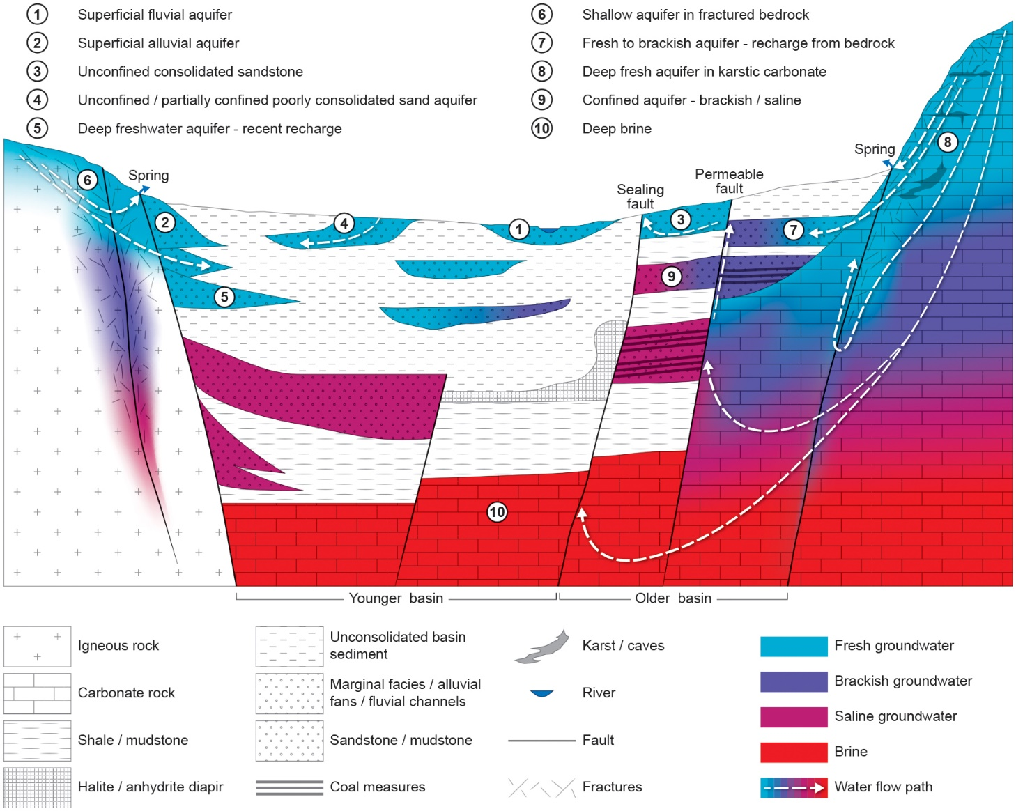
Figure 2 Conceptual model showing of a range of geological environments across Europe with possible groundwater locations and typical groundwater quality (in terms of salinity) and groundwater flow paths.

Groundwater contamination
There are concerns that activities associated with sub-surface energy uses could cause contamination of groundwater by releasing/introducing pollutants within the sub-surface. Pollutants may include the resource itself, such as oil or gas, or brine in the case of geothermal energy, or could be from chemicals used in the extraction processes, such as acids or drilling muds, or even contaminants released from deep rocks such as NORM (Naturally Occurring Radioactive Materials). The location from which these pollutants are released is the source. There must be a pathway from the source to the receptor (groundwater) in order to cause contamination.
Potential contamination pathways are covered in detail in the Technical Report of WP3, D3.1 (Zaadnoordijk et al., 2019). Pathways can be natural or anthropogenically induced, and include:

Natural pathways
- Rock/sediment mass (matrix flow) including;
  - Vertically permeable successions
  - Laterally continuous permeable units
  - Karstic features (particularly in carbonate rocks and evaporites)
- Faults (can either be transmissive or not)
- Fractures (including naturally occurring hydraulic fractures)
Anthropogenic pathways
- Leaky boreholes (due to borehole casing integrity issues) and activity-related infrastructure. Boreholes can be vertical, directional and horizontal
- Leaky, abandoned boreholes
- Activity related permeability changes such a hydraulic fracturing/stimulation
- Abandoned mines and related infrastructure
For contamination to occur, there must be a driver (or force) for contamination to flow along a pathway to the receptor. The driving forces are also summarised in D3.1 (Zaadnoordijk et al., 2019).
Driving forces from source to receptor can be natural. For example, deep sedimentary basin gravitational flow results in flow from topographic highs at basin margins towards basin lows, and in the centre of a basin may result in upwelling water. Over-pressure in the centre of basins can also lead to upwelling fluids. In some cases, convection may even occur due to buoyancy effects of a warm water body, if the permeability is high enough. However, there are many reasons why gradients may vary, and in it can be difficult to determine the natural head gradient and groundwater flow pathways due to very limited data in most regions.
A driving force is also required in order to extract (or inject) sub-surface energy products. Sometimes these are natural, for example, oil and gas often rise to the surface under pressure once a borehole is drilled. However, pressures must be altered in other cases. For example, for coal bed methane, dewatering of coal measures is required to release methane from the coal, driving flow from the coal to the borehole. Hydraulic fracturing initially increases pressures in order to fracture rock, and then allows pressures to decrease – so there is a transient pressure change. Injection of gases such as CO₂ would cause sustained pressure increased. It is possible that these induced driving forces can alter natural driving forces and groundwater flow pathways. These effects are considered for each of the sub-surface energy uses below.

Conventional oil and gas

Background and extraction activities
There has been drilling for onshore conventional hydrocarbons in Europe since the mid-1800s. In conventional oil and gas extraction, boreholes are drilled into a reservoir and oil and/or gas flows to the surface under natural pressure (BGS, 2011). Conventional reservoir rocks are commonly sandstone or limestone with a relatively high porosity and permeability (from 1 mD to several D), allowing the oil and gas to flow. Hydrocarbons have a lower density than other crustal fluids and conventional hydrocarbons therefore migrate upwards through permeable rock and along discrete pathways such as through rock matrix or permeable faults. The hydrocarbons are prevented from further migration by low permeability traps such as a low permeability geological fault or rock unit behaving as a ‘cap rock’ (Figure 3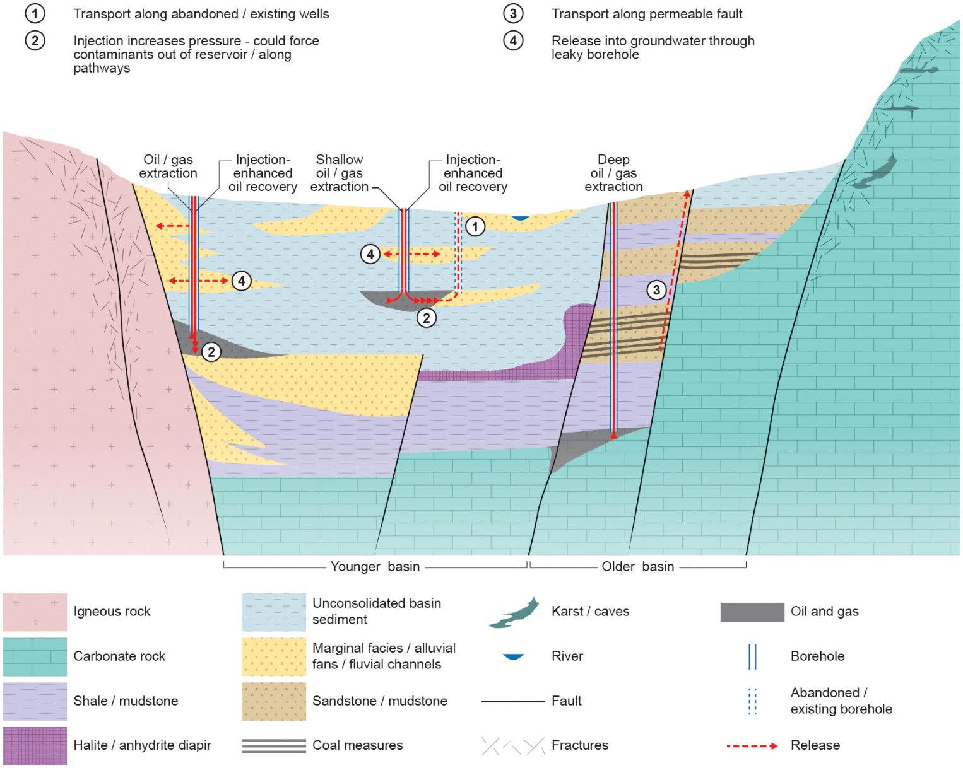
Figure 3). This allows for the accumulation of hydrocarbons within the pore spaces of the reservoir (Loveless et al., 2018).
When reservoir pressure decreases, oil and gas can be pumped to the surface (BGS, 2011). Secondary, or Enhanced Oil Recovery (EOR) uses reinjected water to displace and drive out remaining oil or to maintain reservoir pressure (BGS, 2011). Hydraulic fracturing is not commonly required but has been conducted from vertical wells since the 1940s. Thermal recovery or chemical injection can also be used for reservoir stimulation (BGS, 2011).

Geological and hydrogeological setting
Conventional oil and gas are generally found in, or around, sedimentary basins of various ages. The hydrocarbon source rock ranges from a few meters to hundreds of meters in thickness, and the thickness of reservoir rocks is also variable. Exploitation depths can range from 0 to 9 km (Hu et al., 2013). Conventional oil and gas is not restricted to a particular hydrogeological environment, and can be found at basin margins or the center of basins. However, oil and gas have a tendency to rise in the sub-surface due to their natural buoyancy, and therefore could travel along contamination pathways without an additional driving force.

Contamination pathways
The main potential pathway for contamination arising from conventional oil and gas reservoirs is the borehole infrastructure and other existing/abandoned boreholes in the area (Figure 3, Table 3). This is because conventional hydrocarbons can be exploited in areas with a large number of existing boreholes. Well integrity failure is also possible if reservoir stimulation techniques are used, such as hydraulic fracturing or enhanced oil recovery (EOR) (Ward et al., 2015). Often, multiple boreholes will be drilled into the reservoir but borehole density is lower than for unconventional hydrocarbons (US EPA, 2016).
Pressure or permeability changes within the reservoir, perhaps due to stimulation techniques, might also alter the behavior of the fault or cap rock with respect to fluid movement, and potentially allow leakage. In some cases, particularly in shallower reservoirs, extraction can result in land subsidence at the surface. Since hydrocarbon reservoirs have relatively high porosity and permeability, the same rock unit could be an aquifer at shallower depths. If a reservoir seal is breached, mass transfer is possible towards the aquifer.
Table 3 Conventional oil and gas activity, characteristics and risks. * Here, a mature basin refers to one in which sediments have been buried deep enough to reach the oil/gas window, sediments are often consolidated in this case.
Sub-surface techniques | Activity Description | Pressure Change | Typical geological setting (energy source) | Specific risks
Directional drilling.  Enhanced oil recovery (EOR).  In some cases  can stimulate or frack borehole. | Oil/Gas target reached by conventional drilling techniques  In EOR, water or CO₂ pumped into to the reservoir to sustain pressures  Target is reservoir rock (permeable). Typically no need to enhance permeability, but may use a “mini-frac” in the instances that it is necessary. | Pressure decrease - removal of oil/gas from reservoir  EOR can increase pressure in reservoir. | Mature sedimentary basins* | Well integrity.  Major pathway to surface is the well itself.  Natural faulting in mature basin - may act as a trap, or a pathway for migration.  Mini-fracs may create artificial pathways, but unlikely considering the lower pressure compared to high volume and pressure fracturing used in shale gas.

Figure 3 Contamination pathways for conventional oil and gas. 1) Transport along abandoned/existing wells into formations with groundwater. 2) Injection for EOR (water/steam/CO₂) can increase reservoir pressures and force contaminants out of the reservoir and along other pathways. 3) Transport of contaminants along permeable faults. 4) Release of contaminants into groundwater through leaky borehole.

Shale Gas

Background and extraction activities
There is currently no shale gas production in the UK or Europe. Several countries in Europe have announced moratoria or bans on shale gas. There is active exploration in England for the Carboniferous (Namurian) aged Bowland-Hodder shale formations in the Fylde of Lancashire and the Vale of Pickering, Yorkshire.
Shale gas and shale oil are extracted directly from organic rich shales. The low permeability of shales (<0.001 to 0.0001 mD) (CSUR, 2016) means that a proportion of gas or oil produced from the organic material in shales is trapped within the pore spaces. Gas can also be bound to the matrix by adsorption. Other tight (low permeability) reservoirs (such as limestone or siltstone) are also often called shale gas reservoirs even through the rocks do not contain a high enough proportion of clay minerals to generally be called shales (Lefebvre, 2017).
Shale gas is extracted via a borehole, which may be deviated from vertical and/or have horizontal sections within the shale, in order to access a greater volume of rock. High volume, high pressure hydraulic fracturing (fracking) is used to increase the permeability of the shale, allowing gas to flow from the shale to the borehole. The process involves injecting a high volume of ‘frack fluid’ (water containing a proppant (sand or ceramic beads) and chemical additives) into the borehole under a very high pressure in order to fracture the rock surrounding the well. These induced fractures increase the shale porosity from 1-10% to 35% (Brownlow et al., 2016). The fractures are kept open by the proppant after the borehole is depressurized to allow the gas to flow to the surface. Hydraulic fracturing is not always required for oil production from “tight” formations (US EPA, 2016).
The volumes of water and pressures required for high volume hydraulic fracturing depend on the geological conditions and composition of the hydraulic fracturing fluid, but are relatively large. In the U.S., the average water volume injected per horizontal borehole in 2014 was nearly 20,000 m³ (typically between 10,000 to 25,000 m³, AEA (2012)) per well for gas and up to 16,000 m³ for oil (Gallegos et al., 2015). The volumes required for vertical boreholes are much lower, with medians of < 2,000 m³ and < 1,000 m³ for gas and oil respectively (Gallegos et al., 2015), and generally reflect the length of the borehole (Gallegos et al., 2015). Between 40-80 % of injected fluids flow back to the surface as flowback (Prpich et al., 2015). In the Marcellus and Haynesville Shales, injection pressures range from 13.8 MPa to 82 MPa (US EPA, 2016).
Hydraulic fracturing activities can last from one day to several weeks (US EPA, 2016). If the horizontal wells are too long to maintain pressure along their length, plugs can be used to fracture the well in stages (The Royal Society, 2012). Re-fracturing or re-completions are sometimes required in wells, but this is thought to be for < 2 % boreholes (US EPA, 2016). In some cases, more than 20 boreholes can originate from a single well pad (Jackson et al., 2013a).

Geological and hydrogeological setting
Shales and tight formations with the potential for shale/tight gas are often found in sedimentary basins, or sometimes in halo plays, around the edges of historical oil and gas production sites, or in larger geostratigraphic plays (CSUR, 2016). Shale and tight oil and gas formations are found within clastic depositional systems with sandstone, siltstone, mudstone and shale, or carbonate systems with limestone, dolomite, shale and halite/anhydrite.
In younger basins, without a long history of deformation (e.g. the Panonanian Basin), shale structure may be relatively straight forward. In areas where basins are older, such as in the UK, the basin and formation structure can be complex due to the age and deformation history of the rock units. The thickness of shales with gas resources vary from tens to hundreds of meters in thickness. The thickness of tight formations is variable for oil but for gas plays they are commonly located in deep basins and are very thick with continuous gas saturation (Aguilera & Harding, 2008).
In the U.S., the average depths of large gas-producing reservoirs in shales are between 2 km (Marcellus shale) and 3.7 km (Haynesville-Bossier shale). The minimum and maximum depths of exploitation range from 200 m in New Albany to 4.12 km in Haynesville-Bossier (US EPA, 2016). Tight oil formations are typically exploited from 1-3 km depth and gas from deep (> 4.5 km) basins. Biogenic gas can be < 1 km bgl (Naik, 2003). Hybrid plays can be shallow, such as the Antrim biogenic gas play (430 m bgl) and the Niobraran shale oil resource (305 m bgl) (Monaghan, 2014).

Contamination pathways
There are a number of potential pathways for contamination from shale gas exploitation. There is no requirement for a cap rock because the gas is trapped in the rock unit. Therefore, once gas is released, transport of gas and fluid through the rock mass is possible (Figure 4, Table 4). There are no characteristic proximities between shales (or tight formations) and aquifers, although regulations exist in some countries which limit the separation distance between shales and aquifers, such as in the UK. There, a minimum depth of high volume hydraulic fracturing was set at 1 km in the UK Infrastructure Act (2015), which means that there is a minimum 600 m vertical separation between the ‘default’ maximum thickness of designated groundwater bodies in the UK (400 m) (UKTAG, 2012) and shale gas formations.
Shales and tight formations are not commonly aquifers due to their low permeability. However, water-bearing zones can be present within shales or tight formations where depositional settings led to localised or transitional silt/sandstone or limestone deposition. For example, in Pavillion, Wyoming, the Wind River Formation is the principal source of groundwater and also one of the main gas hydrocarbon source units. Contamination of the groundwater here is thought to have occurred because stimulation fluids were directly injected into water-bearing units, but there was also casing failure at five production wells which probably allowed migration into water-bearing units (DiGiulio and Jackson, 2016).
Because of the high density of boreholes in areas where shale gas is being exploited, in comparison to conventional hydrocarbons, there are more likely to be existing boreholes in the vicinity of active boreholes. The presence of horizontal boreholes increases the likelihood of the path of the new borehole being close to existing boreholes and the older infrastructure providing an anthropogenic pathway to the surface.
Ingraffea et al. (2014) found a six-fold higher incidence of cement and/or casing issues for shale gas wells relative to conventional wells from analysis of 75,505 compliance reports from Pennsylvania, 2000-2012. Borehole integrity failures may be more common when boreholes are used for high volume hydraulic fracturing due to the different geometries (longer and sometimes curved) and high volumes and pressures involved in the hydraulic fracturing process. It is also difficult to maintain casings centered in the horizontal section of boreholes, which makes it difficult to ensure a good cementation of the casing (Lefebvre et al., 2017). Integrity failure may also occur due to ground movement and seismic events that could be triggered by hydraulic fracturing (Ward et al., 2015).
Hydraulic fractures could potentially provide preferential pathways for contaminants from source to receptors depending on the height and aperture of the fractures and the vertical separation distance between the source and the receptor. Even if the fractures do not directly link the source and receptor, they can shorten the pathway that a contaminant would have to travel without a preferential flow path (modified separation). Data regarding hydraulic fracture height (vertical dimension) remains relatively limited since only 3% of hydraulic fracturing operations in North America are currently monitored with seismic arrays (Gassiat et al., 2013). Nevertheless, studies assessing induced fracture height from micro-seismic and micro-deformation data for high volume hydraulic fracturing indicate that most hydraulic fractures are less than 100 m in height (Davies et al., 2012; Fisher and Warpinski, 2012). Statistically, less than 1% of hydraulic fracturing stages have fractures that are greater than 350 m in height (Davies et al., 2012). The maximum upward propagation of recorded fractures in the data from five shale gas plays in the US, analysed by Davies et al. (2012), is 588 m in height. This work also concluded that fracture height probabilities are likely to be over-estimated due to difficulties identifying smaller fractures. Fisher and Warpinski (2012) show that fracture height distributions differ between regions and shale formations.
There is limited information on the lateral extent of hydraulic fractures. The US EPA (2016) report fractures extending to horizontal lengths of 300 m from borehole data in the Fisher and Warpinski (2012) dataset. Evidence from well communications between closely spaced boreholes might also help to elucidate the fracture half lengths; Lefebvre (2017) found that the average horizontal distance for well communication at depth was 400 m, with a range from 30 to 2000 m.
Hydraulic fractures can also interact with other pathways such as faults or boreholes and seismicity resulting from hydraulic fracturing can impact borehole integrity as seen at Preece Hall, Lancashire (Ward et al., 2015).

Table 4 Shale gas activity, characteristics and risks
Sub-surface techniques | Activity Description | Pressure Change | Typical geological setting (energy source) | Specific risks
Hydraulic fracturing  Directional drilling | Shale gas target reached by conventional oil and gas drilling techniques, including directional drilling.  Target zone is hydraulically fractured, with high volume, high pressure fluids to increase permeability in target zone. | Initial pressure increase - injection of hydraulic fracture fluids to fracture shale.  Pressure decrease during production to allow flow-back. | Mature sedimentary basins – generally consolidated shales for thermogenic methane.  Less mature shales for biogenic methane. | Injection of chemicals and mobilisation of natural gas and deep substrates.  Well integrity under high pressures.  Co-located with abandoned/old boreholes.  Hydraulic fracture propagation to permeable pathways such as faults or groundwater bearing units.  Modifying deep groundwater flow patterns by injection.

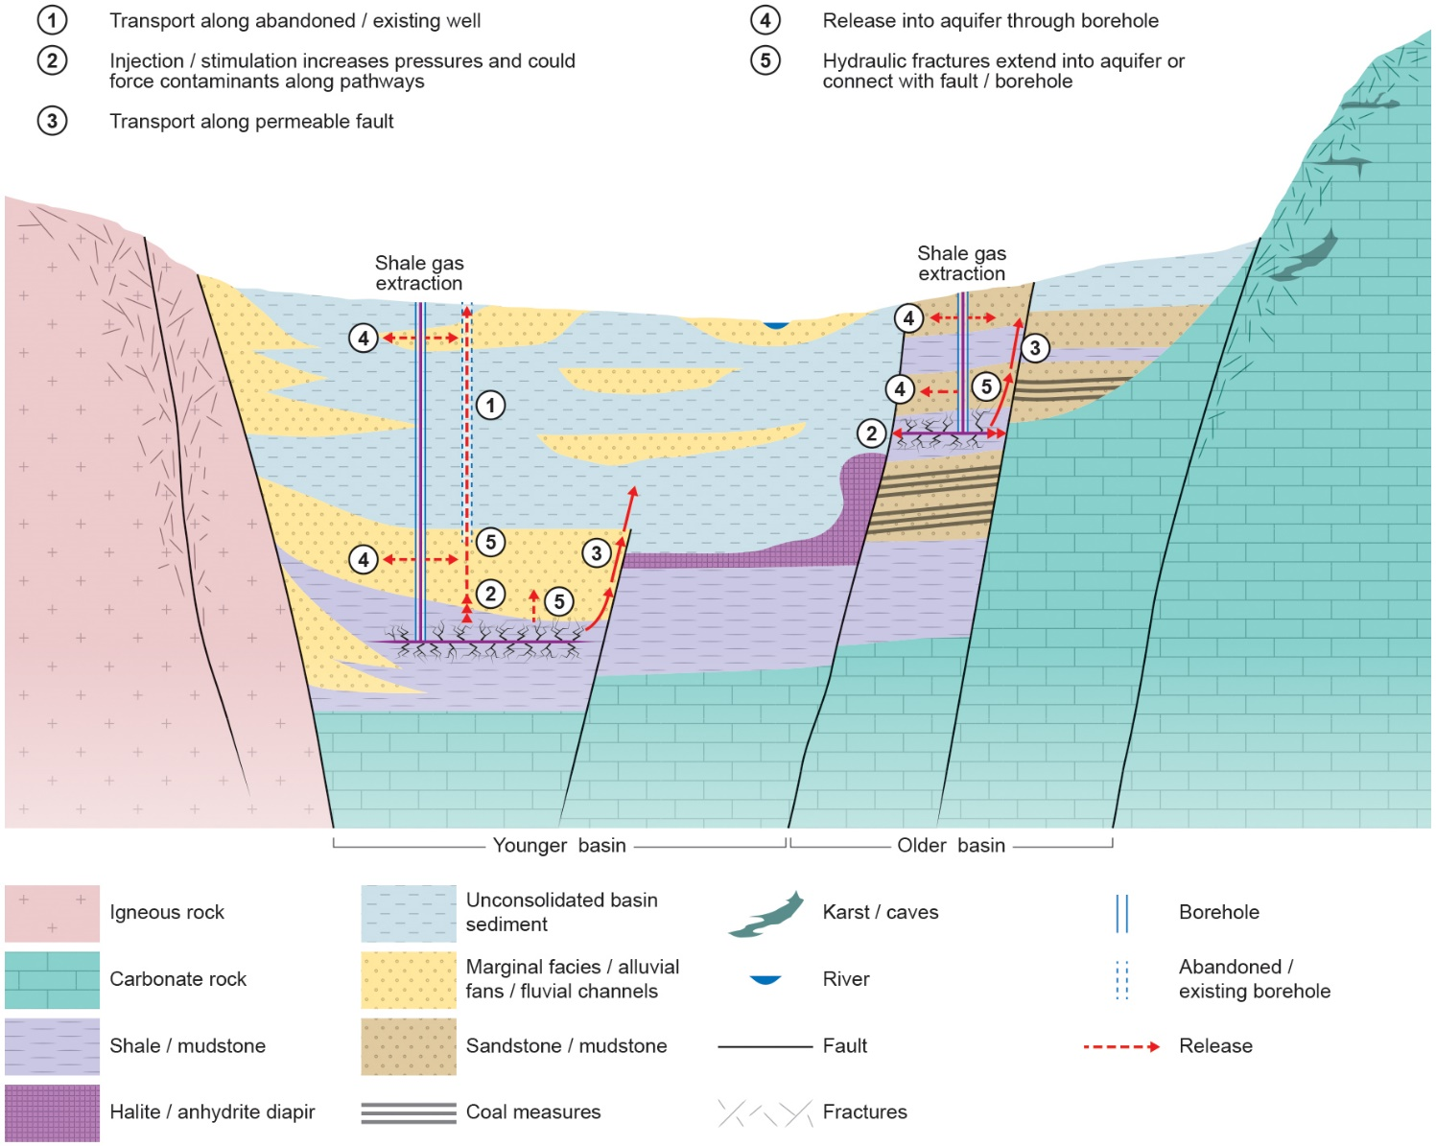
Figure 4 Contamination pathways for shale gas. 1) Transport along abandoned/existing wells into formations with groundwater. 2) Injection/stimulation to increase permeability (e.g. hydraulic fracturing) can increase reservoir pressures and force contaminants out of reservoir and along other pathways. 3) Transport of contaminants along permeable faults. 4) Release of contaminants into groundwater through leaky borehole. 5) Hydraulic fractures extend into aquifer or connect with a permeable fault.

Coal bed methane (CBM)

Background and extraction activities
CBM is well established around the world and has been used at a small scale in Europe. Natural gas can be bound within coal seams by adsorption in which gas molecules adhere to the surfaces within the coal. This gas can be extracted in situ, i.e. directly from coal seams. For the extraction of CBM a borehole is drilled into the coal seam and water is pumped out in order to lower the pressure in the seam (Jones et al., 2004). In some cases, particularly where there has previously been mining, coal-bearing strata may already be dewatered (Al-Jubori et al., 2009). The lowering of pressure allows methane to desorb from the internal surfaces of the coal and diffuse into cleats (fractures within the coal) where it is able to flow, either as free gas or dissolved in water, towards the production well (DECC 2013). A good permeability is necessary to allow flow of gas to the production well during CBM production. Bituminous coals can have permeabilities of 1 mD, sometimes up to 30 mD although this is often anisotropic (Jones et al., 2004). Permeability can be imparted by cleats, and in some cases this may be as high as 100 mD. In areas of pre-existing mines, the permeability of coal seams and surrounding strata is increased due to rock collapses associated with longwall mining; this can be up to 160-200 m above and 40-70 m below the worked seam (Jones et al., 2004).
CBM boreholes may have many sub-surface horizontal or multilateral side tracks drilled from one surface location in order to penetrate more coal (DECC, 2013). Horizontal sections of wells are often 1-3 km in length (The Scottish Government, 2014). There may also be multiple pads per production operation (Environment Agency, 2014).
Coal mine methane (CMM) and abandoned mine methane (AMM) can be considered as subdivisions of CBM. CMM involves the removal of methane from a working mine to enable safe mining, by capturing it at high concentrations. AMM recovers gas that accumulates in abandoned mines which would otherwise find its way to the surface. Boreholes are drilled into underground roadways or former workings. Drilling may be used to link adjoining mines and improve connectivity and to aid minewater drainage away from production zones (Environment Agency, 2014). In AMM, gas is also released via suction pumps (Environment Agency, 2014).

Geological and hydrogeological setting
Organic material forming coal seams was often deposited cyclically with other sedimentary rocks in sedimentary basins. Therefore, coal seams are generally interbedded with other rock types including mudstone, sandstone, siltstone, conglomerate and limestone, which may be aquifers. Coal seams in Europe tend to only be several meters in thickness. In older basins, structural features such as faulting and folding are common in the coal bearing units.
CBM basins can range from 0 to > 2000 m depth (US EPA, 2016). In Europe, they are more likely to be exploited from 200 to 1200 m bgl. CMM and AMM resources are in areas with existing and abandoned mines with methane.

Contamination pathways
Since aquifers and coal seams can be interspersed, contaminants do not necessarily have to travel far from coal activities to reach a receptor (Figure 5, Table 5). In addition, because CBM can take place at only 200 m bgl, this could be shallower than a receptor.
Hydraulic fractures are not necessary for CBM, although often permeability is relatively low. Hydraulic fractures for CBM are generally expected to be smaller in extent than for hydraulic fracturing for shale gas. Pressures required for hydraulic fracturing are 50-70% lower than for shale gas, often of the order of 24-34 MPa, although this is depth dependent (Environment Agency, 2014). The volume of fluid injected for fracturing is also smaller than for shale gas, between 200 m³ – 1500 m³ water per borehole (Environment Agency, 2014) due to shorter well lengths (US EPA, 2016). Injected fluids include water, water and sand or nitrogen foam with proppants and other additives (Environment Agency, 2014). In addition, because the hydrocarbon source unit is often shallower than 600 m bgl, the fractures are more likely to be horizontal instead of vertical.
De-gassing of coal seams could result in matrix shrinkage and formation of cleats (Moore, 2012) and associated depressurization within the sub-surface has resulted in instability/subsidence in relation to CBM (Environment Agency, 2014). Mines and infrastructure such as boreholes and shafts related to mines, often found in coal bearing regions, can create preferential sub-surface pathways with high permeability. Coal measures in Europe tend to be old and have undergone multiple phases of deformation, they may therefore be highly fractured and faulted, with lots of pathways for contamination.
Table 5 Coal Bed Methane activity, characteristics and risks
Sub-surface techniques | Activity Description | Pressure Change | Typical geological setting (energy source) | Specific risks
Dewatering  Possibly hydraulic fracturing | Borehole drilled to target coal seam.  Water level lowered to promote gas migration from inside formation towards well.  Methane desorbs from coal, and migrates towards well. Ideally, gas leaves solution and migrates up borehole  Gas collected at surface with manifold sealing borehole – compressed and distributed to grid. | Decrease in pressure (brief increase if fractured) | Mature sedimentary basins - coal-bearing | Methane migration. Possible contamination from fracking or drilling fluids if used.  Well integrity.  Natural faulting in coal sequences creates pathways for fluid migration.  May dewater overlying/surrounding aquifer.  Artificial pathways for fluid migration along historical workings - either open, sealed, or backfilled with a permeable material.
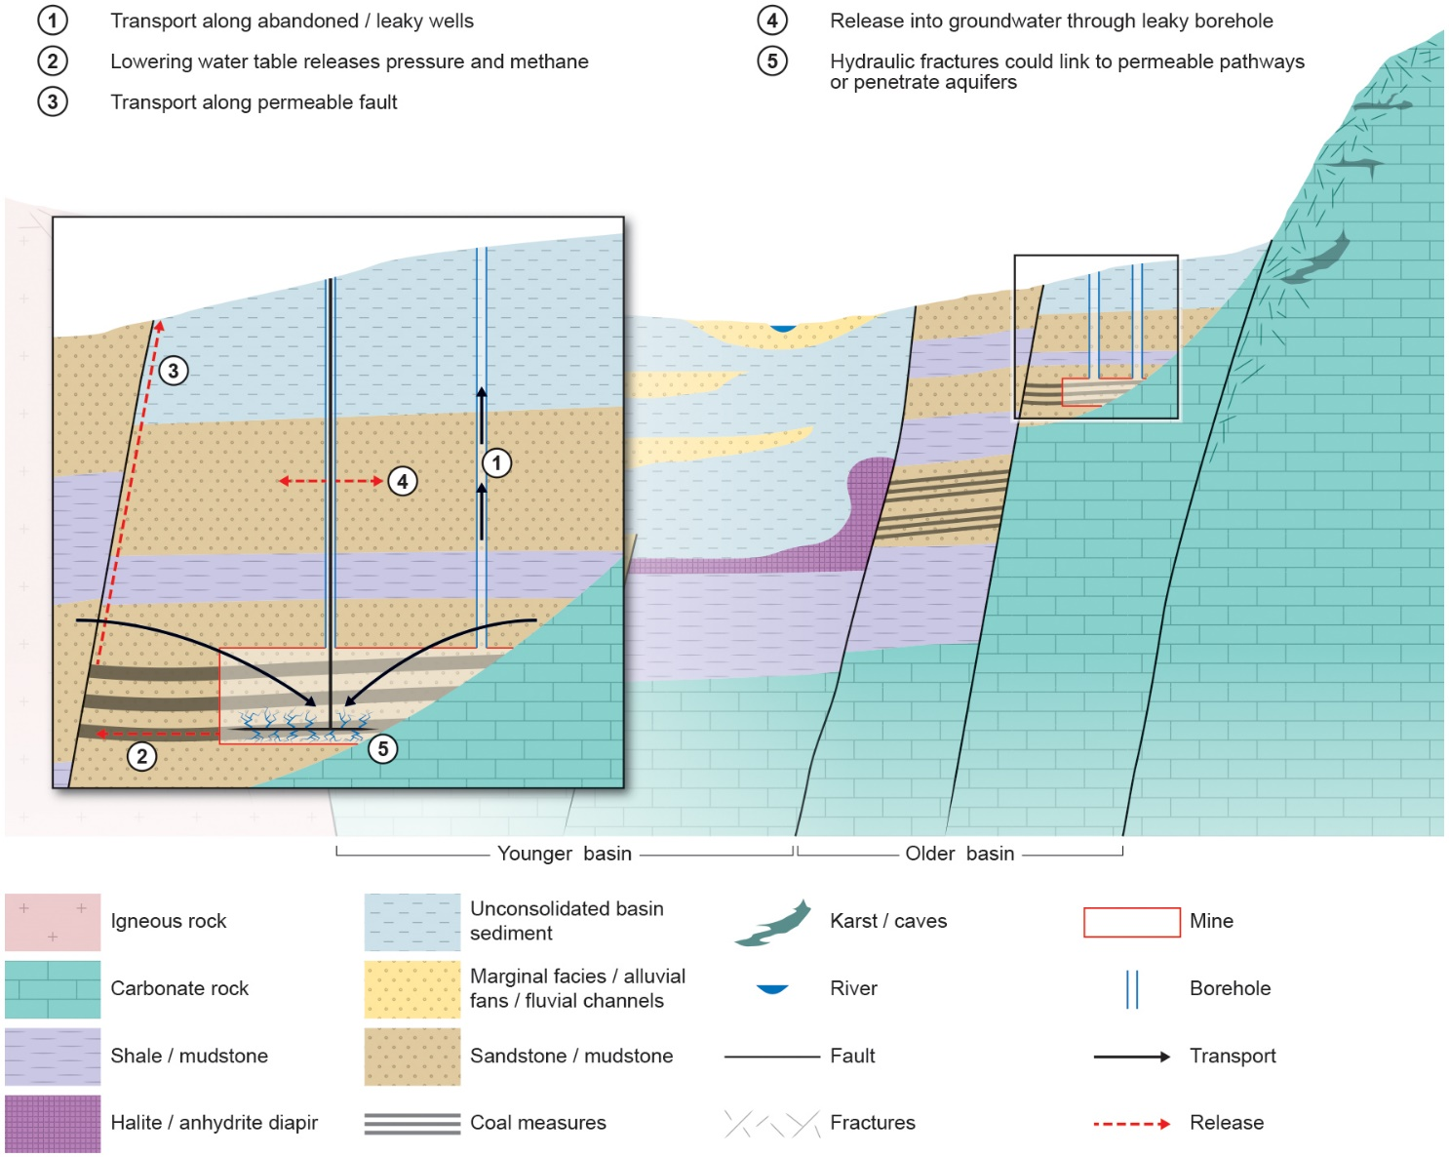
Figure 5 Contamination pathways for CBM. 1) Transport along abandoned/existing wells into formations with groundwater and through mine infrastructure. 2) Lowering of water table releases pressure and methane 3) Transport of contaminants along permeable faults. 4) Release of contaminants into groundwater through leaky borehole. 5) Hydraulic fractures could extend into aquifer or connect with a permeable fault.

Geothermal energy

Background and activities
Deep geothermal energy uses the earth’s natural geothermal gradient for direct-use heat (at temperatures of around 50ºC) or electricity (temperatures > 120ºC). In a standard geothermal system, warm fluids are extracted from the ground at depth through one borehole, and reinjected at depth via an injection borehole. While the boreholes may be in a single location at the surface, they are sufficiently far apart in the sub-surface such that thermal breakthrough between the boreholes does not occur. “Scaling” (or precipitation of minerals) is a common problem with geothermal energy therefore scaling fluids may be used to prevent this.
Where natural permeability is not sufficient to abstract naturally occurring hot fluids, the geothermal systems may be “engineered” or “enhanced”, whereby the hot rock is fractured or sheared with water and/or acid in order to re-break existing fractures. This allows circulation of fluids which will then transfer heat to the surface. Faults can be targeted in these geothermal systems because they can have higher permeability/more fractures than the background rock.
Minewater geothermal uses the large volume of water stored within flooded mines to transfer heat to the surface where it is concentrated using heat pumps. Mines may have high permeability, so abstraction and injection boreholes are located further away from one another to avoid thermal breakthrough.

Geological and hydrogeological setting
Deep geothermal energy requires permeable rocks in the sub-surface. These can either be permeable sediments, or fractured and/or rock units such as limestone in which permeability has been enhanced through dissolution. In order to attain sufficient temperatures, these are usually at depths of > 2 km, and sometimes much deeper, and are often overlain by low thermal conductivity lithologies. However, in regions of higher heatflow such as the Pannonian Basin in Hungary, Italy and Turkey, these reservoirs may be shallower.
Engineered geothermal systems can be located anywhere if they are drilled deep enough, but tend to be in rocks with high heat flow such as radiogenic granites (which release their own heat due to decaying radioactive elements) or close to plate margins where the background heat flow is higher and the geothermal gradient steeper. Target depths may be in excess of 2 km (e.g. Cornwall, England) or < 1000 km, such as the Weardale Granite, England.
Minewater geothermal takes place in areas of old mine-workings where mines have subsequently flooded, such as in Heerlen, the Netherlands (Verhoeven et al., 2014). Often these are coal mines, but they could also be mineral mines.

Contamination pathways
Since geothermal reservoirs have relatively high porosity and permeability, the same rock unit could be an aquifer at shallower depths, and therefore, mass transfer is possible within the unit towards the aquifer where in continuity – particularly in shallower geothermal systems (Figure 6, Table 6). A regional low permeability/aquitard layer could be an important barrier in these cases.
Borehole infrastructure and other existing/abandoned boreholes in the area could be a source of contamination from geothermal energy. Well integrity failure is also possible if reservoir stimulation techniques are used, such as hydro-shearing or stimulation (Ward et al., 2015).
Pressure or permeability changes within the reservoir, perhaps due to stimulation techniques, might also alter the behaviour of the faults with respect to fluid movement and potentially allow leakage. Contaminants may travel along faults, particularly if these are targeted for their permeability.
For engineered geothermal systems (EGS) (Figure 6, Table 7) fractures could potentially provide preferential pathways for contaminants from source to receptors depending on the height and aperture of the fractures and the vertical separation distance between the source unit and the receptor. Even if the fractures do not directly link the source and receptor, they can shorten the pathway that a contaminant would have to travel without a preferential flow path (modified separation). There is limited information about the nature of fractures in EGS. Hydraulic fractures can also interact with other pathways such as faults or boreholes.
For minewater (Figure 6, Table 8), geothermal mines and infrastructure such as boreholes and shafts related to mines can create preferential sub-surface pathways with high permeability, either directly in the mines, or in fractured units above and below the mined seams.

Table 6 Geothermal – hot sedimentary aquifer activity, characteristics and risks
Sub-surface techniques | Activity Description | Pressure Change | Typical geological setting (energy source) | Specific risks
Injection/ abstraction loops | Conventional drilling techniques.  Water abstracted from aquifer and usually reinjected to balance system. | Reduction in pressure around abstraction well.  Increase in pressure around injection well.  Sufficient pressure connection may balance pressures. | Deep sedimentary aquifers, karstic or with high permeability. | Well integrity.  Changes in hydraulic flow patterns as a result of large abstractions/injections - affecting deeper flow paths.  Hydraulic connections via historical/ongoing deep industry, including ore mining (Hungary).  Natural faulted/fractured pathways to surface.

Table 7 Geothermal – EGS/Hot Dry Rock systems activity, characteristics and risks
Sub-surface techniques | Activity Description | Pressure Change | Typical geological setting (energy source) | Specific risks
Possibly stimulation/ hydro-shearing.  Injection/abstraction loops | Conventional drilling techniques.  Targets either have naturally high fracture permeability or enhanced through stimulation/ hydro-shearing  Water abstracted from aquifer and usually reinjection to balance system. | Temporary increase in pressure if stimulated/ hydro-sheared.  Reduction in pressure around abstraction well.  Increase in pressure around injection well. | Crystalline basement rocks, typically granite (radiogenic) or volcanic. | Well integrity under high pressures.  Changes in hydraulic flow patterns as a result of large abstractions/injections - affecting deeper flow paths.  Natural pathways may be large structural features which may connect shallower resources to granite target (e.g. Slitt Vein structure)  Historical infrastructure in granitic settings – metalliferous mining

Table 8 Geothermal – minewater systems activity, characteristics and risks
Sub-surface techniques | Activity Description | Pressure Change | Typical geological setting (energy source) | Specific risks
Injection/ abstraction loops | Conventional drilling techniques.  Water abstracted from mine and usually reinjected elsewhere in mine to balance system. | Reduction in pressure around abstraction well.  Increase in pressure around injection well.  Likely to be sufficient pressure connection to balance pressures. | Shallow to mid-depth sedimentary basins with coal measures and historic mines. | Well integrity.  Changes in hydraulic flow patterns as a result of large abstractions/injections.  Activity can be close to surface and aquifers.  Hydraulic connections via mining infrastructure.  Natural faulted/fractured pathways to surface.

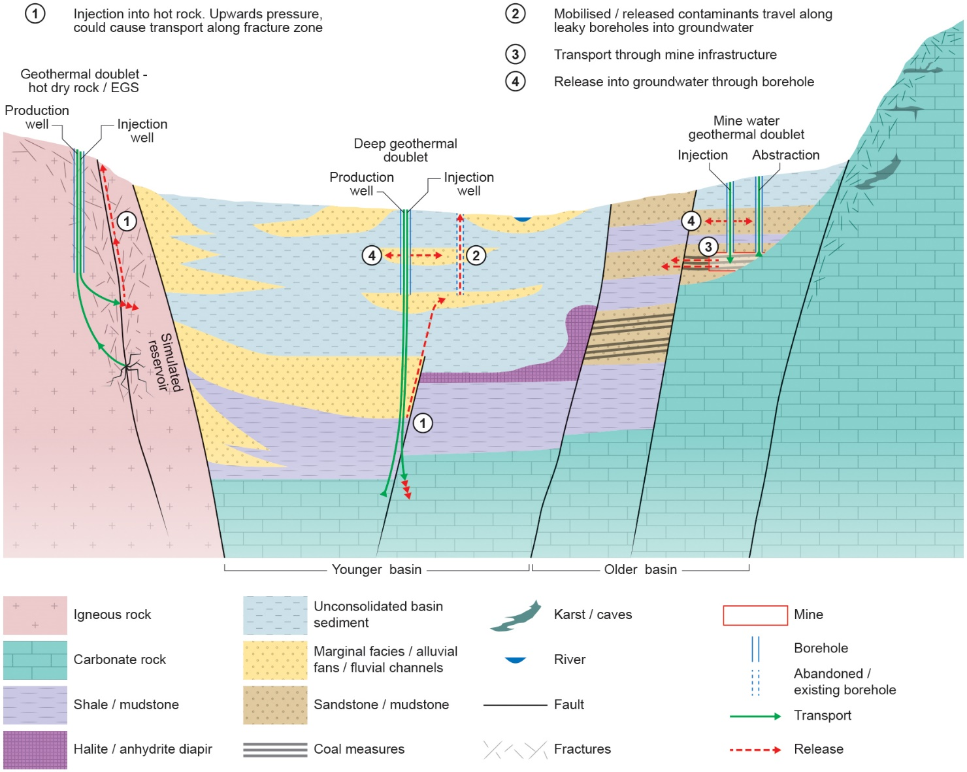
Figure 6 Contamination pathways for geothermal energy. 1) Injection into permeable zone, such as a fault, increased pressure could cause transport along fracture zone. 2) Mobilization/release of contaminants which travel along leaky boreholes into groundwater. 3) Transport of contaminants through mine infrastructure. 4) Release of contaminants into groundwater through leaky borehole. 5) Sheared fractures could extend into aquifer or connect with a permeable fault.

Energy and gas storage

Background and activities
Many forms of renewable energy produce more at certain times of the year or the day, for example, wind and solar. In order to fully make use of their potential, energy must be stored. Energy can be stored on a daily to seasonal basis in the sub-surface. These may include compressed air energy storage (CSAES), hydrogen gas, or synthetic methane (Bauer et al., 2017). Excess heat or cold may also be stored, similar to geothermal energy (Bauer et al., 2017). Other types of energy storage are already in use, for example the storage of natural gas. This is already common in salt caverns, with 51 gas storage sites in Germany, 715 in salt caverns and porous formations worldwide (Kabuth et al., 2017). Gas or waste from energy production may also be disposed of permanently in the sub-surface, for example, waste CO₂.
Energy storage is different to other sub-surface energy uses due to its cyclicity which induces mechanical and hydraulic and thermal effects. High temperature (>100ºC) storage induces cyclical geomechanical, hydraulic and thermal changes (Bauer et al., 2017). Disposal of gas or fluids results in sustained sub-surface pressure increase.

Geological and hydrogeological setting
Gas can be stored in caverns (such as salt caverns for gas) or porous formations (for gas and heat) (Bauer et al., 2017). Sensible heat can be stored in the shallow sub-surface, up to a few hundred meters depth. Gas storage for hydrogen, methane or air uses porous formations or salt caverns in the deeper sub-surface, at depths from a few hundred meters to about 2 km (Kabuth et al., 2017). Very large storage capacities can be realised in geological storage solutions. In many cases the porous reservoirs may be old oil or gas fields.

Contamination pathways
Injection of gas or energy storage in the sub-surface increases pressures. Particularly at shallow depths, this can impact the integrity of confining units (e.g. Bauer et al., 2017) if pressure increase is too high it may cause leaks – which may also be directly into groundwater if the storage is at shallower depths. It also forces possible contaminants away from the injection well, which may be towards groundwater in the same formation, or along pathways to a different formation (Figure 7, Tables 9 to 11).
Cyclical increased and decreased pressures can lead to cyclical land subsidence or uplift, which can create fractures in the sub-surface and subsequent contamination pathways. Injection can also lead to changes of groundwater flow field and composition (Bauer et al., 2017).
Heat can be a contaminant itself. If stored at shallow depths, it could be transferred by convection and conduction in the sub-surface. Griebler et al. (2015) in Kabuth et al. (2017) suggest that 90º C could be considered a maximum temperature for injection into formations.
Contamination may occur along old or abandoned boreholes if old oil or gas fields are utilised. Generally, permeable faults will be avoided since the aim is to store the energy without leakage, but if they had not been identified, or if the fluid extended past intended formations then contaminants could reach permeable faults.
Table 9 Gas storage in salt caverns, activity, characteristics and risks. NOTE – assuming caverns already present
Sub-surface techniques | Activity Description | Pressure Change | Typical geological setting (energy source) | Specific risks
Injection + pressure release/ expansion | Borehole drilled to target unit.  Compressed gas pumped into cavern under pressure.  Gas released during peak demand. | Pressure increase for storage, decrease when released. | Evaporite sequences, amongst consolidated sedimentary sequences | Well integrity under pressure.  Salt should be a hydraulic seal preventing fluids.  Dissolution of salt must be controlled to avoid subsidence at surface

Table 10 Gas/CO₂ storage in exploited gas fields, activity, characteristics and risks.
Sub-surface techniques | Activity Description | Pressure Change | Typical geological setting (energy source) | Specific risks
Injection/ abstraction | Borehole drilled to target unit.  Compressed gas pumped into old oil or gas reservoir or saline aquifer. | Decrease/ increase in pressure depending whether gas is abstracted/ injected.  For long-term storage (CO₂) can be sustained increase in pressure. | Sedimentary basin, with exploited gas fields or saline aquifers. | Well integrity under high/changing pressures.  Natural faulted/fractured pathways to surface, can be exacerbated under high pressure.

Table 9 Thermal storage in exploited gas fields, activity, characteristics and risks.
Sub-surface techniques | Activity Description | Pressure Change | Typical geological setting (energy source) | Specific risks
Injection/ abstraction | Borehole drilled to target unit.  Hot/cold water pumped into permeable formation and abstracted when needed. | Decrease/ increase in pressure depending whether fluid is abstracted/ injected. | Sedimentary basin, with permeable formations. | Well integrity under high/changing pressures.  Natural faulted/fractured pathways to surface, can be exacerbated under high pressure.  Thermal effects can transfer through conduction as well as advection.

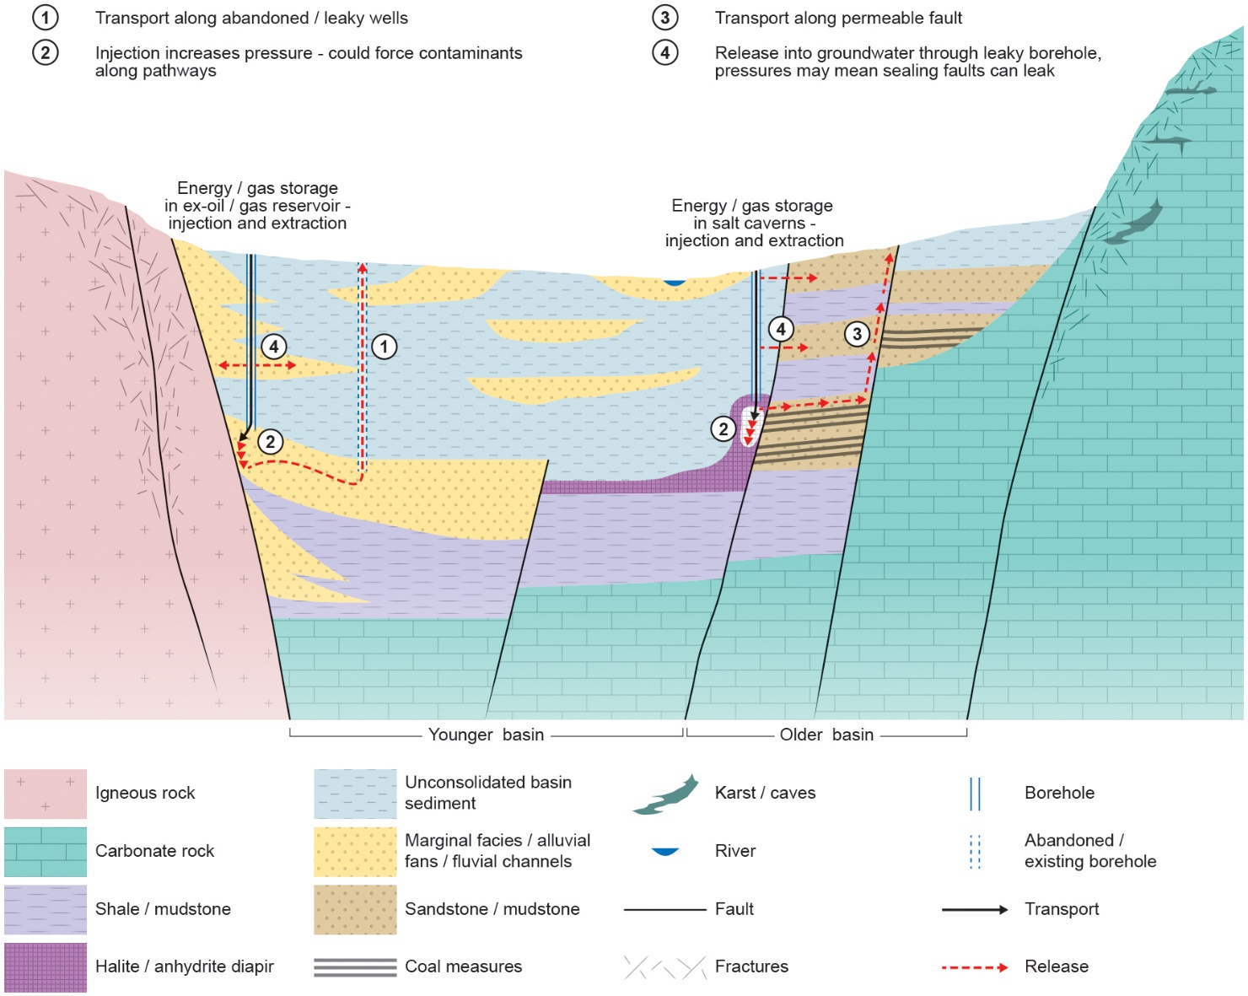
Figure 7 Contamination pathways for energy and energy waste storage. 1) Transport along abandoned/leaky wells. 2) Injection increases pressure could cause contaminant transport out of initial reservoir. 3) Transport of contaminants along permeable faults. 4) Release of contaminants which travel along leaky boreholes into groundwater.

Concluding remarks
The conceptual models diagrams developed in this first part of the VoGERA WP4 serve as a basis for understanding the various sub-surface risks to groundwater from a range of sub-surface energy activities.
This is the first time potential groundwater contamination pathways for a range of sub-surface energy activities have been compared. The conceptual models indicate many similarities between contamination pathways, such as borehole integrity and presence of permeable fault zones. However, there are some key differences in processes, many of which relate to the pressure changes introduced as a result of injection and abstraction throughout the lifetime of the energy activities which may impact the overall vulnerability of groundwater. In addition, there may be some differences in terms of the typical locations an activity may be expected to be found, such as shallow versus deep or close to or far away from known aquifers. The conceptual models also highlight the importance of understanding the structure of the sub-surface as it is now, taking into account historical infrastructure.
These diagrams will be used at the understanding / basis for creating a tool for risk and vulnerability assessments in the sub-surface in the subsequent phase of WP4, and will be tested through the process understanding pilot studies as part of WP3.

REFERENCES
Aea, 2012. Support to the identification of potential risks for the environment and human health arising from hydrocarbons operations involving hydraulic fracturing in Europe. Report for European Commission, DG Environment, AEA/R/ED57281.
Aguilera,R and Harding, TJ. 2008. State-of-the-art of tight gas sands-Characterization and production technology. Journal of Canadian Petroleum Technology, Vol. 47, 37-41
Al-Jubori, A., Johnston, S., Boyer, C., Lambert, S.W., Bustos, O.A., Pashin, J.C. and Wray, A. 2009. Coalbed Methane: Clean Energy for the World. Oilfield Review Vol. 21(2).
Bauer, S., Dahmke, A. and Kolditz, O. 2017. Sub-surface energy storage: geological storage of renewable energy – capacities, induced effects and implications. Environmental Earth Sciences. Vol. 76. 695. https://doi.org/10.1007/s12665-017-7007-9
British Geological Survey. 2011. BGS Mineral and planning factsheet, onshore oil and gas [online]. British Geological Survey and Communities and Local Government. Available from https://www.bgs.ac.uk/downloads/directDownload.cfm?id=1366&noexcl=true&t=Onshore%20oil%20and%20gas [cited 31 August 2017].
Brownlow, J.W., James, S. and Yelderman Jr, J.C. 2016. Influence of Hydraulic Fracturing on Overlying Aquifers in the Presence of Leaky Abandoned Wells. Groundwater, Vol. 54(6), 781–792.
CSUR. 2016. Understanding tight oil. Canadian Society for Unconventional Resources. http://www.csur.com/sites/default/files/Understanding_TightOil_FINAL.pdf [cited 18 October 2016].
Davies, R.J., Mathias. S.A., Moss, J., Hustoft, S. and Newport L. 2012. Hydraulic fractures: How far can they go? Marine and Petroleum Geology. Vol. 37, 1-6.
Decc, 2013. The unconventional hydrocarbon resources of Britain’s onshore basins – coalbed methane. (London: Department for Energy and Climate Change)
DiGiulio, D.C. and Jackson, R.B. 2016. Impact to Underground Sources of Drinking Water and Domestic Wells from Production Well Stimulation and Completion Practices in the Pavillion, Wyoming Field, Environmental Science & Technology Vol 50(8), 4524-4536.
Environment Agency. 2014. An environmental risk assessment for coal bed, coal mine and abandoned mine methane operations in England. Environment Agency, Bristol. SC130029/R
European Commission. 2000. Directive 2000/60/EC of the European Parliament and of the Council of 23 October 2000 establishing a framework for Community action in the field of water policy. Official Journal of the European Communities, OJ L Vol 327, 1-72
European Commission, 2006. Directive 2006/118/EC of the European Parliament and of the Council of 12 December 2006 on the protection of groundwater against pollution and deterioration. Official Journal of the European Communities, OJ L 372, 19-31
Fisher, K, and Warpinkski, N. 2012. Hydraulic-Fracture-Height Growth: Real Data, Spe Production & Operations Water, Vol. 27(1), 8-19.
Gassiat, C., Gleeson, T., Lefebvre, R. and McKenzie, J. 2013. Hydraulic fracturing in faulted sedimentary basins: Numerical simulation of potential contamination of shallow aquifers over long time scales. Water Resources Research. Vol 49(12), 8310-8327
Gallegos, T. J., Varela, B.A., Haines, S.S. and Engle, M.A. 2015. Hydraulic fracturing water use variability in the United States and potential environmental implications, Water Resources Research, 51, 5839–5845,
GEOENVI. 2019. Tackling the environmental concerns for deploying geothermal energy in Europe (online). Available: https://www.geoenvi.eu/.
Hu, W., Bao, J. and Hu, B. 2013. Trend and progress in global oil and gas exploration. Petroleum Exploration and Development 40(4), 439-443
Ingraffea, A.R., Wells, M.T., Santoro, R.L. and Shonkoff, S.B.C. 2014. Assessment and risk analysis of casing and cement impairment in oil and gas wells in Pennsylvania, 2000-2012. Proceedings of the National Academy of Sciences of the United States of America, Vol. 111(30), 10955-10960.
Jackson, R.E., Gorody, A.W., Mayer, B., Roy, J.W., Ryan, M.C., and Van Stempvoort, D.R. 2013a, Groundwater protection and unconventional gas extraction: the critical need for field-based hydrogeological research, Groundwater, Vol 51(4), 488-510.
Jones, N.S., Holloway, S., Creedy, D.P., Garner, K., Smith, N.J.P., Browne, M.A.E. and Durucan, S. 2004. UK Coal Resource for New Exploitation Technologies Final Report. British Geological Survey Report CR/04/015N.
Kabuth, A., Dahmke, A., Beyer, C., Bilke, L., Dethlefsen, F., Dietrich, P., Duttmann, R., Ebert, M., Feeser, V., Gӧrke, U-J., Kӧber, R., Rabbel, W., Schanz, T., Schäfer, D., Würdemann, H., Bauer, S. 2017. Energy storage in the geological sub-surface: dimensioning, risk analysis and spatial planning: the ANGUS+ project. Environmental Earth Sciences. Vol. 76: 23. https://doi.org/10.1007/s12665-016-6319-5
Lefebvre, R. 2017. Potential impacts of shale gas development on groundwater quality. Wiley Interdisciplinary Reviews: Water, Vol. 4 (1). doi: 10.1002/wat2.1188
LOVELESS, S; LEWIS, M A; BLOOMFIELD, J P; TERRINGTON, R; STUART, M E; WARD, R S. 2018. 3D Groundwater Vulnerability, Internal Report OR/18/12, British Geological Survey, 201pp.
Monaghan, A.A. 2014. The Carboniferous shales of the Midland Valley of Scotland: geology and resource estimation. (London: British Geological Survey for Department of Energy and Climate Change). 96 pp.
Moore, T.A. 2012. Coalbed methane: a review. International Journal of Coal Geology, Vol. 101, 36-81.
Naik, G.C. 2003. Tight gas reservoirs–An unconventional natural energy source for the future [online]. Available from http://pinedaleonline.com/socioeconomic/pdfs/tight_gas.pdf [cited 15 September 2017]
Prpich, G., Coulon, F. and Anthony, E.J. 2015. Review of the scientific evidence to support environmental risk assessment of shale gas development in the UK. Science of the Total Environment, Vol. 563-564, 731-740.
The Royal Society and Royal Academy of Engineering. 2012. Shale gas extraction in the UK: a review of hydraulic fracturing. (London: The Royal Society and Royal Academy of Engineering).
The Scottish Government. 2014. Independent Expert Scientific Panel - Report on Unconventional Oil and Gas. The Scottish Government, Edinburgh
UKTAG. 2012. Defining and reporting on groundwater bodies, UK Technical Advisory Group on the Water Framework Directive, working paper V6.22/Mar/2011 [online]. Available from http://www.wfduk.org/resources%20/defining-and-reporting-groundwater-bodies. [cited 12 September 2014].
US EPA. 2016. Hydraulic Fracturing for Oil and Gas: Impacts from the Hydraulic Fracturing Water Cycle on Drinking Water Resources in the United States (Final Report). U.S. Environmental Protection Agency, Washington, DC, EPA/600/R-16/236F.
VERHOEVEN, R., WILLEMS E., HARCOUËT-MENOU,V., DE BOEVER, E., HIDDES, L., OP ‘T VELD, P., DEMOLLIN, E. 2014. Minewater 2.0 project in Heerlen the Netherlands: transformation of a geothermal mine water project into a full scale hybrid sustainable energy infrastructure for heating and cooling. Energy Procedia, 8th International Renewable Energy Storage Conference and Exhibition, IRES 2013.
Ward, R., Stuart, M. E. and Bloomfield, J. P. 2015. The hydrogological aspects of shale gas extraction in the UK. In: Issues in Environmental Science and Technology: Fracking. (London: Royal Society of Chemistry). Pp 122-150.
Zaadnoordijk, W., Szalkai, Á., Beerten, K., Mallin-Martin, D., Ward, R., Bowes, M., Newell, A., Smedley, P., Broers, H-P., Slenter, C., Loveless, S. 2019. Scope – terms and definitions – literature survey on pathways – inventory of pilot areas and data collection plans. Deliverable 3.1. VoGERA project, GeoERA, EU H2020.

